MONDAY
AFTER THE SUNDAY WITHIN THE OCTAVE OF THE ASCENSION.
IN THE FIRST NOCTURN
From the first Epistle of blessed John the Apostle.
Lesson j Ch.3
BEHOLD, what manner of love the Father hath bestowed upon us, we should be called the sons of God: therefore the world knoweth us not, because it knew him not. Beloved, now are we the sons of God, and it doth not yet appear what we shall be: but we know that, when he shall appear, we shall be like him; for we shall see him as he is. And every man that hath this hope in him purifieth himself, even as he is pure. Whosoever committeth sin transgresseth also the law: for sin is the transgression of the law. And ye know that he was manifested to take away our sins; and in him is no sin. Whosoever abideth in him sinneth not: whosoever sinneth hath not seen him, neither known him.

 After his passion he was seen of them forty days, and spake of the things pertaining to the kingdom of God, alleluia: * And while they beheld, he was taken
up, alleluia; and a cloud received him out of their sight, alleluia.
 And being assemblcd together with them, he commanded them that they should not depart from Jerusalem, but wait for the promise of the Father. And.

Lesson ij
LITTLE children, let no man deceive you: he that doeth righteousness is righteous, even as he is righteous, He that committeth sin is of the devil; for the devil sinneth from the beginning. For this purpose the Son of God was manifested, that he might destroy the works of the devil. Whosoever is born of God doth not commit sin; for his seed remaineth in him: and he cannot sin, because he is born of God. In this the children of God are manifest, and the children of the devil: whosoever doeth not righteousness is not of God, neither he that loveth not his brother. For this is the message that ye heard from the beginning, that we should love one another. Not as Cain, who was of that wicked one, and slew his brother. And wherefore slew he him? Because his own works were evil, and his brother's righteous.

 The Lord hath set his beauty above the stars: * His loveliness is in the clouds of heaven, and his Name endureth for ever, alleluia.
 He goeth forth from the uttermost part of the heaven, and runneth about unto the end of it. His loveliness.

Lesson iij
MARVEL not, my brethren, if the world hate you. We know that we have passed from death unto life, because we love the brethren. He that loveth

913
not his brother abideth in death. Whosoever hateth his brother is a murderer: and ye know that no murderer hath eternal life abiding in him. Hereby perceive we the love of God, because he laid down his life for us: and we ought to lay down our lives for the brethren. But whoso hath this world's good, and seeth his brother have need, and shutteth up his bowels of compassion from him, how dwelleth the love of God in him? My little children, let us not love in word, neither in tongue; but in deed and in truth.

 Be thou exalted, Lord, alleluia, * In thine own strength, alleluia.
 O God, thou hast set thy glory above the heavens. In thine. Glory be. In thine.
.
IN THE SECOND NOCTURN
Sermon by S.John Chrysostom.
Lesson iv Sermon on the Lord's Ascension.
CHRIST, ascending into heaven, offered the firstfruits of our nature to the Father,and the Father wondered at the offeeed gift, both that he that offered was of such high worth, and that he that was offered was not marred by any spot. For he both received the offering with his own hands, and made him partaker of his throne, and what is more, set him at his right hand. Let us know, who it is, who hears the words: Sit thou at my right hand: what nature it is, to which God says: Be partaker of my throne. It is that nature which heard the words: Dust thou art, and unto dust thou shalt return.

 My time is come that I should return unto him that sent me, saith the Lord; be not sorrowful, neither let your heart be troubled: * I pray the Father for you, that he may keep you, alleluia, alleluia.
 If I go not away, the Comforter will not come unto you: when I am taken up, I will send him unto you. I pray.

Lesson v
FOR it was not enough to have gone to all glory in heaven, nor to stand with the Angels: but he went into heaven, he ascended above the Cherubim, he rose beyond the Seraphim, and ceased not until he had earned the Lord's throne. Behold how far heaven is separated from earth, and indeed how far the earth is from hell, how far from heaven itself to the higher heaven, and from the higher heaven to the Angels how far, and to the higher powers, and to the Lord's throne itself. Above all these our nature has been raised, that man, who held so low a place that he could go no lower, might be raised to so high a throne, that he could go no higher.

 Let not your heart be troubled: I go to the Father; and when I am taken up from

914
you, I will send you, alleluia, * The Spirit of truth, and your heart shall rejoice, alleluia.
 I will pray the Father, and he shall give you another Comforter. The Spirit.

Lesson vj
SHOWING this,Paul said: He that descended, the same is he that ascended. And again, He descended into the lower parts of the earth, and ascended far above all heavens. Learn therefore who has ascended, and what nature has been raised. For I desire to linger on this word, that by remembrance of the human race we may learn the divine mercy with all admiration, which has bestowed on our nature the highest honour and the greatest glory, which today was found worthy to be higher than all. Today Angels and Archangels saw our nature upon the Lord's throne, shining with immortal glory.

 When Christ ascended up on high, and led captivity captive, * He gave gifts unto men, alleluia, alleluia, alleluia.
 God is gone up with a merry noise, and the Lord with the sound of the trump.
He gave. Glory be. He gave.

IN THE THIRD NOCTURN
The Lesson from the holy Gospel according to Mark.
Lesson vij Ch. 16, 14-20
JESUS appeared unto the eleven as they sat at meat, and upbraided them with their unbelief and hardness of heart, because they believed not them which had seen him after he was risen. And the rest.
Homily by S. Gregory the Great Homily 29 on the Gospels
SO then, after the Lord had spoken unto them he was received up into heaven, and sat at the right hand of God. We know from the Old Testament that Elijah was taken up into heaven. but in his case, heaven could mean either the heavenly regions, or else, just sky. The sky is, comparatively speaking, near the earth, and we speak of birds in the sky when we see them in flight. When therefore Elijah was taken up into heaven. it was into the sky; he was suddcnly led to some secret region of the earth, there to dwell in pcace of body and soul until the time comes at the end of the world when he will have to return and pay the price of mortality. For him death was postponed; he did not escape from it; but our Redeemer did not postpone death, he overcame it: by his resurrection he annulled it, and by his ascension he declared the glory of that resurrection.

 I will pray the Father and he shall give you another Comforter, * That he may abide with you for ever, even the Spirit or truth, alleluia.
 For if I go not away, the Comforter will not come unto you: but if I depart, I will send him unto you. That he.
915
Lesson viij
OBSERVE that we read of Elijah ascending in a chariot; clearly this is meant to show that man needs some external aid. In Elijah's case this aid was provided by the Angels. For man cannot ascend alone by his own efforts even into the sky, for he is weighed down by the infirmity of his nature. It is written that our Redeemer was taken up neither by chariot nor by Angels: obviously he by whom all things were made was borne upwards by his own strength. He returned to the place where he already was: and hc came back to where he remained. For although it was with his Humanity that he ascended into heaven, it is through his Divinity that he dwells equally both in heaven and in earth.

 Thou makest the clouds thy chariot, O Lord: * And walkest upon the wings of the wind, alleluia.
 Thou art clothed with majesty and honour, thou deckest thyself with light as it were with a garment. And walkest. Glory be. And walkest.

Lesson ix
JUST as the selling of Joseph by his brethren is a type of the selling of our Redeemer, so the translation of Enoch and Elijah's being taken up into heaven are both types of the Ascension of thc Lord. Therefore the Lord has heralds and witnesses of his Ascension, one berore the law, and one under the law; waiting for the time that he should come who was in very deed able to penetrate the heavens. Thcre is a progressive sequence to be traced in the manner in which each of these is taken up: Enoch was taken away, Elijah was caught up by a whirlwind, both preparing the way for him that should come, who was neither taken away, nor caught up by a whirlwind, but penetrated the highest heavens by his own strength.
Te Deum Laudamus, 24.
__________________________________________________________________

TUESDAY
IN THE FIRST NOCTURN
From the first Epistle of blessed John the Apostle.
Lesson j Ch.4
BELOVED, believe not every spirit, but try the spirits, whether they are of God: because many false prophets are gone out into the world. Hereby know ye the Spirit of God: Every spirit that confesseth that Jesus Christ is come in the flesh is of God: and every spirit that confesseth not that Jesus Christ is come in the flesh is not of God: and this is that spirit of antichrist, whereof ye have heard that it should come; and even now: already is it in the world. Ye are of God, little children, and have overcome them: because greater is he that is in you, than he that is in the world. They are of the world: therefore speak they of the world, and

916
the world heareth them. We are of God: he that knoweth God heareth us; he that is not of God heareth not us. Hereby know we the spirit of truth. and the spirit of error.

 After his passion he was seen of them forty days, and spake of the things pertaining to the kingdom of God, alleluia: * And while they beheld, he was taken
up, alleluia; and a cloud received him out of their sight, alleluia.
 And being assemblcd together with them, he commanded them that they should not depart from Jerusalem, but wait for the promise of the Father. And.

Lesson ij
BELOVED, let us love one another: for love is of God; and everyone that loveth is born of God, and knoweth God. He that loveth not knoweth not God; for God is love. In this was manifested the love of God toward us, because that God sent his only begotten Son into thc world, that we might live through him. Herein is love, not that we loved God, but that he loved us, and sent his Son to be the propitiation for our sins. Beloved, if God so loved us, we ought also to love one another. No man hath seen God at any time. If we love one another, God dwelleth in us, and his love is perfected in us. Hereby know we that we dwell in him, and he in us, because he hath given us of his Spirit. And we have seen and do testify that the Father sent the Son to be the Saviour of the world.

 The Lord hath set his beauty above the stars: * His loveliness is in the clouds of heaven, and his Name endureth for ever, alleluia.
 He goeth forth from the uttermost part of the heaven, and runneth about unto the end of it. His loveliness.

Lesson iij
WHOSOEVER shall confess that Jesus is the Son of God, God dwelleth in him, and he in God. And we have known and believed the love that God hath to us. God is love; and he that dwelleth in love dwelleth in God, and God in him. Herein is our love made perfect, that we ,may have boldness in the day of judgment: because as he is, so are we in this world. There is no fear in love; but perfect love casteth out fear: because fear hath torment. He that feareth is not made perfect in love. We love him, because he first loved us. If a man say, I love God, and hateth his brother, he is a liar: for he that loveth not his brother whom he hath seen, how can he love God whom he hath not seen? And this commandment have we from him, That he who loveth God love his brother also.

 Be thou exalted, Lord, alleluia, * In thine own strength, alleluia.
 O God, thou hast set thy glory above the heavens. In thine. Glory be. In thine.

917
IN THE SECOND NOCTURN
Sermon of Saint Maximus, Bishop.
Lesson iv Homily 43, 2, of Pentecost, before the middle.
YE remember, holy brethren, that we have compared that eagle, of which we read in the Psalter that his youth is renewed, to the Saviour. For there is no small similarity. For as the eagle forsakes the low places, seeks the high places, climbs to the edge of heaven: so also the Saviour forsook the low places of hell, sought the higher places of paradise, entered the heights of heaven. And as the eagle, leaving earthly squalor, flying high, enjoys the healthy, purer air: so also the Lord, forsaking the dregs of earthly sinners, flying in his holy places, rejoices in the simplicity of the purer life.

 My time is come that I should return unto him that sent me, saith the Lord; be not sorrowful, neither let your heart be troubled: * I pray the Father for you, that he may keep you, alleluia, alleluia.
 If I go not away, the Comforter will not come unto you: when I am taken up, I will send him unto you. I pray.

Lesson v
IN everything, therefore, the eagle is properly compared to the Saviour. But what do we make of this, that the eagle frequently snatches its prey, and frequently snatches another's prey? In this also it is not unlike the Saviour. For in a certain sense he takes up prey, when he lifts up some man, snatched from the jaws of hell, and carries him to heaven: and from another's domination, that is from the captivity of the devil's power he rescues the servant, and leads the captive to higher things, as is written in the Prophet: Ascending up on high, he led captivity captive, and gave gifts to men.

 Let not your heart be troubled: I go to the Father; and when I am taken up from you, I will send you, alleluia, * The Spirit of truth, and your heart shall rejoice, alleluia.
 I will pray the Father, and he shall give you another Comforter. The Spirit.
.
Lesson vj
ASCENDING, he says, up on high, he led captivity captive. How well the Prophet describes the Lord's triumph! They say it was the custom for a chariot of captives to precede prosession of kings in triumph. Behold, the Lord, going into heaven, is not preceded, but accompanied, by a glorious captivity; it is not led before his carriage, but itself carries the Saviour. For by some mystery, while the Son of God lifts the son of man to heaven, captivity itself both carries and is carried.

918
 When Christ ascended up on high, and led captivity captive, * He gave gifts unto men, alleluia, alleluia, alleluia.
 God is gone up with a merry noise, and the Lord with the sound of the trump.
He gave. Glory be. He gave.

IN THE THIRD NOCTURN
The Lesson from the Holy Gospel according to S. Mark
Lesson viij Ch.16, 14-20
JESUS appeared unto the eleven as they sat at meat, and upbraided them with their unbelief and hardness of heart, because they believed not them which had seen him after he was risen. And the rest.
Homily by S. Gregory the Great Homily 29 on the Gospels
LET us consider these words of Mark: He sat on the right hand of God. Stephen said, I see the heavens opened, and the Son of Man standing on the right hand of God. How is it that according to Mark, he was sitting, and yet Stephen declared that he saw him standing? We must realize, my brethren, that one sits for judgment, and stands to fight or to give help.

 I will pray the Father and he shall give you another Comforter, * That he may abide with you for ever, even the Spirit or truth, alleluia.
 For if I go not away, the Comforter will not come unto you: but if I depart, I will send him unto you. That he.

Lesson viij
OUR Redeemer was received up into heaven, judges all things now, and will come again as Judge at the end of the world. Therefore Mark says that after he was received up, he sat, because after his glorious Ascension he will be seen as Judge in the last days. Stephen, on the other hand, in the throes of his conflict, saw Jesus, who he knew was his helper, standing: because, so that Stephen might overcome the unbelief or his persecutors, the Lord fought for him from heaven by giving him his grace.

 Thou makest the clouds thy chariot, O Lord: * And walkest upon the wings of the wind, alleluia.
 Thou art clothed with majesty and honour, thou deckest thyself with light as it were with a garment. And walkest. Glory be. And walkest.

Lesson ix
IT follows: And they went rorth and preached everywhere, the Lord working with them, and confirming the word with signs following. What are we to learn from this, what does it teach us? Surely that when obedience follows

919
commandments, signs follow obedience. And now, by the grace or God, we have run through the exposition of the Gospel Lesson, so let us pause awhile and think about this solemn festival.
Te Deum Laudamus, 24.
__________________________________________________________________

WEDNESDAY
IN THE FIRST NOCTURN
Here beginneth the second Epistle of blessed John the Apostle.
Lesson j
THE elder unto the elect lady and her children, whom I love in the truth; and not I only, but also all they that have known the truth; For the truth's sake, which dwelleth in us, and shall be with us for ever. Grace be with you, mercy, and peace, from God the Father, and from the Lord Jesus Christ, the Son of the Father, in truth and love. I rejoiced greatly that I found of thy children walking in truth, as we have received a commandment from the Father. And now I beseech thee, lady, not as though I wrote a new commandment unto thee, but that which we had from the beginning, that we love one another.

 After his passion he was seen of them forty days, and spake of the things pertaining to the kingdom of God, alleluia: * And while they beheld, he was taken
up, alleluia; and a cloud received him out of their sight, alleluia.
 And being assemblcd together with them, he commanded them that they should not depart from Jerusalem, but wait for the promise of the Father. And.

Lesson ij
AND this is love, that we walk after his commandments. This is the commandment, That, as ye have heard from the beginning, ye should walk in it. For many deceivers are entered into the world, who confess not that Jesus Christ is come in the flesh. This is a deceiver and an antichrist. Look to yourselves, that we lose not those things which we have wrought, but that we receive a full reward. Whosoever transgresseth, and abideth not in the doctrine of Christ, hath not God. He that abideth in the doctrine of Christ, he hath both the Father and the Son.

 The Lord hath set his beauty above the stars: * His loveliness is in the clouds of heaven, and his Name endureth for ever, alleluia.
 He goeth forth from the uttermost part of the heaven, and runneth about unto the end of it. His loveliness.

Lesson iij

920
IF there come any unto you, and bring not this doctrine, receive him not into your house, neither bid him God speed. For he that biddeth him God speed partaketh of his evil deeds. Having many things to write unto you, I would not write with paper and ink: but I trust to come unto you, and speak face to face, that our joy may be full. The children of thy elect sister greet thee. Amen.

 Be thou exalted, Lord, alleluia, * In thine own strength, alleluia.
 O God, thou hast set thy glory above the heavens. In thine. Glory be. In thine.

IN THE SECOND NOCTURN
Sermon of Saint Gregory of Nyssa.
Lesson iv Speech on the Ascension of the Lord.
TODAY'S celebration, great enough in itself, is made greater by the prophet David, by the addition to it of rejoicing from the Psalms. For here the lofty Prophet excels himself, and calls upon the heavenly powers, reporting to us their voices, as, accompanying the Lord as he returns to heaven, they command the Angels who dwell in the earth, to whom was committed the entrance into human life, in this manner: * Lift up your heads, O ye gates *, and be ye lift up, ye everlasting doors, and the King of glory shall come in.

 My time is come that I should return unto him that sent me, saith the Lord; be not sorrowful, neither let your heart be troubled: * I pray the Father for you, that he may keep you, alleluia, alleluia.
 If I go not away, the Comforter will not come unto you: when I am taken up, I will send him unto you. I pray.

Lesson v
AND since wherever he is, who contains all things in himself, he adapts himself to those who receive him, (for he not only became Man among men, but also, when conversing with Angels, conformed himself to their speech) so the door-keepers ask: Who is this King of glory? And the others reply, and proclaim
him strong and mighty in battle, who was to fight against him who held human nature captive in servitude, and was to overturn him who had the power of death, that having defeated the worst enemy, he might deliver the race of men into liberty and peace.

 Let not your heart be troubled: I go to the Father; and when I am taken up from you, I will send you, alleluia, * The Spirit of truth, and your heart shall rejoice, alleluia.
 I will pray the Father, and he shall give you another Comforter. The Spirit.

921

* Tollite portas, principes, vestras = Lift up your gates, O ye Princes *
Lesson vj
MEETING him, the guards order the gates to be opened, that he may gain glory in them also. But they do not recognize him, clothed in the lowly garment of our life: whose garments are red from the winepress of human evils. And so again his companions are asked in those words: Who is this King of glory? And the reply is not again, Strong and mighty in battle; but, The Lord of Hosts, who has obtained the princedom of this world.who holds all things together in himself, who has restored all things to their original state: he is the King of glory.

 When Christ ascended up on high, and led captivity captive, * He gave gifts unto men, alleluia, alleluia, alleluia.
 God is gone up with a merry noise, and the Lord with the sound of the trump.
He gave. Glory be. He gave.

IN THE THIRD NOCTURN
The Lesson from the Holy Gospel according to S. Mark
Lesson vij Ch. 16, 14-20
JESUS appeared unto the eleven as they sat at meat, and upbraided them with their unbelief and hardness of heart, because they believed not them which had seen him after he was risen. And the rest.
Homily by S. Gregory the Great Homily 29 on the Gospels
THE first thing we must ask is this: How is it that at the Lord's Birth, when
the Angels appeared, it is not said that they were arrayed in white garments, while it is said that they were arrayed in white at his Ascension? For it is written, While they beheld, he was taken up, and a cloud received him out of their sight. And while they looked stedfastly toward heaven as he went up, behold, two men stood by them in white apparel. Now, white garments signify joy and festivity. Surely then, if at the Lord's Birth the Angels did not appear in white apparel, while at his Ascension they did, it shows how greatly they rejoiced when God-made-Man penetrated the highest heavens. The humiliation of the Divinity is manifested in the Birth of the Lord, whereas the exaltation of the Humanity is shown in the Ascension. White apparel is more in keeping with exaltation than with humiliation.

 I will pray the Father and he shall give you another Comforter, * That he may abide with you for ever, even the Spirit or truth, alleluia.
 For if I go not away, the Comforter will not come unto you: but if I depart, I will send him unto you. That he.

Lesson viij
922
IT is fitting, the, that at the Ascension the Angels were seen in white garments, for while in his Birth God appeared in his lowliness, in his Ascension he showed forth the sublimity of his Manhood. We must dwell on this point, beloved brethren, during this festival, for to-day is blotted out the handwriting of the day of our condemnation, and the sentence of our corruption is changed. No longer is it said of our human nature, Dust thou art, and unto dust shalt thou return; for to-day it returns to heaven. So, foreshadowing the resurrection of the body, blessed Job is a figure of the Lord when he is called a bird. He saw too that the Jews would not understand the mystery of the Lord's Ascension, and so he pronounced sentence on them, saying, He knew not the path of the bird.

 Thou makest the clouds thy chariot, O Lord: * And walkest upon the wings of the wind, alleluia.
 Thou art clothed with majesty and honour, thou deckest thyself with light as it were with a garment. And walkest. Glory be. And walkest.

Lesson ix
THE Lord is rightly termed a bird, he who in a body of flesh soared up into the sky, and whoever does not believe that he ascended into heaven does not know the path of the bird. This festival was foretold by the Psalmist: Thou hast set thy glory above the heavens; and again, God is gone up with a merry noise, and the Lord with the sound of the trump; and, Thou art gone up on high, thou hast led captivity captive and received gifts for men. And indeed, when Christ ascended up on high, he led captivity captive, for our corruption was swallowed up by the power of his incorruption. He did indeed give gifts to men, for by sending the Holy Spirit from above, to one was given the word of wisdom, to another the word of knowledge, to another faith, to another the gift of healing, to another diverse kinds of tongues, to another the interpretation of tongues.
Te Deum Laudamus, 24.
AT VESPERS, DOUBLE.
All as in first Vespers of the Feast, p. 888.
__________________________________________________________________

ON THE OCTAVE OF THE ASCENSION
All as on the day, p. 888 ff, except the Lessons, which are read as below.

IN THE FIRST NOCTURN
From S. Paul's Epistle to the Ephesians
Lesson j Ch. 4, 21.
ITHEREFORE, the prisoner of the Lord, beseech you that ye walk worthy of the vocation wherewith ye are called, with all lowliness and meekness, with longsutfering, forbearing one another in love; endeavouring to keep the unity of

923
the Spirit In the bond of peace. There is one body, and one Spirit, even as ye are called in one hope of your calling; one Lord, one faith, one baptism, one God and Father of all, who is above all, and through all, and in you all. But unto every one of us is given grace according to the measure of the gift of Christ. Wherefore he saith, When he ascended up on high, he led captivity captive, and gave gifts unto men.

 After his passion he was seen of them forty days, and spake of the things pertaining to the kingdom of God, alleluia: * And while they beheld, he was taken
up, alleluia; and a cloud received him out of their sight, alleluia.
 And being assemblcd together with them, he commanded them that they should not depart from Jerusalem, but wait for the promise of the Father. And.

Lesson ij
NOW that he ascended, what is it but that he also descended first into the lower parts of the earth? He that descended is the same also that ascended up far above all heavens, that he might fill all things. ) And he gave some, apostles; and some, prophets; and some, evangelists; and some, pastors and teachers; for the perfecting of the saints, for the work of the ministry, for the edifying of the body of Christ: till we all come in the unity of the faith, and of the knowledge of the Son of God, unto a perfect man, unto the measure of the stature of the fulness of Christ: that we henceforth be no more children, tossed to and fro, and carried about with every wind of doctrine, by the sleight of men. and cunning craftiness, whereby they lie in wait to deceive.

 The Lord hath set his beauty above the stars: * His loveliness is in the clouds of heaven, and his Name endureth for ever, alleluia.
 He goeth forth from the uttermost part of the heaven, and runneth about unto the end of it. His loveliness.

Lesson iij
BUT speaking the truth in love, may grow up into him in all things, which is the head, even Christ: from whom the whole body fitly joined together and compacted by that which every joint supplieth, according to the effectual working in the measure of every part, maketh increase of the body unto the cdifying of itself in love. This I say therefore, and testify in the Lord, that ye henceforth walk not as other Gentiles walk, in the vanity of their mind, having the understanding darkened, being alienated from the life of God through the ignorance that is in them, because of the blindness of their heart: who being past feeling have given themselves over unto lasciviousness, to work all uncleanness with greediness. But ye have not so learned Christ; if so be that ye have heard him, and have been taught by him.
924
 Be thou exalted, Lord, alleluia, * In thine own strength, alleluia.
 O God, thou hast set thy glory above the heavens. In thine. Glory be. In thine.

IN THE SECOND NOCTURN

Sermon by S. Augustine, Bishop Sermon on the Lord's Ascension
Lesson iv
ALL the wonderful works, dearly beloved, that our Lord Jesus Christ wrought
in this world in the frailty of our nature, are profitable for us: for, in bringing humanity up to the stars, he showed that the heavens may be opened to believers. and in raising the conquest of death to the heavens, he revealed to the conquerors whither to follow. The Lord's Ascension was, then, the confirmation of the Catholic Faith: for we may surely believe that in time to come we too shall share in that wondrous gift, the effect of which we have already perceived in this present time. Then let whosoever is faithful, who has already received so much, learn to hope for that which is promised, because of that which he knows has been given: let him hold the goodness of God in the past and present as an earnest of the things to come.

 My time is come that I should return unto him that sent me, saith the Lord; be not sorrowful, neither let your heart be troubled: * I pray the Father for you, that he may keep you, alleluia, alleluia.
 If I go not away, the Comforter will not come unto you: when I am taken up, I will send him unto you. I pray.

Lesson v
THE earthly body is borne above the highest heavens: he bones, a little while before enclosed in a narrow sepulchre. are brought into the legions of Angels: mortal nature is transported into the bosom of immortality: and this the holy narrative of the Apostolic writings testifies: When he had spoken these things, it says, while they beheld, he was taken up. As you hear that he was taken up, learn that this was by the service of the armies of heaven: whence today's festival reveals the mystery of God and our humanity. Under one and the same person, in him who raises up, acknowledge divine power; while in him who is raised, acknowledge human nature.

 Let not your heart be troubled: I go to the Father; and when I am taken up from you, I will send you, alleluia, * The Spirit of truth, and your heart shall rejoice, alleluia.
 I will pray the Father, and he shall give you another Comforter. The Spirit.

Lesson vj
925
THEREFORE those poisonous eastern errors are altogether to be abhorred, which by a wicked novelty presume to assert that the Son of God and the Son of Man are of one nature. For whichever side they take, if they say that he was man only, they deny the glory of the Creator; or if they say that he was God only, they deny the mercy of the Redeemer. On this account the Arians cannot lay claim to the truth of the Gospels, where we read that the Son of God is now equal to, now less than the Father. Whoso believes, by a deadly persuasion, that our Saviour was of one nature, must say that either only God or only Man was crucified. But it is not so. God alone could not have tasted death, and man alone could not have overcome it.

 When Christ ascended up on high, and led captivity captive, * He gave gifts unto men, alleluia, alleluia, alleluia.
 God is gone up with a merry noise, and the Lord with the sound of the trump.
He gave. Glory be. He gave.

IN THE THIRD NOCTURN
The Lesson from the Holy Gospel according to S. Mark
Lesson vij Ch. 16, 11-20
JESUS appeared unto the eleven as they sat at meat, and upbraided them with their unbelief and hardness of heart, because they believed not them which had seen him after he was risen. And the rest.
Homily by S. Gregory the Great Homily 29 on the Gospels
HABAKKUK heralds the Lord's glorious Ascension with the words, The sun was lifted up on high, and the moon stood still in her habitation. Who does he mean by the sun, but the Lord: who by the moon, but the Church? For until the Lord ascended into heaven, his Church was utterly terrified of the world, but after his Ascension she flourished, and preached openly what she believed in her heart. Therefore, The sun was lifted up on high, and the moon stood still in her habitation; and when Christ ascended up on high, his holy Church grew strong in
her ministry of the Word.

 I will pray the Father and he shall give you another Comforter, * That he may abide with you for ever, even the Spirit or truth, alleluia.
 For if I go not away, the Comforter will not come unto you: but if I depart, I will send him unto you. That he.

Lesson viij
THROUGH Solomon the Church cries out, Behold, he cometh leaping upon the mountains,skipping upon the hills. She contemplates the high summits of the path of our redemption, and cries, Be- hold he cometh leaping upon the mountains. When the Lord came to redeem us, he did come, in a manner of

926
speaking, in leaps. Do you wish to hear how he leapt, beloved brethren? He came from heaven to the womb, from the womb to the manger, from the manger to the cross, from the cross to the sepulchre, from the sepulchre back to heaven. See how the Word, in flesh appearing, went leaping before us to draw us after him, rejoicing as a giant to run his course, that we might cry with all our heart, Draw me, we will run after thee, in the savour of thine ointments.

 Thou makest the clouds thy chariot, O Lord: * And walkest upon the wings of the wind, alleluia.
 Thou art clothed with majesty and honour, thou deckest thyself with light as it were with a garment. And walkest. Glory be. And walkest.

Lesson ix
AND so, beloved brethren, let us follow him in our hearts, to where we believe him to have ascended in body. Let us flee the vain delights of thc world, and let nothing give us pleasure here on earth, for we have our Father in heaven. One thing we must seriously take to heart. He who ascended in calmness will come again with terror, and whatsoever he asked from us in gentleness he will exact from us with severity. Therefore let no one make light of this time given us for repentance, nor neglect to amend himself while he may; for our Redeemer will be the more stern when he comes to judge us, in proportion to the patience he showed in his former pleading with us.
Te Deum Laudamus, p. 24.

In II Vespers conmemoration is not made of the following day. On the following two days the Office is as in the Octave of the Ascension, except the Lessons which are Proper, and the eighth , the Chapters, Antiphons on Benedictus and Magnificat, and Collect, which are said from the Sunday in the Octave of the Ascension, above, pp. 910 ff. And the Prayers are not said at Prime and Compline.
But if on Friday there occur a Feast of ix Lessons, it is of the Feast with commemoration of the Office of the same day, unless that Feast be one of the more solemn, as is said in the Rubric of Commemorations.
__________________________________________________________________

FRIDAY AFTER THE OCTAVE OF THE ASCENSION
IN THE FIRST NOCTURN
Here beginneth the third Epistle of blessed John the Apostle.
Lesson j
THE elder unto the well beloved Gaius, whom I love in the truth. Beloved, I wish above all things that thou mayest prosper and be in health, even as thy soul prospereth. For I rejoiced greatly, when the brethren came and testified of the truth that is in thee, even as thou walkest in the truth. I have no greater joy than to hear that my children walk in truth
927
 After his passion he was seen of them forty days, and spake of the things pertaining to the kingdom of God, alleluia: * And while they beheld, he was taken
up, alleluia; and a cloud received him out of their sight, alleluia.
 And being assemblcd together with them, he commanded them that they should not depart from Jerusalem, but wait for the promise of the Father. And.

Lesson ij
BELOVED, thou doest faithfully whatsoever thou doest to the brethren, and to strangers; which have borne witness of thy charity before the church: whom if thou bring forward on their journey after a godly sort, thou shalt do well: because that for his name's sake they went forth, taking nothing of the Gentiles. We therefore ought to receive much, that we might be fellowhelpers to the truth. I wrote unto the church: but Diotrephes, who loveth to have the preeminence among them, receiveth us not. Wherefore, if I come, I will remember his deeds which he doeth, prating against us with malicious words: and not content therewith, neither doth he himself receive the brethren, and forbiddeth them that would, and casteth them out of the church.

 The Lord hath set his beauty above the stars: * His loveliness is in the clouds of heaven, and his Name endureth for ever, alleluia.
 He goeth forth from the uttermost part of the heaven, and runneth about unto the end of it. His loveliness.

Lesson iij
BELOVED, follow not that which, is evil, but that which is good. He that doeth good is of God: but he that doetll evil hath not seen God. Demetrius hath good report of all men, and of the truth itself: yea, and ye also bear record; and ye know that our record is true. I had many things to write, but I will not with ink and pen write unto thee: But I trust I shall shortly see thee, and we shall speak face to face. Peace be to thee. Our friends salute thee. Greet the friends by name.

 Be thou exalted, Lord, alleluia, * In thine own strength, alleluia.
 O God, thou hast set thy glory above the heavens. In thine. Glory be. In thine.

IN THE SECOND NOCTURN
From the Sermon by Saint Augustine,Bishop.
Lesson iv From the same Sermon 176 at the end.
OUR Saviour,dearly beloved, if he did not triumph in our flesh over the devil, has exerted himself, but wins no victory for us. If he did not rise again in our body, he did nothing for our condition by rising. He who says this, does not understand the reason for accepting and assuming the flesh, he confuses the order,

928
he makes the benefit in vain. If he did not perform the healing in our flesh, then he chose nothing but harm from being born of man. Let so dangerous an opinion be far from our minds. The weight be bore was ours, the gift he gave was his own. Mine to testify that he fell, that I may testify that he rose again. Mine to testify that he lay in the tomb, that I may testify that he ascended into heaven.

 My time is come that I should return unto him that sent me, saith the Lord; be not sorrowful, neither let your heart be troubled: * I pray the Father for you, that he may keep you, alleluia, alleluia.
 If I go not away, the Comforter will not come unto you: when I am taken up, I will send him unto you. I pray.

Lesson v
AND so in that body from our race the death of Christ gave life to us, his resurrection raised us up, his ascension made us holy. In that body taken from us our condition received a pledge of the heavenly kingdom. Let us strive, therefore, dearly beloved, that as the Lord this day ascended to the heavenly places with our body, so we, so far as we are able, may ascend after him in hope and follow him in heart. With the same love and with equal profit let us ascend after him: even through our vices and passions.Surely if each of us studies to subdue them in himself, and accustoms himself to stand above them, he makes of them a ladder for himself, whereby he can climb to higher things. They will lift us up, if they are beneath us.

 Let not your heart be troubled: I go to the Father; and when I am taken up from you, I will send you, alleluia, * The Spirit of truth, and your heart shall rejoice, alleluia.
 I will pray the Father, and he shall give you another Comforter. The Spirit.

Lesson vj
WE make ourselves a ladder from our vices, if we tread down those vices. For with the author of goodness malice does not ascend, nor desire and lust with the Son of the Virgin. Vices, I say, do not ascend after the Father of virtues, nor sins after the righteous one, nor can infirmities and sicknesses go after the Healer. And so if we wish to enter the kingdom of that Healer, first let us cure our wounds. Let us order and guard in ourselves the state of both parts of our nature: lest the soul, indeed the nobler part of man, be overturned in hell by the lower part: but rather let the body acquire also by heavenly sanctification a more glorious nature: by his help, who liveth and reigneth, world without end. Amen.

 When Christ ascended up on high, and led captivity captive, * He gave gifts unto men, alleluia, alleluia, alleluia.
929
 God is gone up with a merry noise, and the Lord with the sound of the trump.
He gave. Glory be. He gave.

IN THE THIRD NOCTURN
The Lesson from the holy Gospel according to John.
Lesson vij Ch. 15
AT that time:Jesus said unto his disciples: When the Comforter is come, whom I will send unto you from the Father, even the Spirit of truth, which proceedeth from the Father, he shall testify of me. And the rest.
From the Homily of S.Augustine, Bishop. Treatise 92 on John, about the middle.
ON the day of Pentecost the Holy Spirit came upon a hundred and twenty people assembled together, among whom were also all the Apostles: and when they were filled by Him, and spoke in the tongues of all nations, many of those who were present, amazed at so great a miracle, (since they saw, as Peter spoke, such a great and divine testimony given to Christ, that he, whom they had killed, and thought to be among the dead, was proved to have risen again, and to be alive) : being pricked to the heart, were converted: and having shed such precious blood so wickedly and cruelly, received forgiveness, being redeemed by the very blood that they had shed.

 I will pray the Father and he shall give you another Comforter, * That he may abide with you for ever, even the Spirit or truth, alleluia.
 For if I go not away, the Comforter will not come unto you: but if I depart, I will send him unto you. That he.

Lesson viij
FOR Christ's blood was so shed for the remission of sins, that it can blot out the very sin by which it was shed. Seeing this, the Lord said: They hated me without a cause: but when the Comforter is come, he shall testify of me. As much as to say: They hated me, and they have seen and killed me: but the Comforter shall bear such witness of me, as to make them believe in me without seeing me. And ye, he says, shall also bear witness, because ye have been with me from the beginning. The Holy Spirit shall testify, and ye shall testify also. For since ye have been with me from the beginning, ye can preach that which ye know, which ye do not yet do only because the fullness of that Spirit is not yet with you.

 If I go not away, the Comforter will not come unto you: but if I depart, I will send him unto you: * And when he is come, he will guide you into all truth, alleluia.
 For he shall not speak of himself: but whatsoever he shall hear, that shall he speak, and he will shew you things to come. And when. Glory be. And when.

930
Lesson ix
SO he will bear witness of me, and ye shall bear witness: for he shall give you confidence to bear witness, the love of God shed abroad in your hearts by the Holy Spirit which is given unto you. Which indeed Peter still lacked, when in fear at the questioning of the maidservant, he could not bear true witness, but contrary to his promise waS compelled by great fear to deny three times. But that fear is not in love: but perfect love casteth out fear. Immediately before the passion of the Lord, his servile fear was questioned by a serving woman: but after the Lord's resurrection, his liberal love by the same Lord of liberty: and so there he was troubled, but here set at peace: there, he denied him that he had loved, here he loved him whom he had denied. But even until then that love had been weak and confined, till it was strengthened and expanded by the Holy Spirit.
Te Deum Laudamus, p. 24.
__________________________________________________________________

SATURDAY
On the Vigil of Pentecost

From this day until the Feast of the Most Holy Trinity inclusively, if there occur a Feast of ix Lessons, it is transferred after the said Feast of the Most Holy Trinity.

IN THE FIRST NOCTURN
Here beginneth the General Epistle of blessed Jude the Apostle.
Lesson j
JUDE, the servant of Jesus Christ, and brother of James, to them that are sanctified by God the Father, and preserved in Jesus Christ, and called: Mercy unto you, and peace, and love, be multiplied. Beloved, when I gave all diligence to write unto you of the common salvation, it was needful for me to write unto
you, and exhort you that ye earnestly contend for the faith which was once delivered unto the saints. For there are certain men crept in unawares, who were before of old ordained to this condemnation, ungodly men, turning the grace of our God into lasciviousness, and denying the only Lord God, and our Lord Jesus Christ.

 After his passion he was seen of them forty days, and spake of the things pertaining to the kingdom of God, alleluia: * And while they beheld, he was taken
up, alleluia; and a cloud received him out of their sight, alleluia.
 And being assemblcd together with them, he commanded them that they should not depart from Jerusalem, but wait for the promise of the Father. And.

Lesson ij
I WILL therefore put you in remembrance, though ye once knew this, how that the Lord, having saved the people out of the land of Egypt, afterward destroyed
931
them that believed not. And the angels which kept not their first estate, but left their own habitation, he hath reserved in everlasting chains under darkness unto the judgment of the great day. Even as Sodom and Gomorrha, and the cities about them in like manner, giving themselves over to fornication, and going after strange flesh, are set forth for an example, suffermg the vengeance of eternal fire. Likewise also these filthy dreamers defile the flesh, despise dominion, and speak evil of dignities.

 The Lord hath set his beauty above the stars: * His loveliness is in the clouds of heaven, and his Name endureth for ever, alleluia.
 He goeth forth from the uttermost part of the heaven, and runneth about unto the end of it. His loveliness.

Lesson iij
YET Michael the archangel, when contending with the devil he disputed about the body of Moses, durst not bring against him a railing accusation, but said, The Lord rebuke thee. But these speak evil of those things which they know not: but what they know naturally, as brute beasts, in those things they corrupt themselves. Woe unto them! for they have gone in the way of Cain, and ran greedily after the error of Balaam for reward, and perished in the gainsaying of Core. These are spots in your feasts of charity, when they feast with you, feeding themselves without fear: clouds they are without water, carried about of winds; trees whose fruit withereth, without fruit, twice dead, plucked up by the roots; raging waves of the sea, foaming out their own shame; wandering stars, to whom is reserved the blackness of darkness for ever.

 Be thou exalted, Lord, alleluia, * In thine own strength, alleluia.
 O God, thou hast set thy glory above the heavens. In thine. Glory be. In thine.

IN THE SECOND NOCTURN
From the Treatise of S. Augustine, Bishop, on the Creed to the Catechumens.
Lesson iv Bk.4, c. I, 9.
AS by the most holy sign of the Cross you were received into the sacred womb of Holy Mother Church, who will give birth to you as to your brethren with great joy, O new future offspring of so great a mother; until she restores you, regenerated by the holy washing, to the true light, she feeds with fitting food in her womb those whom she carries, and sharing their joy leads them to the day of her delivery. For she is not of the same mind as Eve, who in sorrow and groaning brings forth sons; and they do not rejoice, but rather weep. For the former loosens, what the latter had bound: that the offspring who had been delivered to death by her disobedience, by obedience might be restored to life. All the sacraments which

932
have been performed on you and are performed by the ministry of God's servants, with exorcisms, prayers, spiritual songs, breathings, the hairshirt, bowing of the head and knee, that fear which is to be sought in all security: all these, as I said, are foods, which nourish you in the womb, that when you are reborn in baptism your mother may show you to Christ, full of joy.

 My time is come that I should return unto him that sent me, saith the Lord; be not sorrowful, neither let your heart be troubled: * I pray the Father for you, that he may keep you, alleluia, alleluia.
 If I go not away, the Comforter will not come unto you: when I am taken up, I will send him unto you. I pray.

Lesson v
YOU received also the Creed, the mother's protection against the poison of the serpent. In the Revelation of the Apostle John it is written that a dragon stood in the sight of a woman about to give birth, to eat her son when she had brought him forth. You are all aware that the dragon is the devil. That woman represented the virgin Mary, who being undefiled, brought forth our Head undefiled; and she also shewed in herself a figure of the holy Church: as while bringing forth a Son, she remained a virgin: so also the Church always gives birth to her members, without losing her virginity. The same sentences of the most holy Creed, by the help of God, we have undertaken to expound, and impart to your minds what each contains.Your hearts are prepared, for the enemy is shut out from your hearts.

 Let not your heart be troubled: I go to the Father; and when I am taken up from you, I will send you, alleluia, * The Spirit of truth, and your heart shall rejoice, alleluia.
 I will pray the Father, and he shall give you another Comforter. The Spirit.

Lesson vj
HIM you professed to renounce, and in that profession, witnessed not by men, but by God and his Angels, you said: I renounce. Renounce not only in words, but also in deeds: not only with the sound of the tongue, but also in deeds of life: not only with lips that sound, but with works that proclaim. Know that you have undertaken a struggle against a cunning, ancient, slothful enemy: let him not find his works in you after your renunciation, let him gain no right to draw you into his service. For you will be caught and exposed, O Christian, when you profess one thing and do another, faithful in name, proving otherwise in works, not keeping faith with your promise: now entering the Church to pour out prayers, but a little later shouting immodestly with the players in the theatre. What have the pomps of the devil, which you have renounced, to do with you?

933
 When Christ ascended up on high, and led captivity captive, * He gave gifts unto men, alleluia, alleluia, alleluia.
 God is gone up with a merry noise, and the Lord with the sound of the trump.
He gave. Glory be. He gave.

IN THE THIRD NOCTURN
The Lesson from the holy Gospel according to John.
Lesson vij Ch 14
JESUS said unto his disciples: If ye love me, keep my commandments. And I will pray the Father, and he shall give you another Comforter. And the rest.
Homily by S. Augustine, Bishop Homily 74 On John
IN saying, I will pray the Father, and he shall give you another Paraclete, he shews that he is himself a Paraclete. And indeed Paraclete is in our tongue, Advocate: and it is said of Christ, We have an advocate with the Father, Jesus Christ the righteous. And that the world cannot receive the Holy Spirit he said in the same regard as it is said, The wisdom of the flesh is at enmity with God: for to the law of God it is not subject, neither indeed can ~ just as if we should say, Un- righteousness cannot be right- eous. In fact, by World, in this place he means lovers of the world, which love is not of the Father. And therefore, to the love of this world (which it is our business to get diminished and consumed away in us) the love of God is contrary, which love is shed abroad in our hearts by the Holy Spirit which is given to us.

 I will pray the Father and he shall give you another Comforter, * That he may abide with you for ever, even the Spirit or truth, alleluia.
 For if I go not away, the Comforter will not come unto you: but if I depart, I will send him unto you. That he.

Lesson viij
THE world, then, cannot receive him, because it seeth him not, neither knoweth him. For worldly love hath not the invisible eyes by which the Holy Spirit can only be invisibly beheld. But, saith he, ye shall know him, because he shall dwell with you, and shall be in you. Shall be in them that he may dwell, not dwell that he may be: for to be somewhere comes before dwelling. Only, lest they should think the saying, Shall dwell with you, to be spoken in the customary sense of a guest visibly dwelling with a man, he expounded what he meant by, Shall dwell with you, when he further said, Shall be in you. Therefore he is invisibly seen: nor, if he be not in us, can the knowledge of him be in us. For in this way is our own conscience seen by us in ourselves: we see another's face, our own we cannot see, Our conscience we see, another's we see not. But then, conscience never is

934
any where but in us, whereas the Holy Spirit can also be without us, as in fact he is given to be also in us. But seen and known as he ought to be seen and known, by us he cannot be, if he be not in us.

 If I go not away, the Comforter will not come unto you: but if I depart, I will send him unto you: * And when he is come, he will guide you into all truth, alleluia.
 For he shall not speak of himself: but whatsoever he shall hear, that shall he speak, and he will shew you things to come. And when. Glory be. And when.

Lesson ix
AFTER making promise of the Holy Ghost, lest any should imagine that the Lord meant to give him as though instead of himself, so that he should not also himself be with them, he went on to say, I will not leave you orphans; I will come to you. Albeit therefore the Son of God hath adopted us to be sons to his Father, and willed us to have the same to be our Father by grace which is his by nature, yet even he in some sort sheweth toward us a fatherly affection, when he saith, I will not leave you orphans, I will come to you.
Te Deum Laudamus, p. 24.
__________________________________________________________________

ON THE FEAST OF PENTECOST

At Vespers, Antiphons from Lauds below. Psalms 110, 111, 112, 113, and 117 as in I Vespers of Apostles.
Chapter Acts 2.
WHEN the day of Pentecost was fully come, they were all with one accord in one place. And suddenly there came a sound from heaven as of a rushing mighty wind, and it filled all the house where they were sitting.

Hymn E.H. 154 Veni Creator Spiritus Mode viij
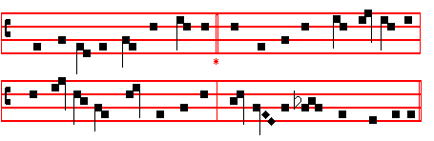
(or the Ratisbon version below at Terce)

935
COME, O Creator Spirit come, 4 Our senses with thy light inflame
And make within our hearts thy home; Our hearts to heavenly love reclaim;
To us thy grace celestial give; Our bodies' poor infirmity
Who of thy breathing move and live. With strength perpetual fortify.

2 O Comforter, that name is thine, 5 Our mortal foe afar repel,
Of God most high the gift divine; Grant us henceforth in peace to dwell;
The well of life, the fire of love, And so to us, with thee for guide,
Our souls' anointing from above. No ill shall come, no harm betide.

3 Thou dost appear in sevenfold dower 6 Make thou to us the Father known,
The sign of God's almighty power Teach us the eternal Son to own,
The Father's promise, making rich Be this our never-changing creed
With saving truth our earthly speech Thou from the Father dost proceed.

7 To thee, who, dead, again dost live,
All glory, Lord, thy people give;
All glory, as is ever meet,
To Father and to Paraclete.

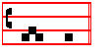
A - men.
¶ Thus the Hymns are ended until Vespers of the following Saturday.
 They were all filled with the Holy Ghost, alleluia.
 And began to speak, alleluia.
On Magnificat, Antiphon. Tone j, 3.
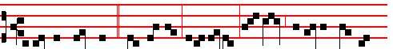
I will not leave you * comfortless, al-le- lu- ia: I go; but I will come to
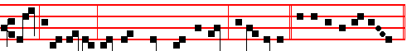
you, alle- lu- ia: and your heart shall rejoice,al-le- lu-ia. Canticle Magnificat

COLLECT
GOD, who on this day didst teach the hearts of the faithful by the light of the Holy Spirit: grant us by the same Spirit to be truly wise and evermore to rejoice in his consolation. Through . in the unity of the same Holy Spirit.
936
WHITSUNDAY
AT MATINS
Invitatory. Tone v.
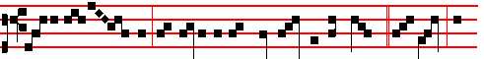
Al- le- lu- ia, the Spirit of the Lord filleth the world: * O come, let
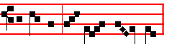
us worship, al- le- lu- ia. It is repeated: Alleluia, the Spirit.
Psalm 95 Venite, exsuktemus Domino XCIV Tone v.
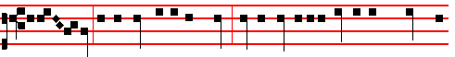
O come, let us sing unto the Lord, let us heartily rejoice in the strength of
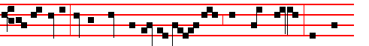
our salvation: let us come before his pres- ence with thanksgiving, and shew
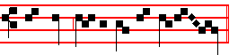
ourselves glad in him with psalms. Choir: Alleluia, the Spirit.
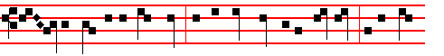
For the Lord is a great God, and a great King above all gods: in his hand
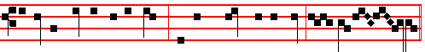
are all the corners of the earth, and the strength of the hills is his al- so.
Choir: O come, let us.
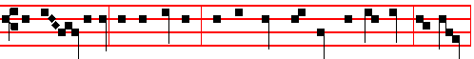 The sea is his, and he made it, and his hands prepared the dry land: O come,
937
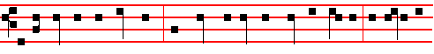
let us worship and fall down, and kneel before the Lord our Maker, for he is the
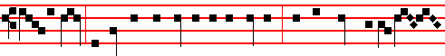
Lord our God; and we are the people of his pasture, and the sheep of his hand....
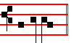
...................... Choir: Alleluia, the Spirit.
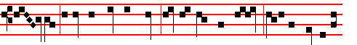
To -day if ye will hear his voice, harden not your hearts, as in the provoca-
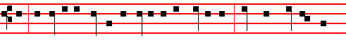
tion, and as in the day of temptation in the wilderness: when your fathers temp-
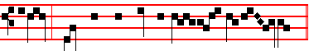
ted me, proved me, and saw my works. ..........................Choir: O come, let us.
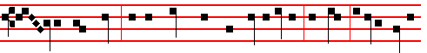
For- ty years long was I grieved with this generation, and said: It is a people
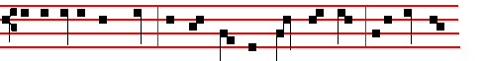
that do err in their hearts, for they have not known my ways; unto whom I
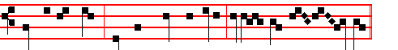
sware in my wrath, that they should not enter into my rest.

938
Choir: Alleluia, the Spirit.
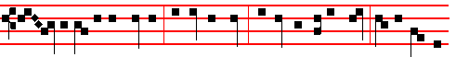
Glo- ry be to the Father, and to the Son, and to the Holy Ghost: As it was in
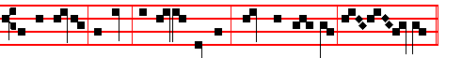
the beginning, is now, and ever shall be, world without end. A- men.
Choir: O come.
Cantors: Alleluia, the Spirit. Choir: O come.

Hymn: E.H. 150 lam Christus astra ascenderat. Mode j.
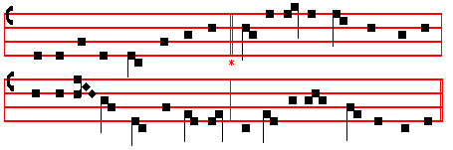
but with vv. 5-9 as below:
WHEN Christ our Lord had passed once more 5 With joy th' Apostles breasts are fired,
Into the heaven he left before, By God the Holy Ghost inspired:
He sent a Comforter below And straight, in divers kinds of speech
The Father's promise to bestow. The wond'rous works of God they preach

2 The solemn time was soon to fall 6 To men of every race they speak,
Which told the number mystical; Alike Barbarian, Roman, Greek:
For since the Resurrection day From the same lips, with awe and fear,
A week of weeks had passed away. All men their native accents hear.

3 At the third hour a rushing noise 7 But Juda's sons, e'en faithless yet,
Came like the tempest's sudden voice, With mad infuriate rage beset,
And mingled with the Apostles' prayer, To mock Christ's followers combine,
Proclaiming loud that God was there. As drunken all with new-made wine

4 From out the Father's light it came, 8 When lo! with signs and mighty deeds
That beautiful and kindly flame, Stands Peter in the midst, and pleads;
To kindle every Christian heart, Confounding their malignant lie
And fervour of the Word impart. With Joel's ancient prophecy.
939
9 To thee, who dead, again dost live,
All glory, Lord, thy people give;
All glory, as is ever meet,
To Father and to Paraclete.
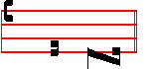
A - men

AT THE NOCTURN
Antiphon. Tone viij, 2.
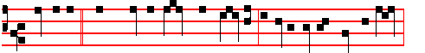
Suddenly * there came a sound from heaven as of a rushing mighty wind,
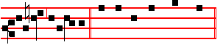
alleluia, allelu-ia. Psalm 48 Magnus Dominus, p. .
Antiphon. Tone viij, 2.
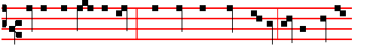
Stablish the thing, O God, * which thou hast wrought in us, for thy temple's
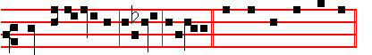
sake at Jerusalem, alleluia, allelu-ia. Psalm 68 Exurgat Deus, p. .
Antiphon. Tone viij, 2.
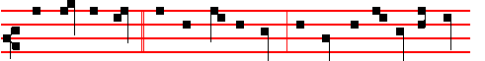
Send forth thy Spirit * and they shall be made: and thou shalt renew the face
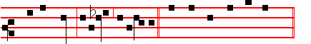
of the earth, alleluia, al-le-lu-ia. Psalm 104 Benedic, anima mea.

940
 The Spirit of the Lord filleth the world, alleluia.
 And that which containeth all things hath knowledge of the voice, alleluia.

Our Father. Absolution Hear, O Lord. Blessing May the Gospel.

The Lesson from the holy Gospel according to John.
Lesson j Ch. 14
AT that time: Jesus said unto his disciples: If a man love me, he will keep my words, and my Father will love him, and we will come unto him, and make our abode with him. And the rest.
Homily by S. Gregory the Great Homily 30 on the Gospels
BELOVED brethren, let us run through the words of the Gospel Lesson, but briefly, so that we may be able to spend longer in contemplation of the unforgettable events of this solemn festival. For on this day suddenly the Holy Spirit came with a rushing sound upon the disciples, changing their fleshly minds into the nature of his own love; and while outwardly fiery tongues appeared, inwardly their hearts were set ablaze; for they who received God in a vision of fire were inflamed with the bliss of love. For the Holy Spirit is Very Love: as John says, God is love. He who yearns for God with all his might does already possess what he loves. Nor is it possible for anyone to have a true love for God if he cannot hold in his possession that which he loves.

 I. Tone iij
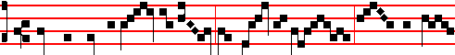
When the day of Pen- te- cost was ful- ly come, they were all
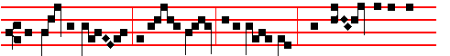
with one accord in one place, al-le-lu- ia: And sud- denly there
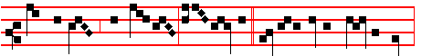
came a sound from hea-ven, alle- lu- ia, * As of a rushing mighty wind,
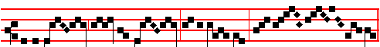
and it filled all the house, al-lelu- ia, al- le- - - - lu- ia.

941
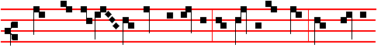
 Where the dis-cip- les were assembled for fear of the Jews, there sudden-
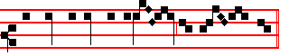
-ly came upon them a sound from heav- en.
As of.
Blessing May the Divine assistance.
Lesson ij
BUT now, if any of you were asked whether you loved God, you would reply with all faith and confidence, I do love him. Yet listen to what the Truth says in today's Gospel: If a man love me, he will keep my words. The proof of love, then, is manifest in works. John says again in his Epistle, If it man say, I love God, and keereth not his commandments, he is a liar. We do indeed love God and keep his commandments, when we deny ourselves our passions. For he who allows himself to be dissipated by unlawful desires does not yet love God, for he wilfully opposes him.

 II. Tone ij
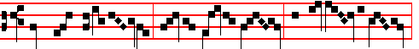
They were all filled with the Ho- ly Ghost, and began to speak
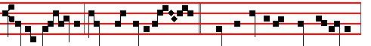
as the Spi- rit gave them utter-ance. * And the multitude came together,
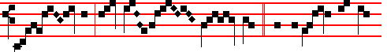
say- ing, al- le- lu- ia.  The Apost-les did speak
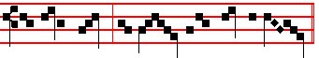
with other tongues the wond- erful works of God.
And the multitude.
942
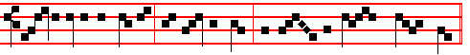
Glo- ry be to the Father, and to the Son, and to the Ho- ly Ghost.
And the multitude.

Blessing May the King of Angels.
Lesson iij
AND my Father will love him, and we will come unto him, and make our abode with him. Beloved brethren, consider how great is this honour: to have God arriving as a guest at the inn of your heart. Surely if some rich or noble friend were about to arrive at our home, the whole place would be thoroughly cleaned with all haste, lest there should be anything to offend the eye of this friend. Therefore let him who is preparing the home of his mind for God rub off the dirt of his sinful works. But behold what the Truth says: We will come unto him, and make our abode with him. For he comes to some hearts and yet does not make his abode in them: by means of a certain degree of penitence these perceive the presence of God, but the temptations of this present life make them forget their repentance, and so they return again to their evil works, even as though they had never repented.
Te Deum Laudamus, p. 24 .
AT LAUDS

AND THE HOURS
Antiphon 1. Tone iij, 3.
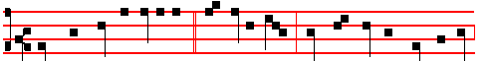
When the day of Pentecost * was fully come, they were all with one accord
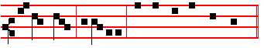
in one place, alle- luia. Ps.93 Dominus regnavit, & c., p. 29.
Antiphon 2. Tone viij, 1.
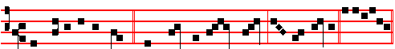
The Spirit of the Lord * hath filled the whole world, al- le- lu-ia. E u o u a e

Antiphon 3. Tone viij, 1.
943
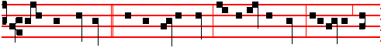
They were all filled * with the Holy Ghost, and began to speak, allelu- ia, al-
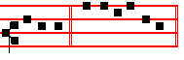
le-lu-ia. E u o u a e. Antiphon 4 Tone j, 4.
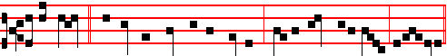
O ye wells, * and all that move in the waters, sing a hymn unto God, alle-luia.
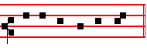
E u o u a e. Antiphon 5. Tone viij, 2.
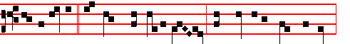
The Apostles * did speak with other tongues the wonderful works of God,
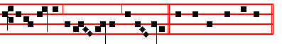
alle- luia, alle- luia, alle- luia. E u o u a e.
Chapter Acts 2
WHEN the day of Pentecost was fully come, they were all with one accord in one place. And suddenly there came a sound from heaven as of a rushing mighty wind, and it filled all the house where they were sitting.
Hymn E.H. 151 Beata nobis gaudia Mode j. 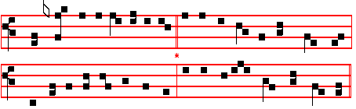

944
observing vv. 6&7 as below:
REJOICE ! the year upon its way 4 These things were done in type that day
Has brought again that blessed day, When Eastertide had passed away;
When on the chosen of the Lord The number told, which once set free,
The Holy Spirit was outpoured. The captive at the jubilee

2 On each the fire, descending, stood, 5 And now, O holy God, this day
In quivering tongues' similitude- Regard us as we humbly pray,
Tongues, that their words might ready prove And send us, from thy heavenly seat,
And fire, to make them flame with love. The blessings of the Paraclete.

3 To all in every tongue they spoke; 6 Thou once in every holy breast
Amazement in the crowd awoke, Didst bid indwelling grace to rest:
Who mocked, as overcome with wine, This day our sins, we pray, release,
Those who were filled with power divine. And in our time, O Lord, give peace.

7 To thee, who, dead, again dost live,
All glory, Lord, thy people give;
All glory, as is ever meet,
To Father and to Paraclete.
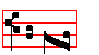
A -men.
 They were all filled with the Holy Ghost, alleluia.
 And began to speak, alleluia.
On Benedictus, Antiphon. Tone vij, 3.
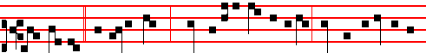
Receive ye * the Holy Ghost:whosesoever sins ye remit, they are remitted un-
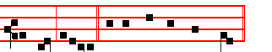
to them, alleluia. Canticle Benedictus, p. 29

COLLECT

O GOD, who on this day didst teach the hearts of the faithful by the light of the Holy Spirit: grant us by the same Spirit to be truly wise and evermore to rejoice in his consolation.Through. in the unity of the same Holy Spirit.

945
AT PRIME
Short  as in the Psalter:
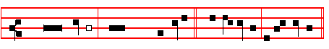
O Christ,
Son of the living God, have mercy upon us. * Al-le-lu-ia, al- le- lu -ia.
O Christ.
 Who sittest
at the right hand of the Father. Al-le-lu-ia, al-le-lu- ia
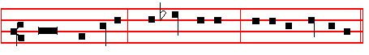
Glory be to the Father, and to the Son, and to the Holy Ghost.
O Christ.
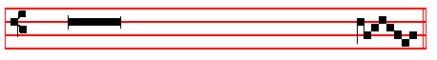
 Arise, O Christ, and help us, allelu- ia.
 And deliver us for thy name's sake, allelu- ia.

AT TERCE
Hymn E.H.154, as above at Vespers, p.935, or this:
(Ratisbon version) Mode viij
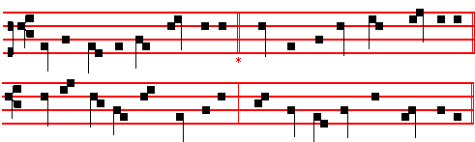
Veni Creator Spiritus
COME, O Creator Spirit come 2 O Comforter, that name is thine,
And make within our hearts thy home; Of God most high the gift divine;
To us thy grace celestial give; The well of life, the fire of love,
Who of thy breathing move and live. Our souls' anointing from above

946
3 Thou dost appear in sevenfold dower 4 Our senses with thy light inflame
The sign of God's almighty power Our hearts to heavenly love reclaim;
The Father's promise, making rich Our bodies' poor infirmity
With saving truth our earthly speech With strength perpetual fortify

5 Our mortal foe afar repel, 6 Make thou to us the Father known,
Grant us henceforth in peace to dwell Teach us the eternal Son to own,
And so to us, with thee for guide, Be this our never-changing creed
No ill shall come, no harm betide Thou from the Father dost proceed.

7 To thee, who, dead, again dost live,
All glory,Lord,thy people give;
All glory, as is ever meet,
To Father and to Paraclete.
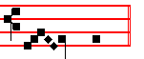
A - - - - men.
which Hymn is said at Terce through the whole Octave instead of the Hymn Nunc Sancte.

Antiphon. The Spirit of the Lord, p. 943.
Chapter When the day of Pentecost, p. 944.
Short 
The Spirit of the Lord hath filled
the whole world. * Al-le-lu-ia, al- le- lu-ia.
The Spirit.
 And that which
contains all things hath knowledge
of the voice. Al-le-lu-ia, al-le- lu-ia.
Glory be to the Father, and to the Son, and to the Holy Ghost.
The Spirit.

947
 The Holy Ghost the Comforter, allelu- ia.
 . Shall teach you all things, allelu- ia.

AT SEXT
Antiphon. They were all filled.
Chapter Acts 2
NOW when this was noised abroad,the multit\.1de came together, and were confounded,because that every man heard them speak in his own language.
Short  The Holy Ghost the Comforter. * Alleluia, alleluia. The Holy Ghost.
 Shall teach you all things. Alleluia, alleluia. Glory be. The Holy Ghost.
 They were all filled with the Holy Ghost, alleluia.
 And began to speak, alleluia.
AT NONE
Antiphon. The Apostles.
Chapter Acts 2
JEWS and proselytes,Ctetes and Arabians,we do hear them speak in our tongues the wonderful works of God.
Short  They were all filled with the Holy Ghost. * Alleluia, alleluia. They were.
 And began to speak. Alleluia, alleluia. Glory be. They were.
 The Apostles did speak with other tongues, alleluia.
 The wonderful works of God, alleluia.

AT VESPERS
Antiphon. When the day of Pentecost, with the rest of Lauds, pp. 943, 944. Psalms 110 Dixit Dominus and the rest of Sunday, p. 202 ff; which are said daily throughout the Octave.

Chapter When the day of Pentecost, p. 935 and Hymn E.H. 154, p. 936.
 The Apcstles did speak with other tongues, alleluia.
 The wonderful works of God, alleluia.

On Magnificat, Antiphon.. Tone j, 3.
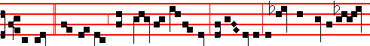
Today * are fulfilled the days of Pentecost, alle- luia: to-day the Holy Spir-

948
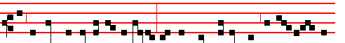
-it appeared in fire to the disciples, and bestowed upon them his manifold gra-
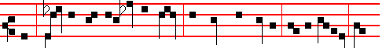
ces: sending them into all the world, to preach the gospel, and to testify: He
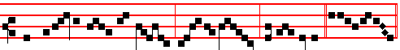
that believeth and is baptized shall be saved, al-le- luia. C. Magnificat

Collect God, who on this day, p. 945.

¶ Within the Octave the Office is as on the day, except the  at the Nocturn, the Lessons, , Antiphons on Benedictus and Magnificat, and the Collect.

¶ If within the Octave there occur a Feast of ix Lessons, it is transferred after the Octave. .But of a Simple in these three days no commemoration is made
__________________________________________________________________

MONDAY

 The Spirit of the Lord hath filled the whole world, alleluia.
 And that which containeth all things hath knowledge of the voice, alleluia.
Our Father. Absolution Hear, O Lord. Blessing May the Gospel.
The Lesson from the holy Gospel according to John.
Lesson j Ch.3
AT that time: Jesus .aid unto Nicodemus: God so loved the world, that he gave his only-begotten Son:that whosoever believeth in him should not perish, but'have everlasting life. And the rest.
Homily by S.Augustine, Bishop. Homily 12 on John.
SO then, as much as in the Physician lieth, he is come to heal the sick. That man is his own destroyer, who will not observe the orders of the physician. He is come, a Saviour, to the world: wherefore is he called Saviour of the world, but that he may save the world, not judge the world? Thou dost not choose to be saved by him: of thine own self thou wilt be judged. And why should I say, Wilt be judged? See what he .saith: He that believeth on him is not judged: but he that

949
believeth not - What thinkest thou he is going to say but, Is judged? Is, saith he, Already judged. Not yet hath the Judgment appeared, but it hath already taken place.

 Henceforth I call you not servants, but I have called you friends: for I have made known unto you all things which I have done in the midst of you, alleluia. * Receive ye the Holy Ghost the Comforter: this is he whom the Father will send unto you, alleluia.
 Ye are my friends, if ye do whatsoever I command you. Receive.

Lesson ij
FOR the Lord knoweth them that are his: knoweth who shall persevere unto the crown, persevere unto the flame: knoweth on his own threshing-floor the wheat, knoweth the chaff; knoweth the corn, knoweth the tares. Already judged is he which bclieveth not. Wherefore judged? Because he hath not believed in the name of the only begotten Son of God. And this is the judgment: that light is come into the world, and men loved darkness more than light, for their works were evil. My brethren, in whom doth the Lord find good works? In none: in all he findeth evil works, In what sense then is it said that certain have done truth, and are come to the Light? For it follows: But he that doeth truth cometh to the light.

 The Holy Ghost, proceeding from the throne, entered unseen into the hearts of the Apostles with a new token of sanctification: * Even that their mouths should give forth all manner of tongues, alleluia.
 The fire of the Divinity fell, not to burn them, but to enlighten them, and gave them gifts of grace. Even. Glory be. Even.

Lesson iij
BUT, saith he, They loved darkness more than light. There hath he laid the stress. For many loved their sins; many confessed their sins. Now he that confesseth his sins, and accuseth his sins, worketh thenceforth with God. God accuseth thy sins: if thou accusest too, thou art joined unto God. They are, as it were, two things; man and sinner. That thou art called man, was God's doing: that thou art called sinner, was man's own doing. Abolish what was thy doing, that God may save what was his doing. It behoveth that thou hate in thee thine own work, and love the work of God in thee. Now, when that which was thy doing shall begin to be displeasing to thee, at that point thy good works begin, in that thou accusest thine evil works. The beginning of good works is the confession of evil works.
Te Deum Laudamus, p. 24.

On Benedictus, Antiphon. Tone viij, 1.
950
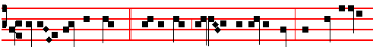
God so loved the world, * that he gave his only- begotten Son, that whosoever
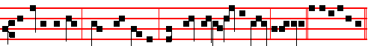
believeth in him should not perish, but have everlasting life, alleluia..Benedictus.

COLLECT
O GOD,who didst give the Holy Spirit unto thine Apostles: grant to thy people the fulfilment of their godly petitions; and as thou hast given to them faith, so also bestow upon them peace. Through. in the unity of the same Holy Spirit.

On Magnificat, Antiphon. Tone iij, 1.
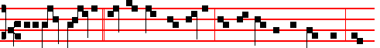
If a man love me,* he will keep my saying, and my Father will love him: and
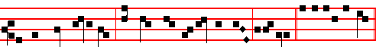
we will come unto him, and make our abode with him, alle-luia. C. Magnificat

Collect O God, as above.
__________________________________________________________________

TUESDAY
 The Holy Ghost the Comforter, alleluia.  Shall teach you all things, alleluia.
Our Father. Absolution May his mercy. Blessing May the Gospel.
The Lesson from the Holy Gospel according to S. John
Lesson j Ch. 10
JESUS said unto the Pharisees: Verily, verily, I say unto you, He that entereth
not by the door into the sheepfold, but climbeth up some other way, the same is a thief and a robber. But he that entereth in by the door is the shepherd of the sheep.
Homily by S. Augustine, Bishop Homily 45 on John
THE Lord hath propounded in the lesson of to-day a similitude concerning his flock and the door by which is the entering into the sheepfold. Then let the

951
pagans say: We lead good lives. If they enter not by the door, what profiteth them that whereof they glory? To each individual who leads a good life, the profit of it ought to be this, that it should be given him to live for ever: if it be not given a man to live for ever what doth his good life profit him? Because they cannot be said even to live well, who either through blindness know not, or through inflation of mind despise that which is the end of good living. Now no man has a true and sure hope of living for ever, unless he acknowledge the Life, which is Christ; and enter by the door into the sheepfold.

 There appeared unto the Apostles cloven tongues like as of fire, alleluia: * And the Holy Ghost rested upon each of them, alleluia, alleluia.
 And they began to speak with other tongues. as the Spirit gave them utterance.
And the Holy.

Lesson ij
NOW it is the aim, generally, of such persons, to persuade other men to lead good lives, and yet not to be Christians. They wish to climb over by another side, to plunder and to kill; not, as the Shepherd, to preserve and to save. So there have been certain philosophers holding much finespun discourse of virtues and vices, dividing, defining, reasoning out most acute conclusions, filling whole books, loud-mouthed in the parade of their own wisdom; who even dared to say to men, Follow us; hold our sect, if ye would live happily. But they entered not by the door: what they wished was to undo men, to slaughter and to kill.

 The Apostles did speak with other tongues the wonderful works of God, * As the Spirit gave them utterance, alleluia.
 They were all filled with the Holy Ghost. and began to speak. As the. Glory be. As the.

Lesson iij
WHAT should I say of them? Lo, the Pharisees themselves read, and in that which they read sounded the name of Christ, hoped for Christ to come, and, when he was come, acknowledged him not: they too boasted that they were among the seeing, that is the wise, and denied Christ, and entered not by the door. Therefore they too, if haply they did draw any after them, it was to slaughter and kill, not to deliver, that they would draw them. Let us leave these also; let us look to those whether haply they enter in by the door, who glory in the name of Christ himself. For there are very many, who not only boast of seeing, but wish to appear illumined by Christ: but they are heretics.
Te Deum Laudamus, 24.

On Benedictus, Antiphon. Tone viij, 1.
952
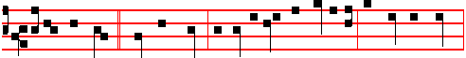
I am the door,* saith the Lord: by me if any man enter in, he shall be saved,
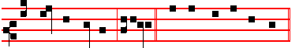
and shall find pasture, alleluia. Canticle Benedictus, p. 29.

COLLECT
WE beseech thee, O Lord, let the power of the Holy Ghost be with us: that it may both mercifully cleanse our hearts, and defend us from all adversities. Through. in the unity of the same.
On Magnificat, Antiphon.
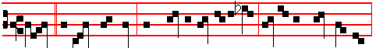
Peace * I leave with you, my peace I give unto you: not as the world giveth,
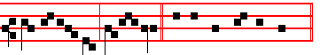
give I unto you, al- le- luia. Canticle Magnificat, p. 210.
__________________________________________________________________

Ember Wednesday
 They were all filled with the Holy Ghost, alleluia.
 And began to speak, alleluia.
Blessing May the Gospel.
The Lesson from the Holy Gospel according to S. John
Lesson j Ch. 6, 44-51
JESUS said to the multitudes of the Jews: No man can come to me, except the Father which hath sent me draw him. And the rest.
Homily by S. Augustine, Bishop Homily 26 on John
DO not imagine that thou art drawn against thy will: the mind is drawn also by love. Nor ought we to fear, lest by men who weigh words nicely while they are far removed from the understanding of divine things, we should, belike, be taken to task in respect of this evangelic word of Holy Writ, and it be said to us, How can I be said to believe with my good will, if I am drawn? I say, Thou art drawn, not merely by the will, but what is more, by very pleasure. What is it to be

953
drawn by pleasure? Delight thou in the Lord, and he shall give thee thy heart's desire. There is a pleasure of the heart, to which sweet is that Bread of heaven. Moreover, if the poet had leave to say, Each has his dear delight which draws him on, not necessity but pleasure; not obligation but delight; how much more strongly ought we to say that a man is drawn to Christ, when he delights in truth, delights in blessedness, delights in righteousness, delights in everlasting life, all which Christ is? Or, while the senses of the body have their pleasures, is the mind left with no pleasure of its own? If the mind hath not its pleasures, how is it said, The children of men shall put their trust under the shadow of thy wings. They shall be satisfied with the plenteousness of thy house: and thou shalt give them drink of thy pleasures, as out of the river. For with thee is the well of life: and in thy light shall we see light.

 The Lord taught them discipline and wisdom, alleluia: he confirmed in them the grace of his Spirit, * And filled their hearts with understanding, alleluia.
 For with a sudden sound the Holy Ghost came upon them. And filled.

Blessing May the divine.
Lesson ij
GIVE me one that loves, and he feels what I say. Give me one that longs, one that hungers, give me one that is on pilgrimage in this wilderness, and doth thirst and pant after the fountain of his eternal home; give me such an one, and he, knows what I would say. But if I speak to one who is cold, he knows not what I speak. Such were they who murmured among themselves. Whom, saith he, the Father shall draw, the same cometh unto me. But what means, Whom the Father shall draw? If we must needs be drawn, let us be drawn by him to whom saith one that loveth: We will run after the odour of thine ointments. Yea, but what he would have to be understood, let us mark, my brethren, and apprehend what we can. The Father draweth to the Son them who believe in the Son, upon the ground that they conceive God to be his Father: for God begat the Son equal to himself: and whoso conceives, and in his faith doth feel and ruminate, how that he on whom he hath believed is equal to the Father, him the Father draweth to the Son.

 Go ye into all the world, and preach the Gospel, alleluia: * He that believeth and is baptized shall be saved, alleluia, alleluia, alleluia.
 In my name shall they cast out devils; they shall speak with new tongues; they shall take up serpents. He that. Glory be. He that.

Blessing May the King of.
Lesson iij
ARIUS believed him a creature: not him did the Father draw; for he considereth not the Father, who believeth not the Son to be equal. What

954
sayest thou, O Arius? What, O heretic, speakest thou! What is Christ? Not, says
he, Very God, but one whom Very God made. Not thee hath the Father drawn, for thou hast not understood the Father, whose Son thou deniest: what thou conceivest is quite another thing, not the Son himself; neither by the Father art thou drawn, nor to the Son art thou drawn: for the Son, and what thou sayest, are quite different things. Photinus said: Christ is man only, he is not God. Whoso believeth so, not the Father hath drawn him. He whom the Father hath drawn saith, Thou art Christ, Son of the living God. Not as a prophet, not as John, not as some great righteous man; but, as Only, as Equal, Thou art Christ, Son of the Living God. See that he hath been drawn, and drawn by the Father. Blessed art thou, Simon Bar-jona; for not flesh and blood hath revealed it to thee. but my Father which is in heaven. This revealing is none other than the attraction, the drawing. Thou holdest out a green bough to a sheep, and drawest the sheep to thee. Nuts are shewn to a child, and he is drawn: even what the child runs to, he is drawn to: drawn by love of the object, drawn without hurt to the body, drawn by the bond or the heart. If then these things, which among the delights and pleasures of earth are revealed to those that love them, do draw them; since it is true, Each has his dear delight, which draws him on, doth not Christ revealed by the Father draw? What doth the soul more strongly desire than truth? For what ought it to have an eager appetite, wherefore wish that there may be a healthy palate within to judge what is true, but that it may eat and drink wisdom, righteousness, truth, eternity?
Te Deum Laudamus, 24.
On Benedictus, Antiphon. Tone viij, 1.
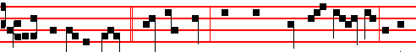
I am the living bread, * saith the Lord, which came down from heav-en, al-le-
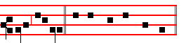
-luia, alleluia. Canticle Benedictus, p. 29.
COLLECT
WE beseech thee,O Lord,that the Paraclete, who proceedeth from thee, may enlighten our minds: and lead us, as thy Son hath promised, into all truth: Who liveth and reigneth with thee in the unity of the same Holy Spirit.
On Magnificat, Antiphon. Tone j, 1.
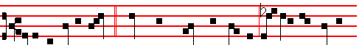
I am the living bread * which came down from heaven: if any man eat of
955
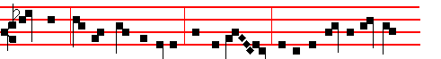
this bread, he shall live for ever: and the bread that I will give is my flesh,
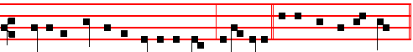
which I will give for the life of the world, alle-luia. Canticle Magnificat.
__________________________________________________________________

Thursday
 The Spirit of the Lord filleth the world, alleluia.
 And that which containeth all things hath knowledge of the voice, alleluia.
Blessing May the Gospel.
The Lesson from the Holy Gospel according to S. Luke
Lesson ij Ch. 9, 1-6.
JESUS called his twelve disciples together, and gave them power and authority over all devils, and to cure diseases. And the rest.
Homily by S. Ambrose, Bishop Bk. 6 on Luke 9
THE Gospel teaches us what sort of a man he should be who preaches the Gospel of the kingdom of God: he is to go forth without staff, scrip, shoes, bread or money, that is, not requiring any material support, but relying on faith, so that the less he needs for himself, the more can he give himself. It is also allowable to put a purely spiritual interpretation on these words, for a man would seem, as it were, to have deprived himself of clothes for his body, when he has not only rejected power and despised riches, but has rejected the pleasures of the flesh itself. First, a general commandment of peace and stability is given; that they should bring peace, stay in one place, and observe the customs pertaining to guests. To go from house to house and to abuse the customs of hospitality is ill-becoming to a preacher of the kingdom of God.

 The fire of the Divinity fell, not to burn them, but to enlighten them; not to devour them, but to illuminate them: and found the hearts of the disciples pure vessels: * And he gave them gifts of his grace, alleluia, alleluia.
 He found them of one heart in love, and the outpoured grace of the Godhead shone through them. And he.

Blessing May the divine .
Lesson ij
BUT while appreciation of hospitality is recommended, at the same time it is ordained that if they are not received, they are to shake off the very dust from
956
their feet when they go out or that city. We are taught that hospitality meets with no small reward: not only do we bring peace to those who receive us, but also, if they are overcast by the clouds of earthly desires, then their chains are loosed as they receive the Apostolic preaching. It is not without reason that, according to Matthew, the Apostles are to enquire who is worthy in the houses that they enter, as they are thus freed from the necessity of going from house to house, and abusing the customs of hospitality. Now this warning is not given to those who receive guests, lest by the act of choosing their guests they should lessen their hospitality.

 The Holy Ghost filled all the house where the Apostles were; and there appeared unto them cloven tongues like as of fire, and it sat upon each of them: * And they were all filled with the Holy Ghost, and began to speak with other tongues as the Spirit gave them utterance, alleluia, alleluia, alleluia.
 Where the disciples were assembled for fear of the Jews, there suddenly came upon them a sound from heaven. And they. Glory be. And they.

Blessing May the King of.
Lesson iij
THIS passage, taken literally, is an admirable precept concerning the sacred duty of hospitality, but its words also offer us a heavenly mystery: he who chooses a house is to enquire as to the worth of his host. Does not this suggest that the house to be chosen is the Church, and the host, Christ? For what house is more worthy of the entrance of the Apostolic preaching than Holy Church, or who is to be preferred before all others but Christ? He who is accustomed to wash the feet of his guests, and who suffers no stain of sin to remain on the soles of the feet of those who enter his house, who, no matter how travel-stained they are by their former life, vouchsafes to send them forth clean into the future. Here alone is the abode never to be left. never to be changed. It is well said of it, Lord, to whom shall we go? Thou hast the words of eternal life.
Te Deum Laudamus, p. 24.
On Benedictus, Antiphon. Tone j, 2.
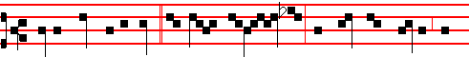
Jesus called unto him * his twelve discip- les, and gave them power and
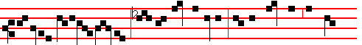
authority over all dev- ils, and to cure diseases: and he sent them to preach

957
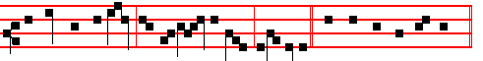
the kingdom of God, and to heal the sick, alle- luia. Canticle Benedictus, p. 29.

COLLECT
GOD,who as at this time didst teach the hearts of thy faithful people, by the sending to them the light of the Holy Spirit: grant us by the same Spirit to have a right judgment in all things,and evermore to rejoice in his holy comfort. Through. in the unity of the same.
On Magnificat, Antiphon.. Tone viij, 1.
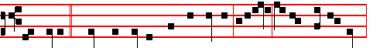
The Spirit * which proceedeth from the Father, alleluia: he shall glorify me,
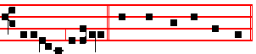
allelu- ia, alleluia. Canticle Magnificat, p. 211. __________________________________________________________________

Ember Friday
 The Holy Ghost the Comforter, alleluia.  Shall teach you all things, alleluia.
The Lesson from the Holy Gospel according to S. Luke
Lesson j Ch. 5, 17-26
IT came to pass on a certain day, that Jesus was teaching, and there were Pharisees and doctors of the law sitting by, which were come out of every town of Galilee, and Judæa, and Jerusalem: and the power of the Lord was present to heal them. And the rest.
Homily by S. Ambrose, Bishop Bk. 5 on Luke 5
IT was no chance occurrence, this healing of the paralytic, nor is its meaning limited to what actually took place at the time. The Lord healed him, not because he was asked to, but to set an example. He showed forth this example, so that others might imitate it: it was not the outward show of prayer that he was seeking. Amongst many other instances of healing the sick in the presence of Pharisees and doctors of the law who had come out of every town of Galilee and Judæa and Jerusalem, this particular paralytic's cure is described. First of all, as I have said before, every sick man ought to ask for prayers to be offered for his recovery, so that, by means of these prayers, the weakened frame of our mortal

958
life and the limping steps of our bodily movements may be made whole again by the healing power of the celestial word.

 Ye have not chosen me, but I have chosen you, and ordained you: * That ye should go and bring forth fruit, and that your fruit should remain, alleluia, alleluia.
 As the Father hath sent me, even so send I you. That ye.

Lesson ij
THEREFORE there should be men who are able to help the sick in mind, so that when the soul is depressed by the torpor of bodily weakness these men can rouse it again to higher things. By their aid the sick man can easily be brought and laid before Jesus, and be found worthy of the Lord's glance. For the Lord does look upon those that are lowly; For he hath regarded the lowliness of his hand-iden. And when he saw their faith, he said unto him, Man, thy sins are forgiven thee. Great is the Lord, who, for the merits of some, forgives others, who tries some, and forgives the trespasses of others. Why should not your fellow-Christian, O man, have influence with you, if he has the right to intercede and obtain mercy from God ?

 The Spirit of the Lord filleth the world: * And that which containeth all things hath knowledge of the voice, alleluia, alleluia.
 For he is the worker of all things, having all power, and overseing all things. And that. Glory be. And that.

Lesson iij
O THOU who condemnest, learn to forgive: thou who art sick, to pray! If the gravity of thy sins makes thee afraid lest they should not be forgiven thee, betake thyself to the Church. She will pray on thy behalf, and God will pardon, as he looks on her, what he might deny to thee. Moreover, there is something else in this Gospel narrative which we ought not to overlook, while believing that the body of the paralytic was healed; we must recognize that he whose sins were forgiven was healed in soul as well. The Jews, in asserting that God alone can forgive sins, do indeed confess the Godhead, but they themselves betray their own unbelief, in denying his Person.
Te Deum Laudamus, p. 24.

On Benedictus, Antiphon. Tone j, 3.
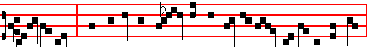
Jes- us said: * But that ye may know that the Son of man hath power on earth

959
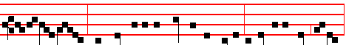
to forgive sins, (he saith unto the sick of the palsy) I say unto thee, Arise,
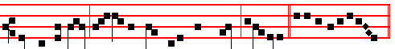
take up thy bed, and go thy way into thine house, alle-luia. Canticle Benedictus

COLLECT
GRANT, we beseech thee, O merciful God, to thy Church: that, being gathered together in the Holy Ghost, she may be disturbed by no assaults of the enemy. Through. in the unity of the same.
On Magnificat, Antiphon. Tone viij, 1.
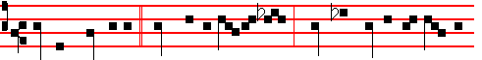
But the Comforter,* which is the Holy Ghost, whom the Father will send in
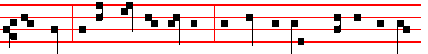
my Name, he will teach you all things, and bring all things to your rememb-
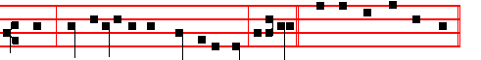
-rance, whatsoever I have said unto you, alleluia. Canticle Magnificat, p. 211.
__________________________________________________________________

Ember Saturday
 They were all filled with the Holy Ghost, alleluia.
 And began to speak, alleluia.
The Lesson from the Holy Gospel according to S. Luke
Lesson j Ch. 4, 38-44
JESUS arose out of the synagogue, and entered into Simon's house. And Simon's wife's mother was taken with a great fever. And the rest.
Homily by S. Ambrose, Bishop Bk. 4 on Luke Ch. 4.
BEHOLD the compassion of our Lord and Saviour: he is not angry with the Jews, nor offended with their evil doings, nor even when they are violently

960
malicious does he leave them; on the contrary, heedless of the wrongs they do him, and regarding only his compassion towards them, by teaching one, freeing another, healing a third, he softens the heart of this unbelieving people. And rightly has Luke recounted the freeing of the man from an unclean spirit, and then gone on to speak of the healing of this woman. The Lord came to work his cure on both sexes, yet it was but fitting that he should heal first the one who was created first; afterwards he was not to overlook the one who had sinned more through levity of mind than through actual malice.

 When the day of Pentecost was fully come, they were all with one accord in one place, alleluia; And suddenly there came a sound from heaven, alleluia; * As of a rushing mighty wind, and it filled all the house, alleluia, alleluia.
 Where the disciples were assembled for fear of the Jews, there suddenly came upon them a sound from heaven. As of.

Lesson ij
THE Lord began his healing on the Sabbath, and this reveals to us that the New Creation begins there, where the old creation left off. It also makes plain that thc Son of God was not under the law but above the law, not come to destroy the law, but to fulfil it. Nor was it through the law that the world was made, but it was made by the Word; as we read, By the Word of the Lord were the heavens made. Therefore the law was not destroyed but fulfilled in the restoration of fallen man. As the Apostle says, Put off the old man, and put on the new man, which after God is created.

 Henceforth I call you not servants, but I have called you friends: for I have made known unto you all things which I have done in the midst of you, alleluia. * Receive ye the Holy Ghost the Comforter: this is he whom the Father will send unto you, alleluia.
 Ye are my friends, if ye do whatsoever I command you. Receive. Glory be. Receive.
Lesson iij
AND rightly did the Lord begin on the Sabbath, that he might show himself to be the very Creator, interweaving all his works together, and that he might continue the work that he had already begun; just as a builder. when he knocks down a house in order to rebuild it, begins not with the foundations, but with the roof. So in this case God begins again where he had left off, on thc Sabbath: and he begins again with lesser works, that he may go on to greater ones. Even men are able to deliver others from demons, as agents themselves of the Word of God, but by the power of the Divine Majesty alone can the raising of the dead be commanded. Perhaps in this woman, the mother-in-law of Simon and Andrew, we

961
are to see a figure of our fleshly nature, languishing under the numerous fevers of sin, and burning with uncontrolled enticements of unlawful desires. Indeed, I would not call the fever of desire a lesser malady than a physical fever: one rages in the soul, the other in the body. Avarice is our fever, lust is our fever: luxury is our fever; ambition is our fever; wrath is our fever.
Te Deum Laudamus, p. 24.
On Benedictus, Antiphon. Tone j, 1.
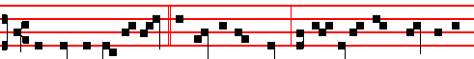
The love of God is shed * abroad in our hearts by his Spirit which dwelleth in
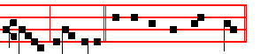
us, alleluia. Canticle Benedictus, p. 29.

COLLECT
WE beseech thee, O Lord, graciously pour the Holy Ghost into our hearts: by whose wisdom we were created, and by whose providence we are governed. Through. in the unity of the same.

¶ After None, when Mass has been celebrated, Eastertide ends.
__________________________________________________________________

ON THE FEAST OF THE MOST HOLY TRINITY
At Vespers, Antiphons of Lauds. Psalms 110, 111, 112, 113, 117, as in I Vespers of Apostles, 202, ij.
Chapter Rom. 11
O THE depth of the riches both of the wisdom and knowledge of God! how unsearchable are his judgments, and his ways past finding out!
Hymn E.H. 164 O Lux beata Trinitas, in the Psalter, pp. 241, 242.
 Let us bless the Father, and the Son, and the Holy Ghost.
 Let us praise him and magnify him above all for ever.

On Magnificat, Antiphon.
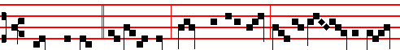
Thanks, O God, * be unto thee, thanks be unto thee, one and ve- ry Tri-

962
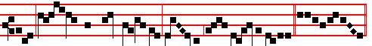
nity, one and supreme De-i- ty, ho- ly and on- ly Unity. C. Magnificat

COLLECT
ALMIGHTY and everlasting God, who hast given unto us thy servants in the confession of the true faith, to acknowledge the glory of the eternal Trinity, and in the power of the Majesty to worship the Unity: we beseech thee; that through the steadfastness of the same faith we may ever be defended from all adversities. Through.
And commemoration is made of the first Sunday after Pentecost.
Antiphon.
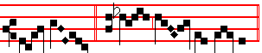
Speak, Lord, * for thy serv- ant hear-eth.
 Let our evening prayer come up before thee, O Lord.
 And let thy mercy come down upon us.
COLLECT
O GOD, the strength of all them that put their trust in thee, mercifully accept our prayers: and because through the weakness of our mortal nature we can do no good thing without thee, grant us the help of thy grace; that in keeping of thy commandments we may please thee, both in will and deed. Through.

At Compline, the Hymn Te lucis in the Tone Tu Trinitatis, as below at Lauds.

AT MATINS
Invitatory.- The true God, One in Trinity and Trinity in Unity, * O come, let us worship. Psalm 95 Venite, p. 2.
Hymn Summae Deus clementiae
O GOD of greatest clemency 2 To us arising give thy hand,
Who mad'st this wondrous world to be, Help us witn sober minds to stand,
In Pow'r essential Unity, Aflame with love, and to thee pay
In Person Holy Trinity: Our debt of thanks, our praise for aye.

3 Glory to thee, O Father, Lord,
And to thy Sole-begotten Word,
Both with the Holy Spirit One
While everlasting ages run. Amen.

963
IN THE FIRST NOCTURN
Antiphon. Be present, * One God Almighty, Father, Son, and Holy Ghost. Psalms as in the first Nocturn of the Common of Virgins, p. . Psalm 8 Domine Dominus noster.
Antiphon.We acknowledge thee, * One in being, Three in persons. Psalm 19 Cæli enarrant.
Antiphon. We testify * that thy Being, thy Life, and thine Understanding are One and eternally unchangeable. Psalm 24 Domini est terra, p. .
 Let us bless the Father, and the Son, with the Holy Ghost.
 Let us praise and exalt him above all for ever.

From the Prophet Isaiah
Lesson j Ch. 6, 1-12
IN the year that King Uzziah died I saw also the Lord sitting upon a throne, high
and lifted up, and his train filled the temple. Above it stood the seraphim: each one had six wings; with twain he covered his face, and with twain he covered his feet, and with twain he did fly. And one cried unto another, and said, Holy, holy, holy, is the Lord of hosts: the whole earth is full of his glory. And the posts of the door moved at the voice of him that cried, and the house was filled with smoke.

 I saw the Lord sitting upon a throne, high and lifted up, and the whole earth was full of his glory: * And his train filled the temple.
 Above it stood the Sera phim; each one had six wings. And his.

Lesson ij
THEN said I, Woe is me! for 1 am undone; because I am a man of unclean lips, and 1 dwell in the midst of a people of unclean lips: for mine eyes have seen the King, the Lord of hosts. Then flew one of the seraphim unto me, having a live coal in his hand, which he had taken with the tongs from off the altar. And he laid it upon my mouth, and said, Lo, this hath touched thy lips; and thine iniquity is taken away. and thy sin purged. Also I heard the voice of the Lord. saying, Whom shall I send, and who will go for us? Then said I, Here am I; send me.

 Blessed be the Lord, even the God of Israel, which only doeth wondrous things: * And blessed be the Name of his Majesty for ever.
 All the earth shall be filled with his Majesty, Amen, Amen. And blessed.

Lesson iij
AND he said, Go, and tell this people, Hear ye indeed, but understand not; and see ye indeed, but perceive not. Make the heart of this people fat, and make their ears heavy, and shut their eyes; lest they see with their eyes, and hear with

964
their ears, and understand with their heart, and convert, and be healed. Then said I, Lord, how long? And he answered, Until the cities be wasted without inhabitant, and the houses without man, and the land be utterly desolate, and the Lord have removed men far away, and there be a great forsaking in the midst of the land.

 God, even our own God. t shall give us his blessing: God shall bless us, * And all the ends of the world shall fear him.
 God be merciful unto us and bless us. And all. Glory be. And all.

IN THE SECOND NOCTURN
Antiphon. We call upon thee,* we praise thee, we worship thee, O blessed Trinity. Psalm 47 Omnes gentes.
Antiphon. Thou art our hope, * thou our salvation, thou our joy, O blessed Trinity. Psalm 48 Magnus Dominus.
Antiphon. Deliver us, save us, quicken us, O blessed Trinity. Psalm 72 Deus judicium tuum.
 Blessed art thou, O Lord, in the firmament of heaven.
 And to be praised and glorified above all for ever.

From the Book on the Faith by S. Fulgentius, Bishop, to Peter
Lesson iv
THE Faith which the holy Patriarchs and Prophets received before the Incarnation of the Divine Son of God, which the holy Apostles also heard from the same Lord clothed in flesh, the Faith which the holy Apostles were instructed by their Divine teacher, the Holy Spirit, not only to preach verbally, but also to leave in writing for the saving instruction of those who should come after them; this Faith proclaims one God in Trinity, that is, the Father, and the Son, and the Holy Ghost. But there would not be a true Trinity if one and the same Person were called Father, and Son. and Holy Ghost.

 Who is so great a god as our God? * Thou art the God that doeth wonders.
 Thou hast declared thy power among the people: thou hast mightily delivered thy people. Thou art.

Lesson v
FOR if, just as the Father, and the Son, and the Holy Ghost are one Substance, they were likewise one Person, then in no wise could it be called a true Trinity. Then again it could be called a Trinity, but could not be said to be one God, if, in the same way that the Father and the Son and the Holy Ghost are each distinct as to their difference of Person, so they were also unlike as regards diversity of nature. But because it is essentially true that in this One God in

965
Trinity, there is not only the One God, but also the Trinity; therefore the One true God is Triune in Person and Onely in Nature.

 To thee be praise, to thee be glory, to thee be thanksgiving for ever and ever, * O blessed Trinity.
 And blessed is thy glorious and holy Name, and to be praised and exalted above all for ever. O blessed.

Lesson vj
IN this Essential Unity the Father is wholly in the Son and the Holy Ghost, the Son is wholly in the Father and the Holy Ghost, and the Holy Ghost is wholly in the Father and the Son. None is in any way without the others: for none came before the others in eternity, nor was greater in majesty, nor mightier in power. As concerning the Unity of the Divine Nature, the Father is neither greater nor before the Son; neither is it possible for the eternity and immensity of the Son to be either greater or before the eternity and immensity of the Holy Ghost, or precede or to exceed it.

 Great is the Lord, and highly to be praised: * Yea, and his wisdom is infinite.
 Great is our Lord, and great is his power: there is no end of his greatness. Yea, and. Glory be. Yea, and.

IN THE THIRD NOCTURN
Antiphon. The Father is love, * the Son is grace, and the Holy Ghost is fellowship, O blessed Trinity. Psalms from the third Nocturn of the Common of Virgins, p. . Psalm 96 Cantate Domino canticum novum.
Antiphon. The Father is true, * the Son is truth, the Holy
Ghost is truth, O blessed Trinity. Psalm 97 Dominus regnavit
Antiphon. The Being * of the Father and the Son and the Holy Ghost is One, O blessed Trinity. Psalm 98 Cantate Domino canticum novum.
 By the Word of the Lord were the heavens made.
 And all the hosts of them by the breath of his mouth.
The Lesson from the Holy Gospel according to S. Matthew
Lesson vij Ch. 28.
JESUS came and spake unto them, saying, All power is given unto me in heaven
and in earth. And the rest.
Homily by S. Gregory Nazianzen Prologue to the Treatise on the Orthodox Faith
WHAT Catholic does not know that the Father is truly the Father, the Son truly the Son, and the Holy Ghost truly the Holy Ghost? As the Lord said to his Apostles: Go ye therefore, and teach all nations, baptizing them in the name of the Father, and of the Son, and of the Holy Ghost. Here is the perfect Trinity,

966
consisting in the Unity which we profess to be of one substance. For we make no division of God according to bodily conditions: but we believe that the Persons named truly consist according to the power of the divine nature which is not of matter, and we testify to the unity of the Godhead.

 Let us bless the Father and the Son with the Holy Ghost: * Let us praise and exalt him ahove all for ever.
 Blessed art thou, O Lord, in the firmament of heaven, and to be praised and glorified for ever. Let us praise.

Lesson viij
NEITHER do we say that the Son of God is some kind of an extension from the Father, as some have thought: nor do we hold that he is a word without substance, like the sound of a voice: but we believe that the three Names and the three Persons are of one essence, one majesty and one power. And we therefore confess one God: for the unity of majesty prohibits him to be named as many gods. Finally, as Catholics we name the Father and the Son; but we neither may, nor can, speak of two Gods. Not that the Son of God is not God, indeed he
is very God of very God; for we know that the Son of God is from no other source than the one Father himself; hence we say that there is one God. This the prophets, this the Apostles handed down: this the Lord himself taught, when he said: I and my Father are one. By the word, One, he refers to the Unity of the Divinity, as I mentioned; by the word, Are, he designates the Persons.

 One Seraph cried unto another, and said, * Holy, holy, holy, is the Lord of hosts: * The whole earth is full of his glory. There are Three that bear
record in heaven, the Father, the Word, and the Holy Ghost; and these Three are One. Holy, holy. Glory be. The whole.

The Lesson from the holy Gospel according to Luke.
Lesson ix Ch.6, 36.
AT that time:Jesus said unto his disciples: Be ye merciful, as your Father also is merciful. And the rest.
Homily by Saint Augustine, Bishop. Sermon 15 on Matthew.
TWO are the works of mercy that deliver us, as the Lord put it briefly in the Gospel: Forgive, and ye shall be forgiven: Give, and it shall be given unto you. Forgive, and ye shall be forgiven, concerns forgiveness: Give,and it shall be given unto you, concerns bestowing alms. For he says of forgiveness, you also wish to be forgiven, for you sin, and you have another whom you can forgive. Again, concerning giving alms, the beggar asks of you, and you are a beggar before God. For we all, when we pray, are beggars before God, we stand before the door of a great householder, indeed we bow down, we groan in supplication,

967
wanting to receive something: and that something is God himself. What does the beggar ask of you? Bread. And what do you ask of God, but Christ who says: I am the living Bread which came down from heaven? You want to be forgiven, forgive: Forgive,and ye shall be forgiven. You want to receive: Give, and it shall be given unto you.
Te Deum Laudamus, p. 24.
AT LAUDS

AND THROUGH THE HOURS
Antiphon 1. Tone j, 3.
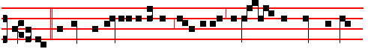
Glory * to thee, O Trinity co-equal, only Deity, ere yet the worlds began
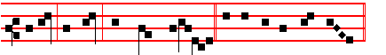
to be, and now, and through eternity. Psalm 93 Dominus regnavit
and the rest, p. 29.
Antiphon 2. Tone ij.
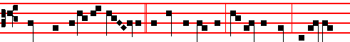
Praise and unending glo- ry * to God the Father, and to the Son, and to the
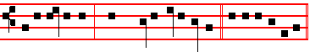
Holy Paraclete, through ages everlasting. E u o u a e.
Antiphon 3. Tone iij, 3.
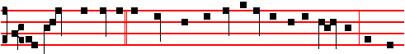
Let praise and glory * resound from the lips of all men to the Fath-er and the
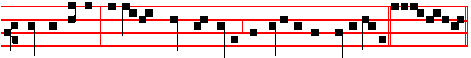
Sole-begotten; and equal praise be given for ever to the Holy Spirit. E u o u a e.

968
Antiphon 4.. Tone iv, 1.
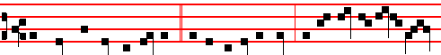
Let praise to God the Father, * to the co-equal Son, and to thee, O Holy Spi-
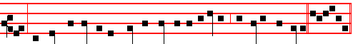
-rit, resound unceasingly from the lips of all creation, for ever and ever. Euouae.
Antiphon 5. Tone v.
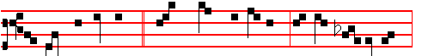
Of whom are all things, * through whom are all things, in whom are all things:
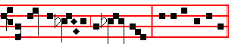
to him be glor-y for ev- er. E u o u a e.
Chapter Romans 11
O THE depth of the riches both of the wisdom and knowledge of God! how unsearchable are his judgments, and his ways past finding out!
Hymn: as E.H. 164, p. 122., or: (Ratisbon) Tu Trinitatis Unitas Mode viij
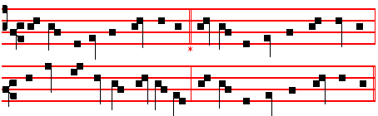
THOU Trinity in Unity 2 The day-starts rays are glittering clear,
Who rulest all things mightily, And tell that day itself is near;
Bow down to hear the songs of praise The shadows of the night depart:
Which we, thy wakeful servants, raise. Thou, holy Light, illume the heart.

3 All laud to God the Father be;
All praise, eternal Son, to thee;
All glory, as is ever meet,
To God the Holy Paraclete.

969

A- men.
 Let us bless the Father,and the Son,and the Holy Ghost.
 Praise him, and magnify him for ever.
On Benedictus, Antiphon. Tone vj.
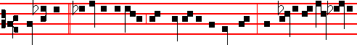
Blessed be * the holy Creator and Governor of all things, the holy and undivi-
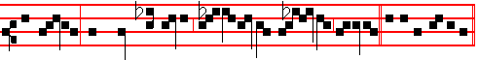
ded Trinity, both now and ever, and to endless ag- es of ages. C. Benedictus

COLLECT
ALMIGHTY and everlasting God,who hast given unto us thy servants in the confession of the true faith, to acknowledge the glory of the eternal Trinity, and in the power of the Majesty to worship the Unity: we beseech thee; that through the steadfastness of the same faith we may ever be defended from all adversities. Through.
And commemoration is made of the Sunday.
Antiphon.
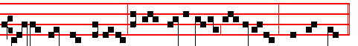
Be ye there-fore merciful, as your Father also is merciful, saith the Lord.
 The Lord is King, and hath put on glorious apparel.
 The Lord hath put on his apparel, and girded himself with strength.
COLLECT
O GOD, the strength of all them that put their trust in thee, mercifully accept our prayers: and because through the weakness of our mortal nature we can do no good thing without thee, grant us the help of thy grace; that in keeping of thy commandments we may please thee, both in will and deed.
Through.
AT PRIME
Psalms as on a Double Feast, with the Athanasian Creed. The Short Lesson There are Three, as below at None.
970
AT TERCE
Antiphon. Praise and unending glory, p. 968.
Chapter O the depth, as above, p. 969.
Short 
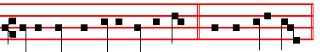
Let us bless the Father,and the Son. * And the Holy Ghost. Let us.
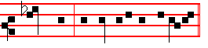
 Praise him, and magnify him for ev-er. And the.
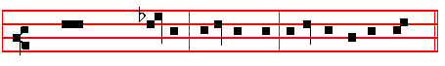
Glory be to the Father, and to the Son, and to the Holy Ghost. Let us.
 Blessed art thou, O Lord, in the firmament of heav- en.
 And to be praised, and glorified, and magnified forev-er.

AT SEXT
Antiphon. Let praise and glory, p. 968.
Chapter 2 Cor. 13
THE grace of our Lord Jesus Christ, and the love of God, and the communion of the Holy Ghost ,be with you all. Amen.
Short 
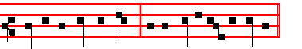
Blessed art thou, O Lord. * In the firmament of heaven. Blessed art.
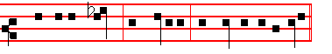
 And to be praised, and glorified, and magnified for ever. In the.
Glory be. Blessed art.
971
 By the word of the Lord were the heavens made.
 And all the hosts of them by the breath of his mouth.

AT NONE
Antiphon. Of whom are all things, p. 969.
Chapter I John 5
THERE are three that bear record in heaven, the Father, the Word, and the Holy Ghost: and these three are one.
Short 
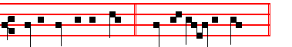
By the word of the Lord. * Were the heav- ens made. By the.
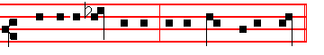
 And all the hosts of them by the breath of his mouth. Were the. Glory be.
By the.
 Blessed be the Name of the Lord.  Henceforth, and for evermore.

AT VESPERS
Antiphons and Chapter of Lauds. Psalms of Sunday, p. 202. Hymn as in I Vespers from the Psalter, pp. 241, 242.
 Blessed art thou, O Lord, in the firmament of heaven.
 And to be praised,and glorified,and magnified for ever.
On Magnificat, Antiphon. Tone iv, 1.
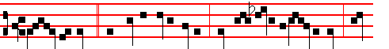
Thee, O God, * the Father unbegotten; thee, O only- begot- ten Son; thee,
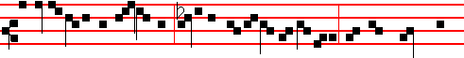
O Holy Spirit, the Paraclete; holy and undi- vided Trinity: with our whole heart
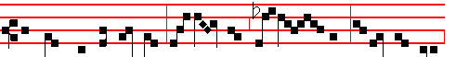
and mouth we confess thee, we praise thee and bless thee: to thee be glory

972
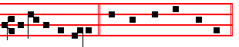
for ever and ev-er. Canticle Magnificat, p. 209.
Collect Almighty, p. 970. For commemoration of the Sunday, Antiphon.
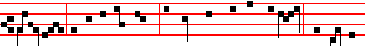
Judge not, that ye be not judged: for with what judgment ye judge, ye shall be
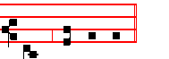
judged, saith the Lord.  Lord, let my prayer be set forth.
 In thy sight as the incense. Collect O God, the strength, p. 970.
__________________________________________________________________

MONDAY
All is said as in the Psalter, with the Collect of the preceding Sunday, O God, the strength, p. 557.
On this night are placed the books of (Samuel and) Kings, from which are the readings until the first Sunday of August: but if anything remains of these books when the said Sunday arrives, it is omitted.
Here beginneth the first book of Samuel, otherwise called the first book of the Kings.
Lesson j Ch. 1.
NOW there was a certain man of Ramathaim-zophim, of mount Ephraim, and his name was Elkanah, the son of Jerobam, the son of Elihu, the son of Tohu, the son of Zuph, an Ephrathite: And he had two wives; the name of the one was Hannah, and the name of the other Peninnah: and Peninnah had children, but Hannah had no children. And this man went up out of his city yearly to worship and to sacrifice unto the Lord of hosts in Shiloh. And the two sons of Eli, Hophni and Phinehas, the priests of the Lord, were there.

 Prepare your hearts unto the Lord, and serve him only: * And he will deliver you out of the hands of your enemies.
 Return unto him with all your hearts, and put away the strange gods from among you. And he.

Lesson ij
973
AND when the time was that Elkanah offered, he gave to Peninnah his wife, and to all her sons and her daughters, portions: But unto Hannah he gave a worthy portion; for he loved Hannah: but the Lord had shut up her womb. And her adversary also provoked her sore, for to make her fret, because the Lord had shut up her womb. And as he did so year by year, when she went up to the house of the Lord, so she provoked her; therefore she wept, and did not eat. Then said Elkanah her husband to her, Hannah, why weepest thou? and why eatest thou not? and why is thy heart grieved? am not I better to thee than ten sons?

 God who heareth all hath sent his Angel, and he took me from keeping my father's sheep: * And anointed me with the oil of his mercy.
 The Lord that delivered me out of the mouth of the lion, and out of the paw of the bear. And anointed.

Lesson iij
SO Hannah rose up after they had eaten in Shiloh, and after they had drunk. Now Eli the priest sat upon a seat by a post of the temple of the Lord. And she was in bitterness of soul, and prayed unto the Lord, and wept sore. And she vowed a vow, and said, O Lord of hosts, if thou wilt indeed look on the affliction of thine handmaid, and remember me, and not forget thine handmaid, but wilt give unto thine handmaid a man child, then I will give him unto the Lord all the days of his life, and there shall no rasor come upon his head.

 The Lord that delivered me out of the mouth of the lion and out of the paw of the bear, * He will deliver me out of the hand of mine enemies.
 God hath sent forth his mercy and truth: my soul is among lions. He will.
Glory be. He will.
__________________________________________________________________

TUESDAY
From the first book of the Kings.
Lesson j I Sam. 1, 12
AND it came to pass, as she continued praying before the Lord, that Eli marked her mouth. Now Hannah, she spake in her heart; only her lips moved, but her voice was not heard: therefore Eli thought she had been drunken. And Eli said unto her, How long wilt thou be drunken? put away thy wine from thee. And Hannah answered and said, No, my lord, I am a woman of a sorrowful spirit: I have drunk neither wine nor strong drink, but have poured out my soul before the Lord. Count not thine handmaid for a daughter of Delial: for out of the abundance of my complaint and grief have I spoken hitherto. Then Eli answered and said, Go in peace: and the God of Israel grant thee thy petition that thou hast

974
asked of him. And she said, Let thine handmaid find grace in thy sight.

 Saul hath slain his thousands, and David his ten thousands.* The hand of the Lord was with him: he killed the Philistine, and took away the reproach from Israel.
 Is not this David: did they not sing one to another of him in dances, saying, Saul hath slain his thousands, and David his ten thousands? The hand.

Lesson ij
SO the woman went her way, and did eat, and her countenance was no more sad. And they rose up in the morning early, and worshipped before the Lord, and returned, and came to their house to Ramah: and Elkanah knew Hannah his wife; and the Lord remembered her. Wherefore it came to pass, when the time was come about after Hannah had conceived, that she bare a son. and called his name Samuel, saying, Because I have asked him of the Lord. And the man Elkanah, and all his house, went up to offer unto the Lord the yearly sacrifice, and his vow. But Hannah went not up; for she said unto her husband, I will not go up until the child be weaned, and then I will bring him, tlmt he may appear before the Lord, and there abide for ever.

 Ye mountains of Gilboa, let there be no dew, neither let there be rain upon you, * For there are the mighty of Israel fallen.
 All ye mountains that stand round about, the Lord look upon you, but let him pass by Gilboa. For there.

Lesson iij
AND Elkanah her husband said unto her, Do what seemeth thee good; tarry until thou have weaned him; only the Lord establish his word. So the woman abode, and gave her son suck until she weaned him. And when she had weaned him, she took him up with her, with three bullocks, and one ephah of flour, and a bottle of wine, and brought him unto the house of the Lord in Shiloh: and the child was young. And they slew a bullock, and brought the child to Eli. And she said, O my lord, as thy soul liveth, my lord, I am the woman that stood by thee here, praying unto the Lord. For this child I prayed; and the Lord hath given me my petition which I asked of him: Therefore also I have lent him to the Lord; as long as he liveth he shall be lent to the Lord. And he worshipped the Lord there.

 Thus saith the Lord: I took thee out of thy father's house, from following the sheep, to be shepherd and ruler over my people: * And I was with thee withersoever thou wentest, to establish thy kingdom for ever.

975
 And I have made thee a great name, like unto the name of the great men that are in the earth; and I have caused thee to rest from all thine enemies. And I was. Glory be. And I was.
__________________________________________________________________

WEDNESDAY
From the first book of the Kings.
Lesson j I Sam. 2, 12
NOW the sons of Eli were sons of Belial; they knew not the Lord. And the priest's custom with the people was, that, when any man offered sacrifice, the priest's servant came, while the flesh was in seething, with a flesh hook of three teeth in his hand; And he struck it into the pan, or kettle, or caldron, or pot; all that the flesh hook brought up the priest took for himself. So they did in Shiloh unto all the Israelites that came thither.

 My sins are many, yea, they are more in number than the sands of the sea; I am not worthy to look up toward heaven because of the multitude of my iniquities, for I have provoked thee to anger, * And done this evil in thy sight.
 For I acknowledge my faults, and my sin is ever before me; against thee only have I sinned. And done.

Lesson ij
ALSO before they burnt the fat, the priest's servant came, and said to the man that sacrificed, Give flesh to roast for the priest; for he will not have sodden flesh of thee, but raw. And if any man said unto him, Let them not fail to burn the fat presently, and then take as much as thy soul desireth; then he would answer him, Nay; but thou shalt give it me now: and if not, I will take it by force. Wherefore the sin of the young men was very great before the Lors: for men abhorred the offering of the Lord.

 O Lord, thou hast hearkened unto the prayer of thy servant,that I might build a temple unto thy Name.* O God of Israel, bless thou and hallow this house for ever.
 O Lord who keepest covenant with thy servants that walk before thee with all their heart. O God.

Lesson iij
BUT Samuel ministered before the Lord, being a child, girded with a linen ephod. Moreover his mother made him a little coat, and brought it to him from year to year when she came up with her husband to offer the yearly sacrifice.
And Eli blessed Elkanah and his wife, and said, The Lord give thee seed of this woman for the loan which is lent to the Lord. And they went unto their own

976

