THE COMMON OF SAINTS
On the Vigils of Apostles
The Office is of the Feria, as was said in the general Rubrics, except for the Lesson and Collect, which are noted in their proper places. But when there are no proper Lessons, the Gospel with the following Homily is read.
In Lent and Eastertide the Office is not to be said of the Vigil of Apostles, but only a commemoration in the Mass.

Blessing: May the Gospel.
The Lesson from the Holy Gospel according to S. John
Lesson j Ch. 15. 12-16
Jesus said unto his disciples: This is my commandment, That ye love one another, as I have loved you.
SHomily by S. Gregory the Great Hom. 27 on the Gospels
INCE all the sacred sayings of our Lord are full of commandments, why is it that the Lord speaks of our loving one another as though that were the only order given (for he says, This is my commandment, that ye love one another), unless it be that love alone is the sum or all his orders, and all the commandments are contained in this one? No matter what is commanded, it is in charity alone that it is confirmed. Just as many branches of a tree grow from one root, so are many virtues generated from one charity. Neither can a branch bear foliage of good works if it have not its root in charity.
 from the Feria of the Season.

Blessing: May the divine assistance.
Lesson ij
THEREFORE the commandments of our Lord are manifold and yet they are but one: manifold in diversity of operation, one in the root of love. God himself makes known to us how we are to cultivate this virtue of charity, he shows us his ways in many places of the Scriptures and orders us to love our friends in him and our enemies for his sake. There are many who do love their neighbours, but with affections of the flesh and of kinship. There is nothing contrary to the sacred sayings in this love, but it is one thing to expend natural affection on our neighbours, and another to pay out of obedience that kind of charity which our Lord demands.

Blessing: May the King of Angels.
Lesson iij
THESE men truly love their neighbours, but they do not attain to the sublime
j
reward of love; for the love that they expend is of the flesh and not of the spirit. Therefore, when the Lord said, This is my commandment, that ye love one another, he added immediately, As I have loved you. As though he were saying plainly: you must love in the same way that I love you. Bearing this in mind, beloved brethren, we must be on our guard because our ancient enemy is continually pulling our minds down to the love of temporal things and inciting us against our neighbours' weaker characteristics with the intent of despoiling us of our love.
________________________________________________________________________

COMMON OF APOSTLES AND EVANGELISTS
OUT OF EASTERTIDE
AT VESPERS
Antiphon. Tone viij, 2.

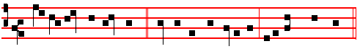 THIS is my commandment, * that ye love one another, as I have loved you.
Ps. 110 Dixit Dominus CIX, of Sunday, p.202

Antiphon. Tone ij.
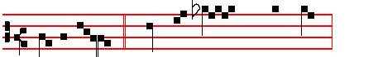 Great-er love * hath no man than this,

that a man lay down his life for his friends. Ps.111 Confiteor CX
of Sunday, p.20

Antiphon. Tone j, 4.
ij
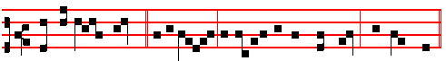 Ye are my friends, * if ye do whatsoever I command you, saith the Lord.
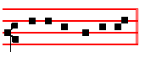
Ps. 112 Beatus vir CXI of Sunday, p. 203.

Antiphon. Tone j,1.
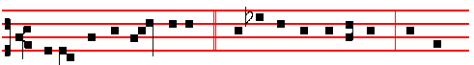
Blessed are the peacemakers, * blessed are the pure in heart, for they
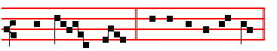
shall see God. Ps. 113 Laudate pueri CXII, p. 203.

Antiphon. Tone ij.
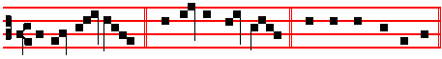
In your pa- tience * possess ye your souls.

Psalm 117 Laudate Dominum omnes Gentes CXVI
O PRAISE the Lord, all ye heathen: * praise him, all ye nations.

2 For his merciful kindness is ever more and more towards us: and the truth of the Lord endureth for ever. Praise the Lord.

Chapter Eph. 2.
BRETHREN: Now therefore ye are no longer strangers and foreigners, but fellow-citizens with the saints, and of the household of God; and are built upon the foundation of the Apostles and Prophets, Jesus Christ himself being the chief corner stone.
iij
HYMN: E.H. 176 Exultet caelum laudibus Mode viij. 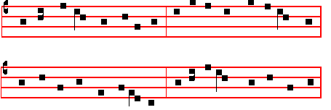
LET the round world with songs rejoice; 4. For at thy will they preached the word
Let heaven return the joyful voice; Which cured disease, which health conferred:
All mindful of the Apostles' fame, O may that healing power once more
Let heaven and earth their praise proclaim. Our souls to grace and health restore:

2. Ye servants who once bore the light 5. That when thy Son again shall come,
Of Gospel truth o'er heathen night, And speak the world's unerring doom.
Still may your work that light impart, He may with them pronounce us blest,
To glad our eyes and cheer our heart. And place us in thy endless rest.

3. O God, by whom to them was given 6. To thee, O Father; Son to thee;
The key that shuts and opens heaven, To thee, blest Spirit, glory be!
Our chains unbind, our loss repair, So was it ay for ages past,
And grant us grace to enter there; So shall through endless ages last.
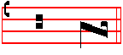
A - men.

 Their sound is gone out into all lands.
 And their words into the ends of the world.
On Magnificat, Antiphon. Tone i, 1.
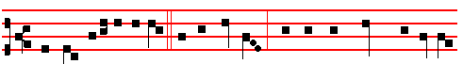 They will deliver you up * to the councils, and they will scourge you in their
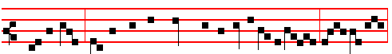synagogues; and ye shall be brought before governors and kings for my sake,

iv
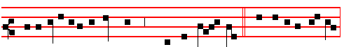
for a testimony against them and the Gen - tiles. Canticle Magnificat
Proper Collect.

AT COMPLINE
and through the Hours
Hymn Te lucis, &c Mode viij.
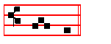
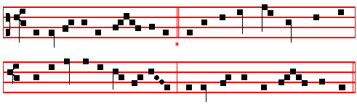

AT MATINS

Invitatory.- The Lord, the King of the Apostles, * O come let us worship.
Psalm 95 Venite exultemus XCIV, p.2.

HYMN EH. 175 Aeterna Christi munera Mode iij.
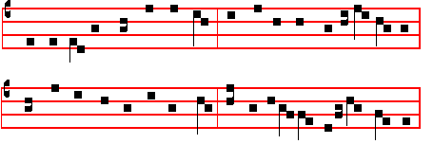
THE eternal gifts of Christ the King, 2 The Church in these her princes boasts,
The Apostles' glorious deeds, we sing; These victor chiefs of warrior hosts;
And while due hymns of praise we pay, The soldiers of the heavenly hall,
Our thankful hearts cast grief away. The lights that rose on earth for all.
v
3 'Twas thus the yearning faith of Saints 4 In these the Fathor's glory shone;
The unconquered hope that never faints, In these the will of God the Son;
The love of Christ that knows not shame, In these exults the Holy Ghost;
The prince of this world overcame Through these rejoice the heavenly host.

5 Redeemer, hear us of thy love,
That, with this glorious band above,
Hereafter, of thine endless grace,
Thy servants also may have place.
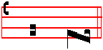
A - men.

IN THE FIRST NOCTURN
Antiphon.
Their sound is gone out * into all lands, and their words into the ends of the world.
Ps.19 Caeli enarrant. XVIII
Antiphon. The righteous cry, *and the Lord heareth them
Ps . 34 Benedicam Dominum. XXXIII
Antiphon. Thou shalt make them princes * in all lands.
Ps.45 Eructavit. XLIV
V/. Their sound is gone out into all lands.
R/. And their words into the ends of the world.
Our Father. Absolution Hear, O Lord Blessing May the blessing

From the First Epistle of Paul the Apostle to the Corinthians
Lesson j Ch. 4, 1-15
LET a man so account of us, as of the ministers or Christ, and stewards of the
mysteries of God, Moreover it is required in stewards, that a man be found faithful. But with me it is a very small thing that I should be judged of you, or of man's judgment: yea, I judge not mine own self. For I know nothing by myself: yet am I not hereby justified: but he that judgeth me is the Lord. Therefore judge nothing before the time, until the Lord come, who both will bring to light the hidden things of darkness, and will make manifest the counsels of the hearts: and thcn shall every man have praise of God.

R/. Behold, I send you forth as sheep in the midst of wolves, saith the Lord: * Be ye therefore wise as serpents and harmless as doves.
V/. While ye have light, believe in the light, that ye may be the children of light. *
Be ye therefore. vj
Blessing May the Only begotten. . .
Lesson ij
AND these things, brethren, I have in a figure transferred to myself and to Apollos for your sakes: that ye might learn in us not to think of men above that which is written, that no one of you be puffed up for one against another. For who maketh thee to differ from another? and what hast thou that thou didst not receive? now if thou didst receive it, why dost thou glory, as if thou hadst not received it?
Now ye are full, now ye are rich, ye have reigned as kings without us: and I would
to God ye did reign, that we also might reign with you. For I think. that God hath set forth us the Apostles last, as it were appointed to death: for we are made a spectacle unto the world, and to angels, and to men.
R/. ij. . Take my yoke upon you, you, saith the Lord, And learn of me. for I am meek. and lowly in heart. * For my y oke is easy and my burden is light.
V/. And ye shall find rest unto your souls. For my.
Blessing May the grace of
Lesson iij
WE are fools for Christ's We are fools for Christ's sake. but ye arc wise in Christ: we are weak. but ye are strong: ye are honourable, but we are.despised.Even unto this present hour we both hunger, and thirst,are naked. and are buffetted, and have no certain dwelling-place; and labour, working with our own hands: being reviled, we bless; being persecuted, we suffer it: being defamed, we intreat: we are made as the filth of the world, and are the offscouring of all things unto this day. I write not these things to shame you, but as my beloved sons I warn you. For though ye have ten thousand instructors in Christ, yet have ye not many fathers: for in Christ Jesus I have begotten you through the gospel.

R/.iij When ye stand before kings and governors, take no thought how or what ye shall speak: * For it shall be given you in that same hour what ye shall speak.
V/. For it is not ye that speak, but the Spirit of your Father. which speaketh in you. For it shall. Glory be. For it shall.

IN THE SECOND NOCTURN

Antiphon.The princes of the people * are joined unto the people of the God of Abraham.
Ps.47 Omnes gentes. XLVI
Antiphon. Thou hast given an heritage unto those that fear thy Name, O Lord.
vij
Ps.61 Exaudi,Deus. LX
Antiphon.They shall say,* this hath God done, for they shall perceive that it is his work.
Ps 64 Exaudi Deus, orationem. LXIII
V/.Thou shalt make them princes in all lands. ~.They shall remember thy name ,0 Lord.
Our Father. Absolution. May his mercy. Blessing. May God the Father.

Sermon by S. Gregory the Great Homily 3 on the Gospels
IT is written, By his spirit the Lord hath garnished the hcavens. Now these heavenly adornments are the powers of the preachers, for so Paul has described them: For to one is given by the Spirit the word of wisdom: to another the word of knowledge by the same Spirit; to another faith, by the same Spirit: to another the gifts of healing by the same Spirit; to another the working of miracles; to another prophecy: to another discerning of spirits: to another divers kinds of tongues: to another the interpretation of tongues; but all these worketh that one and the selfsame Spirit, dividing to every man severally as he will.

R/. I saw a great people who had received glorious garments of the Lord. and the Angel of the Lord spake in me, saying: * These men are holy, for they are the friends of God.
V/. I saw a strong Angel of God flying through .the midst of heaven, crying with a loud voice and saying: These men are.

Blessing May Christ grant.
EACH of these good gifts ofpreaching is an adornment of heaven. Again it is written, By the word of the Lord were the heavens made. The Word of the Lord is the Son of the Father. But to show that it was the Holy and Undivided Trinity who made these heavo:ns (and the word heavens here means the holy Apostles), the work of God the Holy Spirit is also described: And all the hosts of them by the breath of his mouth. Therefore the power of the heavens is derived from the Spirit: for they would never have set at nought the powers of this. world had the power of the Holy Spirit not strengthened them. Now we know what sort of men these teachers of Holy Church were, before the coming of the Spirit: and we see what they became after his coming.

 Blessed.are ye when men shall revile you and persecute you, and shall say all manner of evil against you falsely for my sake. * Rejoice and be exceeding glad, for great is your reward in heaven.
viij
 When men shall hate you, and when they shall separate you from their company, and shall reproach you, and cast out your name as evil, for the Son of Man's sake. Rejoice.

Blessing May God enkindle.
Lesson vj
AND now, as we sit close by the sacred body of the Shepherd of the Church, the maid servant who kept the door could tell us how weak and timid he was before the coming of the Spirit. He was so overcome by the voice of one woman that in his terror of death he denied Life. Consider moreover that Peter denied the Lord when he was a prisoner upon earth, while the thief confessed him as he hung upon the cross. But let us hear how strong this timid man became after the coming or the Spirit: the rulers and elders were assembled togcther, and threatened to scourge the Apostles if thcy dared to teach in the name of Jesus, but Peter answered with great boldness, We ought to obey God rather than men.

R/. These men are conquerors and friends of God, who despised the orders of governors, and earned the everlasting reward: * Now are they crowned and receive palms.
V/. These are they which came out of great tribulation, and have washed their robes in the blood of the Lamb. Now are they. Glory be. Now are they.
IN THE THIRD NOCTURN
Antiphon. The horns of the righteous *shall be exalted, al1eluia.
Ps. 75 Confitabimur LXXIV
Antiphon. There is sprung up * a light for the righteous, alleluia, and joyful gladness for such as are true-hearted, alleluia.
Ps.91 Dominus regnavit, exultet terra. XC
Antiphon. They kept his testimonies, * and the law that he gave them, alleluia.
Ps.99 Dominus regnavit,irascantur populi XCVIII
V/. Exceedingly honoured are thy friends, O Lord.
R/. Firm1y established is their princedom.
Our Father. Absolution. From the chains. Blessing May the Gospel.

Lesson vij Ch 19
Peter said unto Jesus, Behold, we have forsaken all, and followed thee; what shall we have therefore?
Homily by S.Jerome, Priest. Bk.3 on Mat.19
GREAT self-confidence! Peter was a fisherman, he had not been rich, he earned
ix
his bread by labour and skill; and yet he says boldly: 'We have left all things'. And, since to leave all things is not enougn, he adds that which completes it: 'And have followed thee.We have done what thou hast commanded: how then wilt thou reward us?' But Jesus said to them: 'Verily,I say unto you, that ye which have followed me, in the regeneration, when the Son of Man shall sit on the throne of his glory, ye also sha1 sit on twelve thrones, judging the twelve tribes of Israel.' He said not: 'Ye who have left all things'; for even Crates the philosopher did this, and many others have despised riohes; but: 'Ye who have followed me'; which applies to the apostles and to the faithful.

R/.These are they * who,while yet they lived in the flesh, planted the Church in
their own blood. They drank of the Lord's cup,and became the friends of God.
V/. Their sound is gone out into all lands, and their words into the ends of the world. They drank.
May he or they whose feast we are keeping.

Lesson viij
In the regeneration, when the Son of Man shall sit on the throne of his glory (and when the dead shall rise from corruption, incorrupt) ye also shall sit on the judgment-seats, and condemn the twelve tribes of Israel; because, though ye believed, they would not believe .'And every one that hath left home, or brethren, or sisters, or father, or mother, or wife, or children, or lands, for my name's sake shall receive an hundredfold, and shall possess life everlasting. 'This passage is in agreement with those other words in which the Saviour says: 'I came not to send peace, but a sword. For I am come to set a man at variance against his father, and the daughter against her mother, and the daughter-in-law against her mother-in-law. And a man's foes shall be they of his own household. 'Therefore, those who, for the sake of the faith of Christ and the preaching of the Gospel, have despised all natural feelings and riches and the pleasures of this world, those shall receive a hundredfold, and shall inherit life everlasting.

R/. These men are Saints, whom the Lord hath chosen in love unfeigned, and hath given them everlasting glory. * By whose teaching the Church is illumined, as the moon by the light of the sun. The Saints through faith subdued kingdoms, wrought righteousness. By whose. Glory be. By whose.

Lesson ix
SOME have assumed from the conclusion of this phrase that there will be a period of time of a thousand years after the resurrection and that then we shall receive a hundredfold of all that we have given up, and shall inherit eternal life;
x
they do not understand that, though in other things this promised reward would be seemly, in the case of wives it would be unseemly, that a man who had left one wife for the Lord's sake should receive a hundred in the world to come. But the meaning is this: That he who has left earthly things for the sake of the Saviour, shall receive spiritual things; which things will be, by comparison and by their own merit, as if a small number were compared to a hundred.

Te Deum Laudamus , p. 24.
AT LAUDS.
Antiphons as above at Vespers.

Psalm 93 Dominus regnavit XCII
and the rest, p. 28.
Chapter and Hymn as above at Vespers.
V/. They declared the work of God.
R/. And wisely considered of his doing.
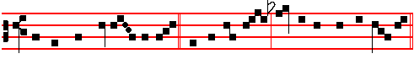
On Benedictus, Antiphon. Tone ij.
Ye which have forsa- ken all, * and followed me, shall receive an hundredfold,
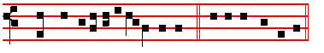
and shall inherit everlasting life. Canticle Benedictus, p. 37.

At the Hours, the Hymns are sung to the Tone Te lucis, p. iij.
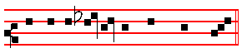
At Prime, Antiphon This is, p. ij.

At Terce, Antiphon. Greater love, p. ij.
Chapter as above at I. Vespers, p. iij.
Short R/.
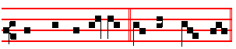
Their sound is gone out * in - to all lands.
Their sound.
xj
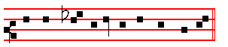
V/. And their words into the ends of the world.
R/. Into all.
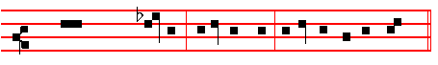
Glory be to the Father, and to the Son, and to the Ho-ly Ghost.
Their sound.
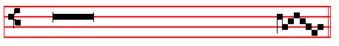
V/. Thou shalt make them princes in all lands.
R/. They shall remember thy name, O Lord.

At Sext, Antiphon. Ye are my friends.
Chapter Acts 5.
BY the hands of the Apostles were many signs and wonders wrought among the people.
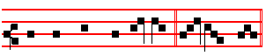
Short R/.
Thou shalt make them princes * in all lands.
Thou shalt.
V/. They shall remember thy Name, O Lord.
In all. Glory be. Thou shalt.
V/. Exceedingly honourable are thy friends, O God.
R/. Right well is their princedom established.
At None, Antiphon. In your patience.
Chapter Acts 5

xij
And they departed from the presence of the council, rejoicing that they were counted worthy to suffer shame for the Name of Jesus.
Short R/.
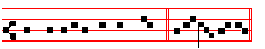
Right honourable are thy friends * Unto me, O God.
Right honourable.
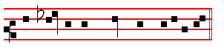
V/.Right well is their princedom establish-ed.
Unto me. Glory be.
Right honourable.
V/. They declared the work of God.
R/. And wisely considered of his doing.

AT II VESPERS
Antiphon. Tone viij, 1
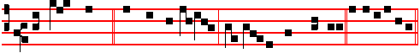
The Lord sware * and wilI not repent: Thou art a priest for ever.
Ps.110 Dixit Dominus as on Sunday
Antiphon. Tone viij, 2
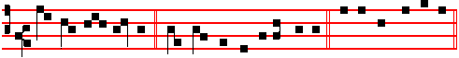
May the Lord set him * with the princes of his people.
Ps.113 Laudate, pueri as on Sunday
Antiphon. Tone vij, 3
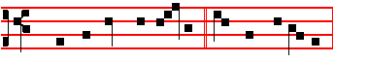
Thou, O Lord, hast broken * my bonds in sunder:
xiij
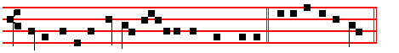
I will offer to thee the sacrifice of thanksgiving.
Ps. 116: 10. Credidi. CXIV
10 I BELIEVED, and therefore will I speak; but I was sore troubled : * I said in my haste, All men are liars.
11 What reward shall I give unto the Lord: * for all the benefits that he hath done unto me ?
12 I will receive the cup of salvation: * and call upon the Name of the Lord.

13 I will pay my vows now in the presence of all his people: * right dear in the sight of the Lord is the death of his saints.
14 Behold, O Lord, how that I am thy servant: * I am thy servant, and the son of thine handmaid; thou hast broken my bonds in sunder.
15 I will offer to thee the sacrifice of thanksgiving: * and will call upon the Name of the Lord.
16 I will pay my vows unto the Lord, in the sight of all his people: * in the courts of the Lord's house, even in the midst of thee, O Jerusalem. Praise the Lord.

Antiphon.Thou,O Lord, as above.
Antiphon.
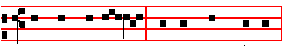
He that now go- eth * on his way weeping,
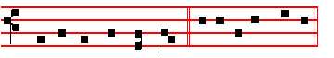
and beareth forth good seed.
Ps. 126 In convertendo CXXV
WHEN the Lord turned again the captivity of Sion: * then were we like unto them that dream.
xiv
2 Then was our mouth filled with laughter: * and our tongue with joy.

3 Then said they among the heathen: * The Lord hath done great things for them.

4 Yea, the Lord hath done great things for us already: * whereof we rejoice.

5 Turn our captivity, O Lord: * as the rivers in the south.

6 They that sow in tears: * shall reap in joy.

7 He that now goeth on his way weeping, and beareth forth good seed: * shall doubtless come again with joy, and bring his sheaves with him.

Antiphon. He that now goeth, as above.
Antiphon. Tone vij, 4.
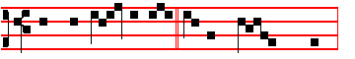
Firm- ly stab - lish- ed * is their prince - dom:
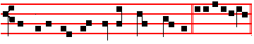
and highly honoured are thy friends, O God.
Ps. 139 Domine, probasti CXXXIX
O LORD, thou hast searched me out, and known me : * thou knowest my down-sitting, and mine uprising; thou understandest my thoughts long before.
2 Thou art about my path, and about my bed: * and spiest out all my ways.

3 For lo, there is not a word in my tongue: * but thou, O Lord, knowest it altogether.
4 Thou hast fashioned me behind and before: * and laid thine hand upon me.

5 Such knowledge is too wonderful and excellent for me: * I cannot attain unto it.

6 Whither shall I go then from thy Spirit: * or whither shall I go then from thy presence?
xv
7 If I climb up into heaven, thou art there: * if I go down to hell, thou art there also.
8 If I take the wings of the morning: * and remain in the uttermost parts of the sea;
9 Even there also shall thy hand lead me : * and thy right hand shall hold me.

10 If I say, Peradventure the darkness shall cover me: * then shall my night be turned into day.
11 Yea, the darkness is no darkness with thee, but the night is as clear as the day: * the darkness & light to thee are both alike.
12 For my reins are thine: * thou hast covered me in my mother's womb.
13 I will give thanks unto thee, for I am fearfully and wonderfully made: * marvellous are thy works, and that my soul knoweth right well.
14 My bones are not hid from the: * though I be made secretly, and fashioned beneath in the earth.
15 Thine eyes did see my substance, yet being unperfect: * and in thy book were all my members written;
16 Which day by day were fashioned: * when as yet there was none of them.

17 How dear are thy counsels unto me, O God: * O how great is the sum of them !

18 If I tell them, they are more in number than the sand: * when I wake up, I am present with thee.
19 Wilt thou not slay the wicked, O God: * depart from me, ye blood-thirsty men.

20 For they speak unrighteously against thee: * and thine enemies take thy Name in vain.
21 Do not I hate them, O Lord, that hate thee: * and am not I grieved with those that rise up against thee?
22 Yea, I hate them right sore: * even as though they were mine enemies.

23 Try me, O God, and seek the ground of my heart: * prove me, and examine my thoughts.
24 Look well if there be any way of wickedness in me: * and lead me in the way everlasting.

Antiphon. Firmly established, as above.

Chapter and Hymn as above at I Vespers.
V/.They declared the work of God.
R/.And wisely considered of his doing.
xvj
On Magnificat, Antiphon. Tone j, 4.
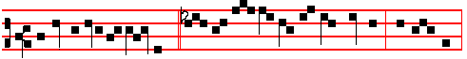
Be ye valiant in warfare, * and con-tend ye with the old serpent: and ye shall
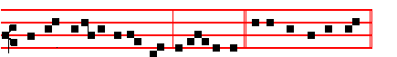
receive an eternal kingdom, al-le - lu- ia.. Canticle Magnificat, p.
Proper Collect.
__________________________________________________________________
2.
Alternative Lessons for Apostles
NOCTURN II

From the Exposition by S. Augustine of Psalm Eighty-seven
Lesson iv
HER foundations are upon the holy hills: the Lord loveth the gates of Sion. I have made the foregoing remarks, that ye may not imagine that the gates are one thing, the foundations another. Why are the Apostles and Prophets foundations? Because their authority is the support of our weakness. Why are they gates? Because through them we enter the kingdom of God: for they proclaim it to us: and while we enter by their means we enter also through Christ, himself being the Gate. And twelve gates of Jerusalem are spoken of, and the one gate is Christ, and the twelve gates are Christ: for Christ dwells in the twelve gates, hence was twelve the number of the Apostles. There is a deep mystery in this number of twelve: Ye shall sit, says our Saviour, on twelve thrones, judging the twelve tribes of Israel.
Lesson v
IF there are twelve thrones there will be no room for the judgment-seat of Paul, the thirteenth Apostle, though he says that he shall judge not men only, but even Angels: which, but the fallen Angels? Know ye not, that we shall judge Angels, he writes. The world will answer, Why dost thou. boast that thou shalt be a judge? Where will be thy throne? Our Lord snoke of twelve thrones for the twelve Apostles: one, Judas, fell, and Matthias being ordained in his place, the number of twelve thrones was made up: first, then, discover room for thy judgment-seat; then threaten that thou wilt judge. Let us therefore reflect upon the meaning of the twelve thrones. The expression is typical of a sort of universality, as the Church

xvij
was destined to prevail throughout the whole world: whence this edifice is styled a building together unto Christ.

Lesson vj
AND because judges come from all quarters, the twelve thrones are spoken of, just as the twelve gates, from the entering from all sides into that city. Not only therefore have those twelve, and the Apostle Paul, a claim to the twelve thrones, but, from the universal signification, all who are to sit in judgment: in the same manner as all who enter the city, enter by one or other of the twelve gates. There are four quarters of the globe: East, West. North, South: and they are constantly alluded to in the Scriptures. The Lord declares in the Gospel that he will call his sheep from the four winds; therefore from all those four winds is the Church called. And how called? On every side she is called in the Trinity: no otherwise is she called than by Baptism in the name of the Father, the Son, and the Holy Ghost: four, then, being thrice taken, twelve are found. Knock, therefore, with all your hearts at these gates: and let Christ cry within you, Open me the gates of righteousness. For he went before us the Head. He follows himself in his body.

IN THE THIRD NOCTURN

The Lesson from the holy Gospel according to Matthew.
Lesson vij. Chapter 19, 27.
At that time: Peter said unto Jesus: Behold, we have forsaken all, and followed thee: what shall we have therefore? and the rest.
Homily of the Venerable Bede, Priest.
THAT man is perfect, who going selleth all that he hath, and giveth to the poor and coming followeth Christ: for he shall have no lack of treasure in heaven. Therefore when Peter did well to ask, Jesus said to such: Verily I say unto you, that ye which have followed me, in the regeneration, when the Son of man shall sit in the throne of his glory, ye also shall sit upon twelve thrones, judging the twelve tribes of Israel.Those indeed who labour for his name in this life, he teaches to hope for a reward in the other: that is, in the regeneration, when, it is clear, we shall have been regenerated by rising again to immortal life, who had been born to a fleeting, mortal life.

Lesson viij.
And truly a just return, that they who here for Christ have neglected the glory of human high estate, there glorified by Christ as judges should sit singly with him, who could be dissuaded by no reason from following his footsteps. Let no one think that because Mathias was chosen instead of the traitor Judas there will be only twelve Apostles judging then: as there are also not twelve tribes of Israel
xviij
only to be judged: otherwise the tribe of Levi, which is the thirteenth, will go away unjudged.
Lesson ix.
And shall Paul, who is the thirteenth Apostle, perhaps be excluded from judging, when he himself says: Know ye not, that we are to judge angels, how much the more worldly things? For ye must know, that all, who after the example of the Apostles have forsaken all their possessions, and followed Christ, shall come as judges with him, as also every mortal race is to be judged. For since by the number twelve in the Scriptures totality is commonly meant, by the twelve seats of the Apostles is repsesented the great number of them that judge: and by the twelve tribes of Israel ,the totality of them that are to be judged.
Te Deum Laudamus .
_________________________________________________________________

Lessons for Evangelists

NOCTURN I

The Beginning of the Book of the Prophet Ezekiel.
Lesson j . Ch 1, 1- 13
NOW it came to pass in the thirtieth year, in the fourth month, in the fifth day of the month, as I was among the captives by the river of Chebar, that the heavens were opened, and I saw visions of God. In the fifth day of the month, which was the fifth year of king Jehoiachin's captivity, the word of the Lord came expressly unto Ezechiel the priest, the son of Buzi, in the land of the Chaldeans by the river Chebar; and the hand of the Lord was there upon him. And I looked and, behold, a whirlwind came out of the north, a great cloud, and a fire infolding itself, and a brightness was about it, and out of the midst thereof as the colour of amber out of the midst of the fire.
Lesson ij
ALSO out of the midst thereof came the likeness of four living creatures. And this was their appearance; they had the likeness of a man. And every one had four faces. and every one had four wings. And their feet were straight feet; and the sole of their feet was like the sole of a calf's foot: and they sparkled like the colour of burnished brass. And they had the hands of a man under their wings on their four sides; and they four had their faces and their wings. Their wings were joined one to another; they turned not when they went; they went everyone straight forward.
Lesson iij
AS for the likencss of their faces, they four had the face of a man, and the face of a lion, on the right side: and they four had the face of an ox on the left side; they four also had the face of an eagle. Thus were their faces: and their wings were
xix
stretched upward; .two wings of every one were joined one to another, and two covered their bodies. And they went everyone straight forward: whither the spirit was to go, they went; and they turned not when they went.

NOCTURN II

From the Commentary of St. Gregory, Pope, on the Prophet Ezechiel

Lesson iv
The prophet gives a minute description of the four holy living creatures which in the spirit he foresaw, as being to come, when he says: "Each had four faces and four wings." What is signified by face if it be not celebrity: or by wings, unless it be the power of flight? For it is by the face that a man is recognized: but by their wings the bodies of birds are raised in the air. Thus the face pertains to faith, the wings to contemplation. For in our faith we are known by almighty God, as he says of his sheep: "I am the good shepherd; and I know mine, and mine know me." And again he says: "I know whom I have chosen". For by contemplation we are raised above ourselves, as it were, to heaven.

Lesson v.
Every one, then, had four faces: for if you enquire what Matthew held concerning the Incarnation of the Lord: he assuredly held the same doctrine as Mark, Luke, and John. If you ask what John held; it was undoubtedly that which was held by Luke, Mark. and Matthew. If you ask what Mark held; it was the same as that of Matthew, John, and Luke. If you ask what Luke held; it was the same as that of John Matthew, and Mark. Every one, then, had four faces; for the knowledge of the faith, in which they are known by God, it is the same in each one, as in all four. For whatsoever you find in one, you will recognize equally in all four.

Lesson vj.
And every one had four wings: for they all, with one accord, preach our Lord Jesus Christ, the Son of Almighty God: and raising the eyes of their mind to his Godhead, they fly upon the wings of contemplation. Therefore the faces of the
Evangelists pertain to the human nature of the Lord, their wings to his Godhcad: for, as if with their faces, they gaze upon him, in whom they see the body: but when they say that in his Godhead he is incomprehensible and incorporeal,
they fly heavenwards in contemplation, as if on wings. Since, then, faith in his incarnation is one and the same in all, and the contemplation of his divinity is equal in each one, it is rightly said: "Each had four faces and four wings." .

NOCTURN III

The Lesson from the Holy Gospel according to S. Luke.
xx
Lesson vij Ch. 10
THE Lord appointed other seventy also, and sent them two and two before his face into every city and place whither he himself would come. and the rest

Homily by S. Gregory the Great Hom. 17 on the Gospels
OUR Lord and Saviour counsels us, beloved when brethren, sometimes by word, and sometimes by deed. For his very deeds are commandments; while he works in silence he demonstrates what we ought to do. And now, behold, he sends his disciples two and two to preach, because there are two commandments of love, that is, the love of God, and the love of our neighbour, and love cannot exist between less than two. No one can properly be said to have chanty towards himself, for love tends outwards towards another, and only so does it become charity.

Lesson viij
BEHOLD, the Lord sends his disciples two and two to preach, and thus he silently demonstrates that no one lacking in charity towards another should on any account take upon himself the Office of a Preacher.It is fittingly said, He sent them two and two before his face into every city and place whither he himself would come.For the Lord does follow his preachers; preaching prepares the way, and then the Lord comes to the dwelling-place of our minds, when the words of exhortation have been the fore-runners, and thus truth is received into the mind.

Lesson ix
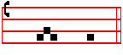
ISAIAH speaks thus to these preachers, Prepare ye the way of the Lord, make straight in the desert a highway for our God. And thus the Psalmist addresses the children of Israel, Magnify him that rideth upon the heavens. Now the Lord has indeed ascended above the heavens, for he fell asleep in his Passion and thus showed his greater glory by his Resurrection. Truly he ascended above the heavens; by undergoing death he trod it underfoot by his Resurrection. Now we prepare a way for him who rideth upon the heavens when we set forth before your minds his glory, that he himself may come afterwards to these minds of yours, and enlighten them with the presence of his love.
Te Deum Laudamus.
_________________________________________________________________

COMMON OF APOSTLES AND EVANGELISTS IN EASTERTIDE

At Vespers, the Antiphon Thy Saints, with the rest from Lauds below.
Pss. 110, 111, 112, 113 from Sunday and 117 from the Common of Apostles out

xxi
of Eastertide above.
Chapter Wisdom 5
THEN shall the righteous man stand in great boldness before he face of such as have afflicted him,and made no account of his labours.
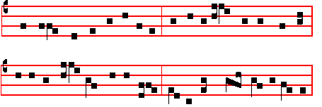
Hymn Tristes erant Apostoli Mode iv.
Melody to E.H.123 / 124, pt.2. at Vespers, Matins, Lauds.
THE Apostles hearts were full of pain 5 O Lord of all with us abide
For their dear Lord so lately slain, In this our joyful Eastcrtlde;
By rebel servants doomed to die From every weapon death can wield
A death of cruel agony. Thine own redeemed for ever shield.

2 With gentle voice the angel gave 6 All praise be thine, O risen Lord,
The women tidings from the grave; From death to endl.:ss lifc rcstored:
Fear not, your Master ye shall see; All praise to God thc Father be
He goes before to Galilee. And Holy Ghost eternally.

3 Then, hastening on their eager way From Ascension to Pentecost:
The joyful tidings to convey,
Their Lord they met, their living Lord, All glory, Lord, to thee we pay,
And falling at his feet ador'd. Ascending o'er thc stars today;
All glory, as is ever meet,
4 The Eleven, when they hear, with speed To Father and to Paraclete.
To Galilee forthwith proceed,
That there once more they may behold
The Lord's dear face, as he foretold.
A - men.

V/. O ye holy and righteous, rejoice in the Lord, alleluia.
R/. God hath chosen you to him to be his inheritance, alleluia.

xxij
On Magnificat, Antiphon. Tone ij.
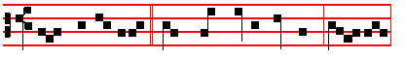
Light per-pet- u-al * shall shine upon thy Saints, O Lord,
and an ageless e-ter-ni-ty, al-le -lu-ia. Canticle Magnificat, p.
Proper Collect.
AT MATINS

The Lord, the King of the Apostles, * O come, let us worship, alleluia.

Hymn Tristes erant Apostoli , as above, p. xxij.

IN THE FIRST NOCTURN

Antiphon.Then shall the righteous man * stand in great boldness before the face of such as have afflicted him, alleluia.
Psalms 19, 34, 45 as above in the Common of Apostles out of E.T.

V/. O ye holy and righteous, rejoice in the Lord, alleluia.
R/.God hath chosen you for his own inheritance, alleluia.

Lessons in each Nocturn as noted in the Proper.
R/. l.Blessed is the man that feareth the Lord, alleluia. * He hath great delight in his commandments,alleluia,alleluia, alleluia.
V/.Riches and plenteousness shall be in his house,and his righteousness endureth for ever.He hath.
R/.2.Your sorrow, alleluia, * Shall be turned into joy, alleluia, alleluia.
V/. The world shall rejoice but ye shall be sorrowful, but your sorrow. Shall be.
R/.3. Right dear in the sight of the Lord,alleluia.* Is the death of his Saints, alleluia.
V/.The Lord keepeth all their bones, so that not one of them is broken.
Is the. Glory be. Is the.
IN THE SECOND NOCTURN
Antiphon. Behold how they are counted * among the sons of God, and their inheritance is among the saints, alleluia.
Psalms 47, 61, 64 as above in the Common of Apostles out of ET.
xxiij
V/. Light perpetual shall shine upon thy Saints, O Lord, alleluia.
R/. And an ageless eternity, alleluia.

R/.4. Light perpetual shall shine upon thy Saints, O Lord, * And an ageless eternity, alleluia, alleluia.
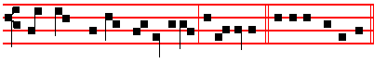
V/. Everlasting joy shall be upon their heads, they shall obtain joy and gladness. And an ageless.
R/.5. With great power gave the Apostles * Witness of the Resurrection of the Lord Jesus, alleluia, alleluia.
V/. They were all filled with the Holy Ghost, and they spake the Word of God with boldness. Witness.
R/.6. These are the new born lambs who have proclaimed, alleluia: they came but just now to the well; * They are all filled with light, alleluia, alleluia.
V/. They stand before the Lamb, clothed in white robes, with palms in their hands. They are all. Glory be. They are all.

IN THE THIRD NOCTURN

Antiphon.Light perpetual * shall shine upon thy Saints, O Lord, and an ageless eternity, alleluia.
Psalms 75, 97, 99 as above in the Common of Apostles out of E.T.

V/. Everlasting joy shall be upon their heads, O Lord, alleluia.
R/. They shall obtain joy and gladness, alleluia.

R/.7. I am the true vine,ye are the branches, * He that abideth in me, the same bringeth forth much fruit, alleluia, alleluia.
V/. As the Father hath loved me, so have I loved you. He that.
R/.8. Her Nazirites are purer than snow, alleluia, they shine with the glory of God, alleluia.* They are whiter than milk, alleluia, alleluia.
V/. Purer than snow, whiter than milk, they are more ruddy in body than rubies, their polishing is of sapphire. They are. Glory be.They are.

AT LAUDS

Antiphon. Tone viij, 1.
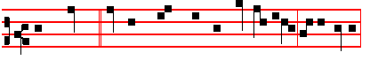
Thy Saints, * O Lord, shall blossom as the li-ly, al-le- lu-ia:

xxiv
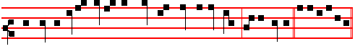
and as the odour of balsam shall they be before thee, al-le- lu-ia. E u o u a e.

Ps. 93 Dominus Regnavit and the rest, p. 28.
Antiphon. Tone vij, 3.
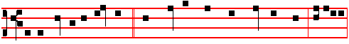
In the heavenly kingdom * the Blessed have their dwelling-place, alleluia:
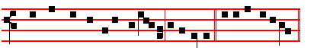
and their rest for ever and ever, al-le-lu-ia. E u o u a e.

Antiphon. Tone ij.
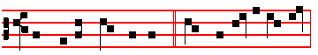
Thy blessed Saints, O Lord, * cried out within the veil,
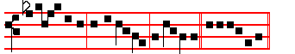
al- le- lu-ia, al-le-lu- ia, al-le-lu-ia. E u o u a e.

Antiphon. Tone viij, 1.
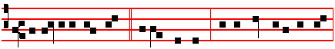
O ye spirits and souls * of the righteous, sing a hymn unto the Lord
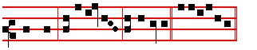
our God, al-le-lu-ia, al-le-lu-ia. E u o u a e.

xxv
Antiphon. Tone ij. 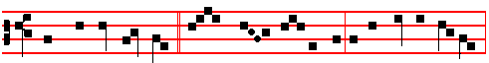 Then shall the righteous * shine forth as the sun in the presence of God,
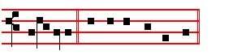
al-le- lu-ia. E u o u a e.
Chapter Wisdom 5.
THEN shall the righteous man stand in great boldness before he face of such as have afflicted him,and made no account of his labours.

Hymn: E.H 124, part 2, Claro paschale gaudio as above, p. xxij, or:
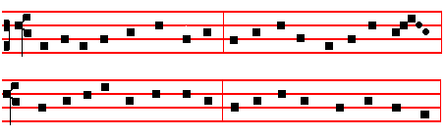
4 On that fair day of Paschal joy 6 O Christ, the King of gentleness,
The sunshine waa without alloy. Our several hearts do thou possess,
When to their very eyes restored That we may render all our days
They looked upon the risen Lord. Thy meed of thankfulness and praise.

5 The wounds before their eyes displayed 7 Maker of all, to thee we pray
They see in living light arrayed, Fulfi1 in us thy joy to-day;
And that they see they testify When death assails, grant, Lord, that we
In open witness fearlessly. May share thy Paschal victory.

8 To thee who, dead, again dost live,
All glory, Lord, thy people give;
All glory, as is ever meet,
To Father and to Paraclete.
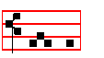
A - men.
xxvj
Right dear in the sight of the Lord, alleluia.  Is the death of his Saints, alleluia. On Benedictus, Antiphon. Tone j, 3.
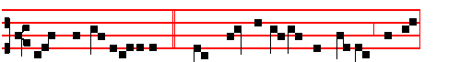
Daughters of Jerusalem, * come forth and behold the Martyrs with the
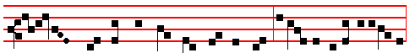
di-adems wherewith the Lord hath crowned them in the day of solemnity and
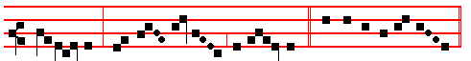
re-joic-ing, al- le- lu - ia, al- le - lu-ia. Canticle Benedictus, p. 28.

At Prime in the short , from Monday after Low Sunday until the Ascension exclusively, is said
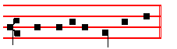
 Who art risen from the dead. But from the Ascension until Pentecost
exclusively, is said:
Who art ascended above the heavens.

At Terce, Short 
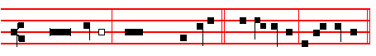
O ye holy and righteous, rejoice in the Lord, * Al-le- lu-ia, al-le- lu-ia.
O ye.
God hath chosen
you to him to be his inheritance. Al-le- lu-ia, al-le- lu-ia.
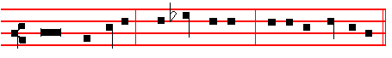 Glory be to the Father, and to the Son, and to the Holy Ghost;
O ye. xxvij
 Light perpetual shall shine upon thy Saints, O Lord Allelu-ia.
 And an ageless eternity, allelu- -ia.

At Sext, Chapter Wisdom 5
HOW is he numbered among the children of God,and his lot is among the Saints!
Short . Light perpetual shall shine upon thy Saints, O Lord. * Alleluia, alleluia. Light perpetual. And an ageless eternity. Alleluia, alleluia.
Glory be. Light perpetual.
 Everlasting joy shall be upon their heads, alleluia.
 They shall obtain joy and gladness, alleluia.

At None, Chapter Romans 8
WE know that all things work together for good to them that love God, to them who are the called according to his purpose.
Short . Everlasting joy shall be upon their heads.* Alleluia, alleluia.
Everlasting.  They shall obtain joy and gladness. Alleluia, alleluia.
Glory be. Everlasting.
 Right dear in the !ight of the Lord, alleluia
 Is the death of his Saints, alleluia

At Vespers, Antiphons of Lauds above, pp. xxiv-xxvj. Psalms of II Vespers of Apostles out of Eastertide, p. xiij-xvj.
Chapter and Hymn as above at I Vespers, p. xxij.
 Right dear in the sight of the Lord, alleluia.
 Is the death of his Saints, alleluia.

On Magnificat, Antiphon. Tone viij, 1. 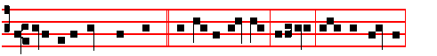
O ye holy and righteous, * rejoice in theLord,alleluia: God hath chosen
 you to him to be his inheritance, alle-luia. Canticle Magnificat, p.
xxviij

