THE OFFICE OF THE DEAD

is said out of Eastertide on the first day of each month, not impeded by a Feast of nine Lessons, or else on another day following not similarly impeded. But in Advent and Lent on Monday of every week if not similarly impeded, except in Holy Week. In choir it is said after the Office of the day, that is Vespers after Vespers and Matins after Lauds of the day, unless the customs of Churches be otherwise: but out of Choir according to opportunity.
AT VESPERS
it begins immediately with the
Antiphon. Tone ij.
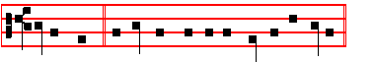
I will walk * before the Lord in the land of the living.

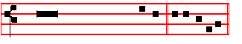
Psalm 116 Dilexi, quoniam CXV U e a e i.

I AM well pleased * that the Lord hath heard the voice of my prayer;

2 That he hath inclined his ear unto me; * therefore will I call upon him as long as I live.
3 The snares of death compasssed me round about, * and the pains of hell gat hold upon me.
4 I shall find trouble and heaviness, and I will call upon the Name of the Lord; * O Lord I beseech thee, deliver my soul.
5 Gracious is the Lord, and righteous; * yea, our God is merciful.

6 The Lord preserveth the simple: * I was in misery, and he helped me.

7 Turn again then unto thy rest, O my soul; * for the Lord hath rewarded thee.

8 And why? thou hast delivered my soul from death, * mine eyes from tears, and my feet from falling.
9 I will walk before the Lord * in the land of the living.

At the end of all Psalms is said: Rest eternal * grant unto them, O Lord.
And let light perpetual * shine upon them.
ccxxxiij
Antiphon 1.
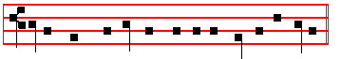
I will walk before the Lord in the land of the living.
Antiphon Tone ij.
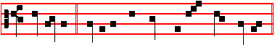
Woe is me * that I am constrained to dwell with Me-sech.
Psalm 120 Ad Dominum CXIX U e a e i.

WHEN I was in trouble I called upon the Lord * and he heard me.

2 Deliver my soul, O Lord, from lying lips, * and from a deceitful tongue.

3 What reward shall be given or done unto thee, thou false tongue? * even mighty and sharp arrows, with hot burning coals.
4 Woe is me, that I am constrained to dwell with Mesech, * and to have my habitation among the tents of Kedar.
5 My soul hath long dwelt among them * that are enemies unto peace.

6 I labour for peace; but when I speak unto them thereof, * they make them ready to battle.
Rest eternal.
Antiphon 2.
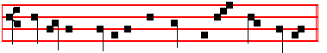
Woe is me that I am constrained to dwell with Mesech.
Antiphon Tone ij.
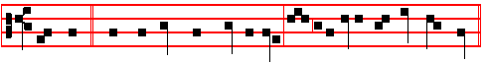
The Lord * shall preserve thee from all evil: yea, it is even he that shall keep

ccxxxiv
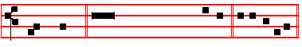
thy soul. Psalm 121 Levavi oculos CXX U e a e i.

I WILL lift up mine eyes unto the hills, * from whence cometh my help.

2 My help cometh even from the Lord, * who hath made heaven and earth.

3 He will not suffer thy foot to be moved; * and he that keepeth thee will not sleep.

4 Behold, he that keepeth Israel * shall neither slumber nor sleep.

5 The Lord himself is thy keeper; * the Lord is thy defence upon thy right hand.

6 So that the sun shall not burn thee by day, * neither the moon by night.

7 The Lord shall preserve thee from all evil * yea, it is even he that shall keep thy soul.
8 The Lord shall preserve thy going out, and thy coming in, * from this time forth for evermore.
Rest eternal. Antiphon 3.
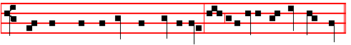
The Lord shall preserve thee from all evil: yea, it is even he that shall keep
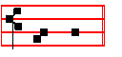
thy soul. Antiphon. Tone vij, 1 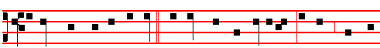
If thou, Lord, wilt be extreme * to mark what is done amiss, O Lord, who may
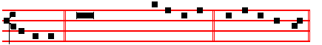
a- bide it? Psalm 130 De profundis CXXIX U e a e i

ccxxxv
OUT of the deep have I called unto thee, O Lord; * Lord, hear my voice.

2 O let thine ears consider well * the voice of. my complaint.

3 If thou, Lord, wilt be extreme to mark what is done amiss * O Lord, who may abide it?
4 For there is mercy with thee; * therefore shalt thou be feared.

5 I look for the Lord, my soul doth wait for him; * in his word is my trust.

6 My soul fleeth unto the Lord * before the morning watch, I say, before the morning watch..
7 O Israel, trust in the Lord, for with the Lord there is mercy, and with him is plenteous redemption.
8 And he shall redeem Israel * from all his sins.
Rest eternal..
Antiphon 4.
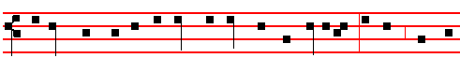
If thou, Lord, wilt be extreme to mark what is done amiss, O Lord, who may
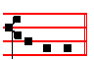
a- bide it? Antiphon. Tone ij.
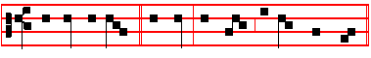
Despise not then, * O Lord, the works of thine own hands.
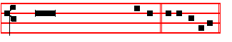
Psalm 138 Confitebor tibi CXXXVII U e a e i.

I WILL give thanks unto thee, O Lord, with my whole heart; * even before the gods will I sing praise unto thee.
2 I will worship toward thy holy temple, and praise thy Name, because of thy loving-kindness and truth; * for thou hast magnified thy Name, and thy Word, above all

ccxxxvj
3 When I called upon thee, thou heardest me; * enduedst my soul with much strength.
4 All the kings of the earth shall praIse thee, O Lord; * for they have heard the words of thy mouth.
5 Yea, they shall sing in the ways of the Lord, * that great is the glory of the Lord.

6 For though the Lord be high, yet hath he respect unto the lowly; * as for the proud, he beholdeth them afar off.
7 Though I walk in the midst of trouble, yet shalt thou refresh me; * thou shalt stretch forth thy hand upon the furiousness of mine enemies, and thy right hand shall save me.
8 The Lord shall make good his loving-kindness toward me; * yea, thy mercy, O Lord, endureth for ever; despise not then the works of thine own hands.
Rest eternal.
Antiphon 5.
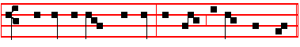
Despise not then, O Lord, the works of thine own hands.

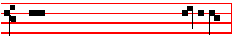
 I heard a voice from . heaven, saying un- to me.
 Blessed are the dead which die in the Lord.

Antiphon. on Magnificat. Tone vij, 1.
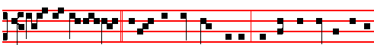
All that the Father * giveth me shall come to me; and him that cometh to me,
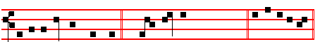
I will in no wise cast out. Canticle Magnificat, as below. U e a e i.

The Song of the Blessed Virgin Mary Magnificat Luke 1:46-55
MY soul doth magnify the Lord, * and my spirit hath rejoiced in God my Saviour.

ccxxxvij
2. For he hath regarded * the lowliness of his handmaiden.

3 For behold, from henceforth * all generations shall call me blessed.

4 For he that is mighty hath magnified me: * and holy is his Name.

5 And his mercy is on them that fear him * throughout all generations.

6 He hath shewed strength with his arm : * he hath scattered the proud in the imagination of their hearts.
7 He hath put down the mighty from their seat, * and hath exalted the humble and meek.
8 He hath filled the hungry with good things; * and the rich he hath sent empty away.

9 He remembering his mercy hath holpen his servant Israel; * as he promised to our forefathers, Abraham and his seed, for ever.
Rest eternal.
Antiphon.
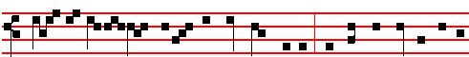
All that the Father giveth me shall come to me; and he that cometh to me,
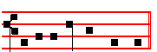
I will in no wise cast out.
The Prayers following are said kneeling, and so likewise at Lauds:
Our Father secretly.  And lead us not into temptation.  But deliver us from evil.
The following Psalm 146 Lauda, anima mea in Vespers, likewise also Psalm 130 De Profundis at the end of Lauds are not said on the day of the Commemoration of all the faithful departed, nor on the day of death or burial only. Otherwise they are always said.
Psalm 146 Lauda, anima mea CXLV

PRAISE the Lord, O my soul; while I live will I praIse the Lord; * yea, as long as I have any being, I will smg praises unto my God.
2 O put not your trust in princes, nor in any child of man; * for there is no help in them.
3. For when the breath of man goeth forth, he shall turn agam to his earth, * and then

ccxxxviij
all his thoughts perish.
4 Blessed is he that hath the God of Jacob for his help, * and whose hope is in the Lord his God;
5 Who made heaven and earth, the sea, and all that therein is; * who keepeth his promise for ever;
6 Who helpeth them to right that suffer wrong; * who feedeth the hungry.

7 The Lord looseth men out of prison; * the Lord until giveth sight to the blind.

8 The Lord helpeth them that are fallen; * the Lord careth for the righteous.

9 The Lord careth for the strangers; he defendeth the fatherless and widow: * as for the way of the ungodly, he turneth it upside down.
10.The Lord thy God, O Sion, shall be King for evermore, * and throughout all generations.
Rest eternal * grant unto them, O Lord.
And let light perpetual * shine upon them.
    From the gate of hell.    Deliver his soul (her soul, their souls), O Lord.
May he (she, they) rest in peace.  Amen.
    O Lord, hear my prayer.  And let my cry come unto thee
    The Lord be with you.  And with thy spirit.
Let us pray
COLLECT

O GOD, who didst cause thy servants to enjoy the dignity of Priest or Bishop in the apostolic Priesthood: grant, we beseech thee, that they may evermore be joined unto the fellowship of the same.
O GOD, the giver of pardon and lover of man's salvation: we beseech thee of thy mercy to grant; that the brethren, kinsfolk, and benefactors of our congregation who have passed out of this world, may at the intercession of blessed Mary, ever Virgin, and of all thy Saints attain unto the fellowship of eternal blessedness.
O GOD, the Creator and Redeemer of all the faithful: grant unto the souls of thy servants the remission of all their sins; that through devout supplications they may obtain the pardon which they have alway desired:Who livest and reignest for ever and ever.  Amen.
But on the day of commemoration of all the faithful departed when this last Collect alone is said, there is said Who livest and reignest with God the Father in the unity of the Holy Spirit, God: throughout all ages, world without end.

On the day of burial of the departed.
COLLECT

ccxxxix
ABSOLVE, we beseech thee, O Lord, the soul of thy servant N., that being dead unto the world he may live unto thee: and those sins which through frailty of the flesh he hath committed in his earthly life, do thou of thy merciful goodness wash away. Through.
If it shall be a woman, it is to be said thine handmaid, and she may, she hath, and in her earthly life.
On the Anniversary Day
COLLECT
O GOD,the Lord of mercies: grant unto the souls of thy servants and handmaids, the anniversary of whose buriel we now commemorate, a place of refreshment, the blessedness of rest, and the brightness of thy light. Through.
If the Anniversary be for one only, it is said in the singular.

For a departed Bishop.
COLLECT
O GOD,who didst cause thy servant N. to enjoy the dignity of a Bishop in the apostolic Priesthood: grant, we beseech thee; that he may evermore be joined unto the fellowship of the same. Through.
If it shall be a Priest, it is to be said dignity of a Priest. And for brethren, kinsfolk, and benefactors is said the Collect O God the giver of pardon, as above.

For a Father and Mother
COLLECT
O GOD, who hast bidden us to honour our father and our mother: of thy loving-kindness have mercy on the souls of my father and mother, and forgive them their sins; and grant that I may behold them in the joy of the eternal brightness. Through.
If it is said for many, there shall be said of our parents; and where I is said shall be said we.
If for a father only, there shall be said the soul of my, or our father.
If for a mother only, there shall be said the soul of my, or our mother.

For one man departed
COLLECT
INCLINE thine ear, O Lord ,unto the prayers wherewith we humbly entreat thy mercy: that thou wouldest set the soul of thy servant N., which thou hast bidden depart this life, in a place of peace and light; and make him to be joined unto the fellowship of thy Saints. Through.

For one woman departed
COLLECT

ccxl
WE beseech thee, O Lord, of thy loving-kindness to have mercy on the soul of thy handmaid N.: that being purged fron the defilements of our mortal nature, she may be restored to the portion of everlasting salvation. Through.
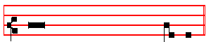
         Rest eternal grant unto them, O Lord.
        And let light perpetual shine up- on them.
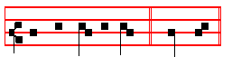
        May they rest in peace.        A - men.
AT MATINS
Invitatory Tone vj.
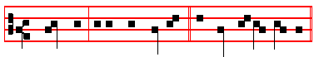
The King unto whom all live, * O come, let us worship. Repeat.: The King.
Psalm 95 Venite, exsultemus XCIV
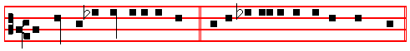
O COME let us sing unto the Lord: * let us heartily rejoice in the strength of
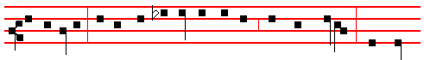
our salvation. Let us come before his presence with thanksgiving, and shew
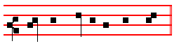
our-selves glad in him with psalms. The King.
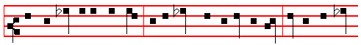
For the Lord is a great God, and a great King above all gods. In his hand are

ccxlj
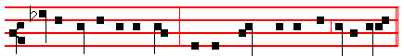
all the corners of the earth : and the strength of the hills is his also.
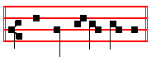
O come, let us worship.
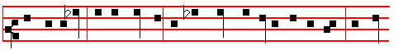
The sea is his, and he made it: and his hands prepared the dry land. O come,
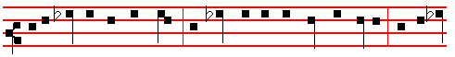
let us worship and fall down: and kneel before the Lord our Maker. For he is
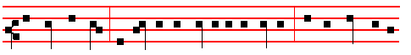
the Lord our God. and we are the people of his pasture, and the sheep of his
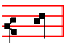
hand.

The King.
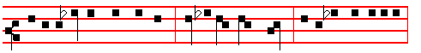
Today if ye will hear his voice, harden not your hearts, as in the provocation,
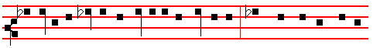
and as in the day of temptation in the wilderness; when your fathers tempted

ccxlij
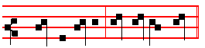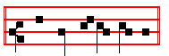
me, prov-ed me, and saw my works. O come, let us worship.
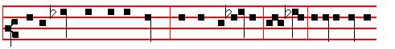
Forty years long was I grieved with this generation, and said: It is a people
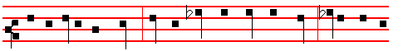
that do err in their hearts; for they have not known my ways; unto whom I
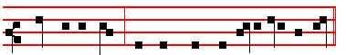
sware in my wrath that they should not enter into my rest.
The King unto whom all live, * O come, let us worship
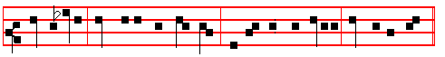
Rest eternal grant unto them, O Lord:*and let light perpetual shine upon them.
O come, let us worship.
The King unto whom all live, * O come, let us worship.

This Invitatory is said only on the day of Commemoration of all the faithful departed, and on the day of burial of the Departed, on which days are said the three

ccxliij
Nocturns below, and the Antphons are doubled. At other times is said only one Nocturn with Lauds, in this order: On Monday and Thursday the first Nocturn, on Tuesday and Friday the second Nocturn, on Wednesday and Saturday the third Nocturn.
IN THE FIRST NOCTURN
For Monday and Thursday
Antiphon Tone vij, 1.
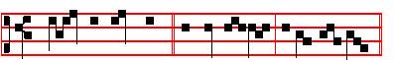
Make thy way plain, * O Lord my God, before my face.
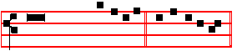
Psalm 5 Verba mea auribus V. U e a e i.

PONDER my words, O Lord, * consider my meditation.

2 O hearken thou the voice of my calling, my King and my God: * for unto thee will I make my prayer.
3 My voice shalt thou hear betimes, 0 Lord; * early in the morning will I direct my prayer unto thee, and will look up.
4 For thou art the God that hast no pleasure in wickedness; * shall any evil dwell with thee.
5 Such as be foolish shall not stand in thy sight; * for thou hatest all them that work vanity.
6 Thou shalt destroy them that speak leasing: * the Lord will abhor both the blood-thirsty and deceitful man.
7 But as for me, I will come into thine house, even upon the multitude of thy mercy; * and in thy fear will I worship toward thy holy temple.
8 Lead me, O Lord, in thy righteousness, because of mine enemies: * make thy way plain before my face.
9 For there is no faithfulness in his mouth; * their inward parts are very wickedness.

10 Their throat is an open sepulchre; * they flatter with their tongue.

11 Destroy thou them, O God; let them perish through their own imaginations; * cast them out in the multItude of their ungodliness; for they have rebelled against thee.
12 And let all them that put their trust in thee rejoice : * they shall ever be giving of thanks, because thou defendest them; they that love thy Name shall be joyful in thee;
ccxliv
13 For thou, Lord, wilt give thy blessing unto the righteous, * and with thy favourable kindness wilt thou defend him as with a shield.
Rest eternal * grant unto them, O Lord. And let light perpetual * shine upon them.
Antiphon 1.
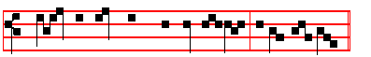
Make thy way plain, O Lord my God, before my face.

Antiphon Tone viij, 1.
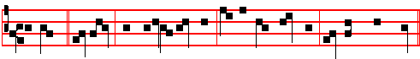
Turn thee, * O Lord, and deliver my soul: for in death no man remembereth thee.
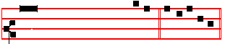
Psalm 6 Domine, ne in furore VI. U e a e i.

O LORD, rebuke me not in thine indignation, * neither chasten me in thy displeasure.
2 Have mercy upon me, O Lord, for 1 am weak; * O Lord, heal me, for my bones are vexed.
3 My soul also is sore troubled: * but, Lord, how long wilt thou punish me?

4 Turn thee, O Lord, and deliver my soul; * O save me for thy mercy's sake.

5 For in death no man remembereth thee; * and who will give thee thanks in the pit?

6 1 am weary of my groaning; every night wash I my bed, * and water my couch with my tears.
7 My beauty is gone for very trouble, * and worn away because of all mine enemies.

8 Away from me, all ye that work vanity; * for the Lord hath heard the voice of my weeping.
9 The Lord hath heard my petition; * the Lord will receive my prayer.

10 All mine enemies shall be confounded, and sore vexed; * they shall be turned back, and put to shame suddenly.
ccxlv
Rest eternal.
Antiphon 2.
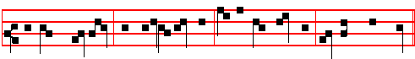
Turn thee, O Lord, and deliver my soul : for in death no man remembereth thee.
Antiphon Tone viij, 1.
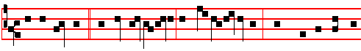
Lest he devour * my soul like a lion, and tear it in pieces, while there is none to
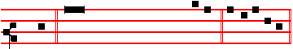
help. Psalm 7 Domine, Deus meus VII. U e a e i.

O LORD my God, in thee have I put my trust: * save me from all them that persecute me, and deliver me;
2 Lest he devour my soul like a lion, and tear it in pieces, * while there is none to help.
3 O Lord my God, if 1 have done any such thing; * or if there be any wickedness in my hands;
4. If I have rewarded evil unto him that dealt friendly with me; * yea, I have delivered him that without any cause is mine enemy;
5 Then let mine enemy persecute my soul, and take me; * yea, let him tread my life down upon the earth, and lay mine honour in the dust.
6 Stand up, O Lord, in thy wrath, and lift up thyself, because of the indignation of mine enemies; * arise up for me in the judgment that thou hast commanded.
7 And so shall the congregation of the people come about thee : * for their sakes therefore lift up thyself again:
8 The Lord shall judge the people; give sentence with me, O Lord, * according to my righteousness, and according to the innocency that is in me.
9 O let the wickedness of the ungodly come to an end; * but guide thou the just.

10 For the righteous God * trieth the very hearts and reins.

11 My help cometh of God, * who preserveth them that are true of heart.

12 God is a righteous Judge, strong and patient; * and God is provoked every day.

ccxlvj
13 If a man will not turn, he will whet his sword; * he hath bent his bow, and made it ready.
14 He hath prepared for him the instruments of death; * he ordaineth his arrows against the persecutors.
15 Behold, he travaileth with mischief; * he hath conceived, sorrow, and forth ungodliness.
16 He hath graven and digged up a pit, * and is fallen himself into the destruction that he made for other.
17 For his travail shall come upon his own head, * and his wickedness shall fall on his own pate.
18 I will give thanks unto the Lord, according to his righteousness; * and I will praise the Name of the Lord Most High.
Rest eternal.

Antiphon 3.
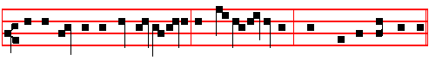
Lest he devour my soul like a lion, and tear it in pieces, while there is none to help.
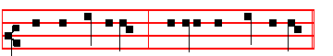
 From the gate of hell.  Deliver their souls, O Lord. Our Father secretly throughout.

The Lessons are read without Absolution, Blessing, or Title.

Lesson j Job 7: 16-21
LET me alone, O Lord, for my days are vanity. What is man, that thou shouldest magnify him? and that thou shouldest set thy heart upon him? and that thou shouldest visit him every morning, and try him every moment? How long wilt thou not depart from me, nor let me alone till I swallow down my spittle? I have sinned; what shall I do unto thee, O thou preserver of men? why hast thou set me as a mark against thee, so that I am a burden to myself? And why dost thou not pardon my transgression, and take away mine iniquity? for now shall I sleep in the dust; and thou shalt seek me in the morning, but I shall not be.

The Lessons are ended without But thou or any other conclusion.

ccxlvij
           j. Tone viij.
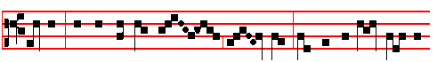
                            I know that my Redeem-er liv- eth, and that he shall stand at
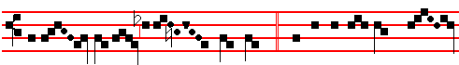
the lat- ter day upon the earth: * And in my flesh shall I ...........
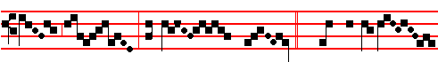
see God my Sav- iour.  Whom I shall see ...........
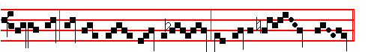
for myself, and mine eyes shall behold, and not an-oth- er.
And in my flesh.

Lesson ij Job 10: 1-7
MY soul is weary of my life; I will leave my complaint upon myself; I will speak in the bitterness of my soul. I will say unto God, Do not condemn me; shew wherefore thou contendest with me. Is it good unto thee that thou shouldest oppress, that thou shouldest despise the work of thine hands, and shine upon the counsel of the wicked? Hast thou eyes of flesh? or seest thou as man seeth? Are thy days as the days of man? are thy years as man's days, that thou enquirest after mine iniquity, and searchest after my sin? Thou knowest that I am not wicked; and there is none that can deliver out of thine hand.

 ij. Tone iv.
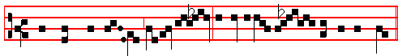
Thou who didst raise Lazar- us already cor- rupt- ing from the grave;

ccxlviij
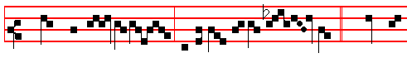
* Grant them rest, O Lord, and a place of forgive- ness.     Thou who
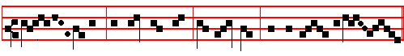
shalt come to judge the quick and the dead, and the world by fire.

Grant them.

Lesson iij Job 10: 8-12.
THINE hands have made me and fashioned me together round about; yet thou dost destroy me. Remember, I beseech thee, that thou hast made me as the clay; and wilt thou bring me into dust again? Hast thou not poured me out as milk, and curdled me like cheese? Thou hast clothed me with skin and flesh, and hast fenced me with bones and sinews.Thou hast granted me 1ife and favour, and thy visitation hath preserved my spirit.
  iij. Tone viij. 
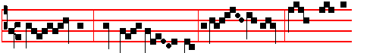
                       O Lord, when thou com- est to judge the earth, where shall I
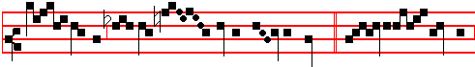
hide myself from the wrath of thy coun-tenance? * For I have sin-ned
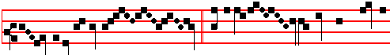
griev- ously in my life.     I am afraid of my transgressions,
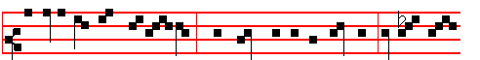
and I am ashamed be-fore thee: when thou comest to judgment, O con- demn

ccxlix
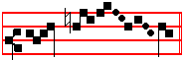
me not. For I have.
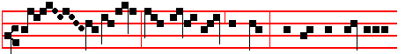
    Rest e- ter-nal grant unto them, O Lord: and let light perpetua1
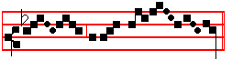
shine upon them. For I have.

Then at Lauds as below, cclxiv, when one Nocturn only is said.
____________________________________________________________________

IN THE SECOND NOCTURN
For Tuesday and Friday,
Antiphon Tone viij, 1.
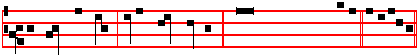
He shall feed me * in a green pasture. Ps. 23 Dmnus regit me.XXII U e a e i.

THE Lord is my shepherd; * therefore can I lack nothing.

2 He shall feed me in a green pasture, * and lead me forth beside the waters of comfort.
3 He shall convert my soul, * and bring me forth in the paths of righteousness, for his Name's sake.
4 Yea, though I walk through the valley of the shadow of death, I will fear no evil; * for thou art with me; thy rod and thy staff comfort me.
5 Thou shalt prepare a table before me against them that trouble me; * thou hast anointed my head with oil, and my cup shall be full.
6 But thy loving-kindness and, mercy shall follow me all the .days of my life; * and I will dwell in the house of the Lord for ever.

Rest eternal.

ccl
Antiphon 1.
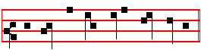
He shall feed me in a green pasture.
Antiphon Tone viij, 1.
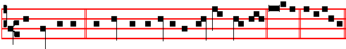
Remember not * the sins and offences of my youth, O Lord. Ps. 24. U e a e i.

Psalm 25 Ad te, Domine, levavi XXIV

UNTO thee, O Lord, will I lift up my soul; my God, I have put my trust in thee: * O let me not be confounded, neither let mine enemies triumph over me.
2 For all they that hope in thee shall not be ashamed; * but such as transgress without a cause shall be put to confusion.
3 Show me thy ways, O Lord, * and teach me thy paths.

4 Lead me forth in thy truth, and learn me : * for thou art the God of my salvation; in thee hath been my hope all the day long.
5 Call to remembrance, O Lord, thy tender mercies, * and thy loving-kindnesses, which have been ever of old.
6 O remember not the sins and offences of my youth; * but according to thy mercy think thou upon me, O Lord, for thy goodness.
7 Gracious and righteous is the Lord; * therefore will he teach sinners in the way.

8 Them that are meek shall he guide in judgment; * and such as are gentle, them shall he learn his way.
9 All the paths of the Lord are mercy and truth, * unto such as keep his covenant, and his testimonies.
10 For thy Name's sake, O Lord, * be merciful unto my sin, for it is great.

11 What man is he that feareth the Lord? * him I shall he teach in the way that he shall choose.
12 His soul shall dwell at ease, * and his seed shall inherit the land.

13 The secret of the Lord is among them that fear him; * and he will show them his covenant.

cclj
14 Mine eyes are ever looking unto the Lord; * for he shall pluck my feet out of the net.
15 Turn thee unto me, and have mercy upon me; * for I am desolate, and in misery.

16 The. sorrows of my heart are enlarged: * O bring thou me out of my troubles.

17 Look upon my adversity and misery, * and forgive me all my sin.

18 Consider mine enemies, how many they are; * and they bear a tyrannous hate against. me.
19 O keep my soul, and deliver me: * let me not be confounded, for I have put my trust in thee.
20 Let perfectness and righteous dealing wait upon me; * for my hope hath been in thee.
21 Deliver Israe1, O God, * out of all his troubles.
Rest eternal.
Antiphon 2.
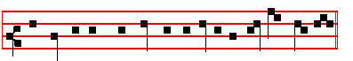
Remember not the sins and offences of my youth, O Lord.
Antiphon Tone iv, 1.
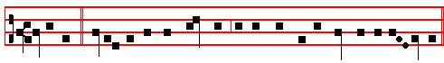
I believe * verily to see the goodness of the Lord in the land of the liv- ing.
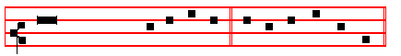
Psalm 27 Dominus Illuminatio XXVI U e a e i.

THE Lord is my light, and my salvation; whom then shall I fear? * the Lord is the strength of my life; of whom then shall I be afraid?
2 When the wicked, even mine enemies and my foes, came upon me to eat up my flesh, * they stumbled and fell.
3 Though an host of men were laid against me, yet shall not my heart be afraid; * and though there rose up war against me, yet will I put my trust in him.
4 One thing have I desired of the Lord, which I will require; * even that I may dwell

cclij
in the house of the Lord all the days of my life, to behold the fair beauty of the Lord,
and to visit his temple.
5 For in the time of trouble he shall hide me in his tabernacle; * yea, in the secret place of his dwelling shall he hide me, and set me up upon a rock of stone.
6 And now shall he lift up mine head * above mine enemies round about me.

7 Therefore will I offer in his dwelling an oblation with great gladness: * I will sing and speak praises unto the Lord.
8 Hearken unto my voice, O Lord, when I cry unto thee; * have mercy upon me, and hear me.
9 My heart hath talked of thee, Seek ye my face: * Thy face, Lord, will I seek.

10 O hide not thou thy face from me, nor cast thy servant away in displeasure.

11 Thou hast been my succour; * leave me not, neither forsake me, O God of my salvation.
12 When my father and my mother forsake me, * the Lord taketh me up.

13 Teach me thy way, O Lord, * and lead me in the right way, because of mine enemies.
14 Deliver me not over into the will of mine adversaries: * for false witnesses are risen up against me, and such as speak wrong.
15 I should utterly have fainted, * but that I believe verily to see goodness of the Lord in the land of the living.
16 O tarry thou the Lord's leisure; * be strong, and he shall comfort thine heart; and put thou thy trust in the Lord.
Rest eternal.
Antiphon 3.
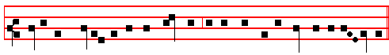
I believe verily to see the goodness of the Lord in the land of the liv- ing.
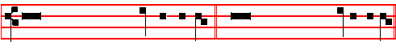
   The Lord shall set them with the princes.     Even with the princes of his people.

Our Father secretly throughout.

Lesson iv Job 13: 22-28
ccliij
ANSWER thou me. How many are mine iniquities and sins? make me to know my transgression and my sin. Wherefore hidest thou thy face, and holdest me for thine enemy? Wilt thou break a leaf driven to and fro? and wilt thou pursue the dry stubble? For thou writest bitter things against me, and makest me to possess the iniquities of my youth. Thou puttest my feet also in the stocks, and lookest narrowly unto all my paths; thou settest a print upon the heels of my feet. And I am as a rotten thing that consumeth, as a garment that is moth eaten.
 iv. Tone ij.
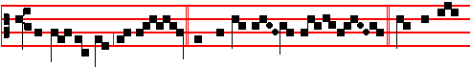
Remember me, O God, that my life is wind: * The eye of
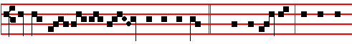
him that hath seen me shall see me no more.  Out of the deep have I called
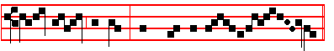
un-to thee, O Lord: Lord, hear my voice. The eye.
Lesson v Job 14: 1-6
MAN that is born of a woman is of few days, and full of trouble. He cometh forth like a flower, and is cut down: he fleeth also as a shadow, and continueth not. And dost thou open thine eyes upon such an one, and bringest me into judgment with thee? Who can bring a clean thing out of an unclean? not one. Seeing his days are determined, the number of his months are with thee, thou hast appointed his bounds that he cannot pass; turn from him, that he may rest, till he shall accomplish, as an hireling, his day.
  v. Tone ij.
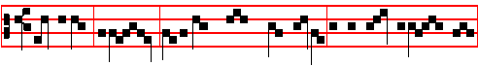
Woe is me, O Lord, for I have sinned griev-ously all the days of my life!
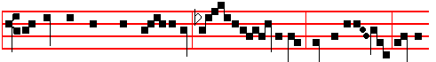
O wretched man, what shall I do? Whither shall I flee, but unto thee, O my
ccliv
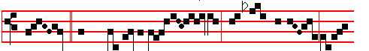
God? * Have mercy up-on me, when thou com-est at the
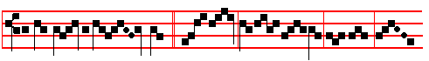
day of judg- ment.  My soul is sore troub-led; but, Lord, be
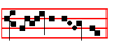
thou my help- er. Have mercy.

Lesson vj Job 14: 13-16
OTHAT thou wouldest hide me in the grave, that thou wouldest keep me secret, until thy wrath be past, that thou wouldest appoint me a set time, and remember me! If a man die, shall he live again? all the days of my appointed time will I wait, till my change come. Thou shalt call, and I will answer thee: thou wilt have a desire to the work of thine hands. For now thou numberest my steps: dost thou not watch over my sin?
  vj. Tone vj
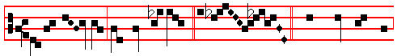
Remember not my trespas- ses, O Lord, * When thou shalt come
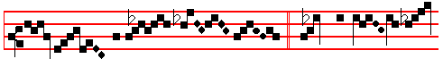
to judge the world by fire.  Make thy way plain
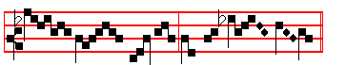
be- fore my face, O Lord my God. When thou.

cclv
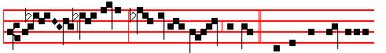
    Rest e- ternal grant un-to them, O Lord. And let light per-petual
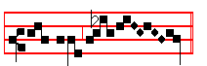
shine upon them. When thou.

Then at Lauds, as below, cclxiv, when one Nocturn only is said.
____________________________________________________________________

IN THE THIRD NOCTURN
For Wednesday and Saturday,
Antiphon Tone ij.
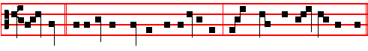
O Lord, * let it be thy pleasure to deliver me; make haste, O Lord, to help me.
Psalm 40 Expectans expectavi XXXIX U e a e i.

I WAITED patiently for the Lord, * and he inclined unto me, and heard my calling.

2 He brought me also out of the horrible pit, out of the mire and clay, * and set my feet upon the rock, and ordered my goings.
3 And he hath put a new song in my mouth, * even a thanksgiving unto our God.

4 Many shall see it, and fear, * and shall put their trust in the Lord.

5 Blessed is the man that hath set his hope in the Lord, * and turned not unto the proud, and to such as go about with lies.
6 O Lord my God, great are the wondrous works which thou hast done, like as be also thy thoughts which are to us-ward; * and yet there is no man that ordereth them unto thee.

cclvj
7 If I should declare them, and speak of them, * they should be more than I am able to express.
8 Sacrifice, and meat offering, thou wouldest not, * but mine ears hast thou opened.

9 Burnt-offerings, and sacrifice for sin, hast thou not required: * then said I, Lo, I come;
10 In the volume of the book it is written of me, that I should fulfil thy will, O my God: * I am content to do it; yea, thy law is within my heart.
11 I have declared thy righteousness in the great congregation: * lo, I will not refrain my lips, O Lord and that thou knowest.
12 I have not hid thy righteousness within my heart; * my talk hath been of thy truth, and of thy salvation.
13 I have not kept back thy loving mercy and truth * from the great congregation.

14 Withdraw not thou thy mercy from me, O Lord; * let thy loving- kindness and thy truth alway preserve me.
15 For innumerable troubles are come about me; my sins have taken such hold upon me that I am not able to look up; * yea, they are more in number than the hairs of my head, and my heart hath failed me;
16 O Lord, let it be thy pleasure to deliver me; * make haste, O Lord, to help me.

17 Let them be ashamed and confounded together, that seek after my soul to destroy it; * let them be driven backward and put to rebuke, that wish me evil.
18 Let them be desolate, and rewarded with shame, * that say unto me, Fie upon thee, fie upon thee.
19 Let all those that seek thee be joyful and glad in thee; * and let such as love thy salvation say alway, The Lord be praised.
20 As for me, I am poor and needy; * but the Lord careth for me.

21 Thou art my helper and redeemer; * make no long tarrying, O my God.

Rest eternal.

Antiphon 1.
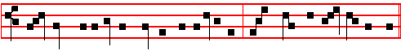
O Lord, let it be thy pleasure to deliver me; make haste, O Lord, to help me.

cclvij
Antiphon Tone ij
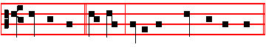
Heal my soul, * O Lord, for I have sinned against thee.
Psalm 41 Beatus qui intelligit XL U e a e i.

BLESSED is he that considereth the poor and needy; * the Lord shall deliver him in the time of trouble.
2 The Lord preserve him, and keep him alive, that he may be blessed upon earth; * and deliver not thou him into tht will of his enemies.
3 The Lord comfort him when he lieth sick upon his bed; * make thou all his bed in his sickness.
4 I said, Lord, be merciful unto me; * heal my soul, for I have sinned against thee.

5 Mine enemies speak evil of me, * When shall he die, and his name perish?

6 And if he come to see me, he speaketh vanity, * and his heart conceiveth falsehood within himself, and when he cometh forth he telleth it.
7 All mine enemies whisper together against me; *even against me do they imagine this evil.
8. Let the sentence of guiltiness proceed against him; * and now that he lieth, let him rise up no more..
9 Yea, even mine own familiar fnend, whom I trusted, * who did also eat of my bread, hath laid great wait for me.
10 But be thou merciful unto me, O Lord; * raise thou me up again, and I shall reward them.
11 By this I know thou favourest me, * that mine enemy doth not triumph against me.

12 And when I am in my health, thou upholdest me, * and shalt set me before thy face for ever.
13 Blessed be the Lord God of Israel, * world without end. Amen.

Rest eternal.

Antiphon 2.

cclviij
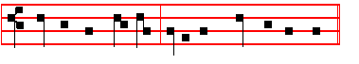
Heal my soul, O Lord, for I have sinned against thee.
Antiphon Tone ij.
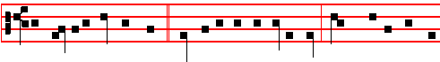
My soul is athirst for God, * yea, even for the living God : when shall I come to
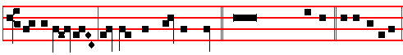
appear be- fore the presence of the Lord? Psalm 42 XLI U e a e i.
Quemadmodum

LIKE as the hart desireth the water-brooks, * so longeth my soul after thee, O God.
2 My soul is athirst for God, yea, even for the living God : * when shall I come to appear before the presence of God?
3 My tears have been my meat day and night, * while they daily say unto me, Where is now thy God?
4 Now :when I think thereupon, I pour out my heart by myself; * for I went with the multitude; and brought them forth into the house of God;
5 In the voice of praise and thanksgiving, * among such as keep holy-day.

6 Why art thou so full. of heaviness, O my soul? * and why art thou so disquieted within me?
7 Put thy trust in God; * for I will yet give him thanks for the help of his countenance.
8 My God, my soul is vexed within me; * therefore will I remember thee concerning the land of Jordan, and the little hill of Hermon.
9 One deep calleth another, because of the noise of the water-pipes; * all thy waves and storms are gone over me.
10 The Lord hath granted his loving-kindness in the day-time; * and in the night-season did I sing of him, and made my prayer unto the God of my life.
11 I will say unto the God of my strength, Why hast thou forgotten me? * why go I thus heavily, while the enemy oppresseth me?
12 My bones are smitten asunder as with a sword, * while mine enemies that trouble

cclix
me cast me in the teeth;
13 Namely, while they say daily unto me, * Where is now thy God?

14 Why art thou so vexed, O my soul? * and why art thou so disquieted within me?

15 O put thy trust in God; * for I will.yet thank him, which is the help of my countenance, and my God.
Rest eternal.
Antiphon 3.
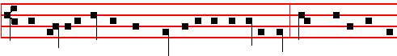
My soul is athirst for God, yea, even for the living God: when shall I come to
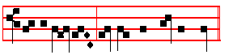
appear be- fore the presence of the Lord?
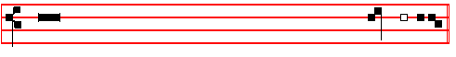
 O deliver not the soul of thy turtle-dove unto the multitude of the en- em-ies.
 Forget not the congregation of the poor for ev- er.
Our Father secretly throughout.
Lesson vij Job 17.1-3, 11-15
MY breath is corrupt, my days are extinct, the graves are ready for me. Are there not mockers with me? and doth not mine eye continue in their provocation? Lay down now, put me in a surety with thee; who is he that will strike hands with me? My days are past, my purposes are broken off, even the thoughts of my heart. They change the night into day: the light is short because of darkness. If I wait, the grave is mine house: I have made my bed in the darkness. I have said to corruption, Thou art my father: to the worm, thou art my mother, and my sister. And where is now my hope? as for my hope, who shall see it?
    vij. Tone j
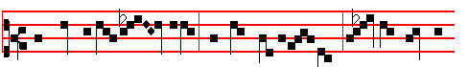
The while I tres-pass daily and have no repent-ance, the fear of death

cclx
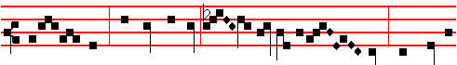
ap-pal-leth me: * Because in hell there is no redemp- tion, have mercy
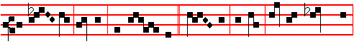
upon me, O God, and save me. Save me, O God, for thy Name's sake,
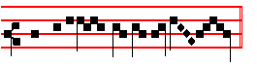
and deliver me in thy strength. Because in hell.
Lesson viij Job 19: 20-27
MY bone cleaveth to my skin and to my flesh, and I am escaped with the skin of my teeth. Have pity upon me, have pity upon me, O ye my friends; for the hand of God hath touched me. Why do ye persecute me as God, and are not satisfied with my flesh? Oh that my words were now written! oh that they were printed in a book! that they were graven with an iron pen and lead in the rock for ever! For I know that my Redeemer liveth, and that he shall stand at the latter day upon the earth: and though after my skin worms destroy this body, yet in my flesh shall I see God: whom I shall see for myself and mine eyes shall behold, and not another; though my reins be consumed within me.
   viij. Tone viij
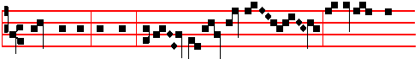
Judge me not, O Lord, accord- ing to my deeds; for I have done
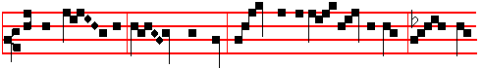
nothing worth- y in thy sight : wherefore I humbly beseech thy Maj-
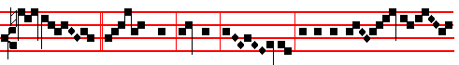
est- y, * That thou, O God, may- est do away mine of-fen-

cclxj
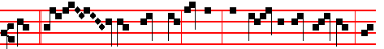
ces.  Wash me throughly, O Lord, from mine unrighteousness, and
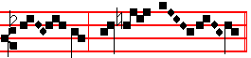
cleanse me from my sin. That thou.

Lesson ix Job 10: 18-22.
WHEREFORE then hast thou brought me forth out of the womb? Oh, that I had given up the ghost, and no eye had seen me! I should have been as though I had not been; I should have been carried from the womb to the grave. Are not my days few? cease then, and let me alone, that I may take comfort a little, before I go whence I shall not return, even to the land of darkness and the shadow of death; a land of darkness, as darkness itself; and of the shadow of death, without any order, and where the light is as darkness.

 ix. Tone j.
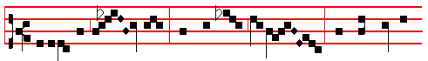
Deliver me, O Lord, from the paths of hell, thou that brakest
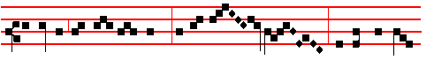
in pieces the gates of brass; and vis-it- edst hell, and gavest them
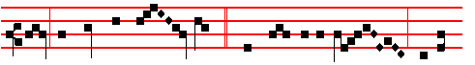
light, that they might see thee, * Who dwelt in the pains of dark-
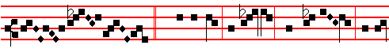
ness.  Crying out and saying, Thou art come, O our

cclxij
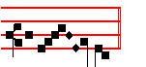
Re-deem- er. Who dwelt.
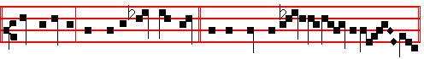
Rest eternal grant unto them, O Lord. And let light perpetual shine upon them.
Who dwelt.
The following Responsory is said only on the day of the Commemoration of all the Departed, and whenever nine Lessons are said for the Departed.
       ix * Tone j.
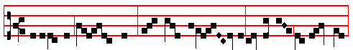
Deliver me , O Lord, from death eter- nal in that day of trembling:
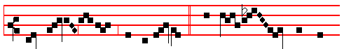
* When heaven and earth shall be shaken: * When thou shalt come
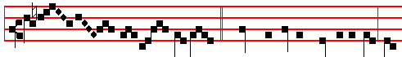
to judge the world by fire.   Trembling taketh hold upon me, and
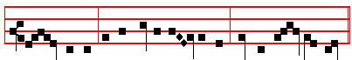
fear- fulness, as the sifting draweth on, and the wrath to come. It is repeated:
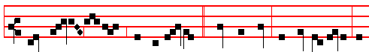
When heaven and earth shall be shaken. . Ah, that day, that day of anger, of

* Simple tone: see p. cclxxiij.
cclxiij
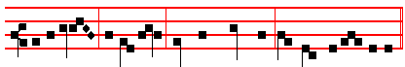
calamit-y and misery; Ah, that great day, and exceed-ing bitter! It is repeated:
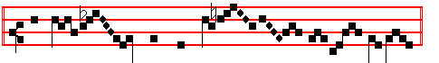
When thou shalt come to judge the world by fire.
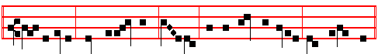
 Rest eternal grant unto them, O Lord, and let light perpetual shine upon them.
Deliver me as above, p. cclxiij.
__________________________________________________________________________

AT LAUDS
They begin at once.
Antiphon Tone j, 1.
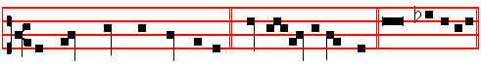
The bones which thou hast broken * shall rejoice in the Lord. Psalm 51
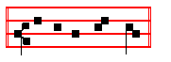
U e a e i.
Psalm 51 Miserere mei, Deus L

HAVE mercy upon me, O God, after thy great goodness; * according to the multitude of thy mercies do away mine offences.
2 Wash me throughly from my wickedness, * and cleanse me from my sin.

3 For I acknowledge my faults, * and my sin is ever before me.

4 Against thee only have I sinned, * and done this evil in thy sight; * that thou mightest be justified in thy saying, and clear when thou art judged.

cclxiv
5 Behold, I was shapen in wickedness, * and in sin hath my mother conceived me.

6 But lo, thou requirest truth in the inward parts, * and shalt make me to understand wisdom secretly.
7 Thou shalt purge me with hyssop, and I shall be clean; * thou shalt wash me, and I shall be whiter than snow.
8 Thou shalt make me hear of joy and gladness, * that the bones which which thou hast broken may rejoice.
9 Turn thy face from my sins, * and put out all my misdeeds.

10 Make me a clean heart, O God, * and renew a right spirit within me.

11 Cast me not away from thy presence, * and take not thy holy Spirit from me.

12 O give me the comfort of thy help again, * and stablish me with thy free Spirit.

13 Then shall I teach thy ways unto the wicked, * and sinners shall be converted unto thee.
14 Deliver me from blood-guiltiness, O God, thou that art the God of my health; * and my tongue shall sing of thy righteousness.
15 Thou shalt open my lips, O Lord, * and my mouth shall shew thy praise.

16 For thou desirest no sacrifice, else would I give it thee; * but thou delightest not in burnt-offerings.
17 The sacrifice of God is a troubled spirit: * a broken and contrite heart, O God, shalt thou not despise.
18 O be favourable and gracious unto Sion; * build thou the walls of Jerusalem.

19 Then shalt thou be pleased with the sacrifice of righteousness, with the burnt-offerings and oblations; * then shall they offer young bullocks upon thine altar.
Rest eternal.
Antiphon 1.
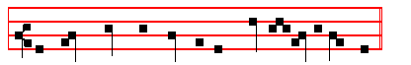
The bones which thou hast broken shall rejoice in the Lord.
Antiphon Tone viij, 1.
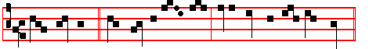
Thou, O Lord, * that hearest the prayer, unto thee shall all flesh come.

cclxv

Psalm 65 Te decet hymnus LXIV U e a e i.

THOU, O God, art praised in Sion; * and unto thee shall the vow be performed in Jerusalem.
2 Thou that hearest the prayer, * unto thee shall all flesh come.

3 My misdeeds prevail against me : * O be thou merciful unto our sins.

4 Blessed is the man whom thou choosest, and receivest unto thee: * he shall dwell in thy court, and shall be satisfied with the pleasures of thy house, even of thy holy temple.
5 Thou shalt shew us wonderful things in thy righteousness, O God of our salvation; * thou that art the hope of all the ends of the earth, and of them that remain in the broad sea.
6 Who in his strength setteth fast the mountains, * and is girded about with power.

7 Who stilleth the raging of the sea, * and the noise of his waves, and the madness of the people.
8 They also that dwell in the uttermost parts of the earth shall be afraid at thy tokens, * thou that makest the outgoings of the morning and evening to praise thee.
9 Thou visitest the earth, and blessest it; * thou makest it very plenteous.

10 The river of God is full of water : * thou preparest their corn, for so thou providest for the earth.
11 Thou waterest her furrows, thou sendest rain into the little valleys thereof * thou makest it soft with the drops of rain, and blessest the increase of it.
12 Thou crownest the year with thy goodness; * and thy c1ouds drop fatness.

13 They shall drop upon the dwellings of the wilderness; * and the little hills shall rejoice on every side.
14 The folds shall be full of sheep; * the valleys a1so shall stand so thick with corn, that they shall laugh and sing.
Rest eternal.
Antiphon 2.

Thou, O Lord, that hearest the prayer, unto thee shall all flesh come.
cclxvj
Antiphon Tone vij, 1.
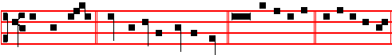
Thy right hand * hath upholden me, O Lord. Psalms 63, 67. U e a e i.

Psalm 63 Deus, Deus meus LXII

O GOD, thou art my God; * early will I seek thee.

2 My soul thirsteth for thee, my flesh also longeth after thee * in a barren and dry land where no water is.
3 Thus have I looked for thee in the sanctuary * that I might behold thy power and glory.
4 For thy loving-kindness is better than the life itself: * my lips shall praise thee.

5 As long as I live will I magnify thee in this manner * and lift up my hands in thy Name.
6 My soul shall be satisfied, even as it were with marrow and fatness * when my mouth praiseth thee with joyful lips.
7 Have I not remembered thee in my bed * and thought upon thee when I was waking?
8 Because thou hast been my helper; * therefore under the shadow of thy wings will I rejoice.
9 My soul hangeth upon thee; * thy right hand hath upholden me.

10 These also that seek the hurt of my soul, * they shall go under the earth.

11 Let them fall upon the edge of the sword * that they may be a portion for foxes.

12 But the King shall rejoice in God; all they also that swear by him shall be commended; * for the mouth of them that speak lies shall be stopped.

Here is not said, Glory be to the Father.
Psalm 67 Deus misereatur nostri LXVI

GOD be merciful unto us, and bless us * and show us the light of,,his countenance, and be merciful unto us;
2 That thy ways may be known upon earth, * thy saving health among all nations.

3 Let the people praise thee, O God; * yea, let all the people praise thee.

cclxvij
4 O let the nations rejoice and be glad; * for thou shalt judge the folk righteously, and govern the nations upon earth.
5 Let the people praise thee, O God; * yea, let all the people praise thee.

6 Then shall the earth bring forth her increase; * and God, even our own God, shall give us his blessing.
7 God shall bless us; * and all the ends of the world shall fear him.
Rest eternal.
Antiphon 3.
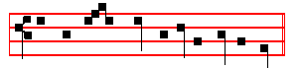
Thy right hand hath upholden me, O Lord.
Antiphon Tone ij.
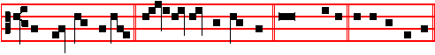
From the gate of hell * deliver my soul, O Lord. Cant. Ego dixi. U e a e i.

The Song of Hezekiah Ego dixi Isaiah 38: 10-20

I SAID in the cutting off of my days, I shall go to the gates of the grave: * I am deprived of the residue of my years.
2 I said, I shall not see the Lord, even the Lord, in the land of the living: * I shall behold man no more with the inhabitants of the world.
3 Mine age is departed, * and is removed from me as a shepherd's tent;

4 I have cut off like a weaver my life : he will cut me off with pining sickness: * from day even to night wilt thou make an end of me.
5 I reckoned till.morning, that, as a lion, so will he break all my bones: * from day even to night wilt thou make an end of me.
6 Like a crane or a swallow, so did I chatter: * I did mourn as a dove.

7 Mine eyes fail with looking upward: * O Lord, I am oppressed; undertake for me.

8 What shall I say? He hath both spoken unto me, and himself hath done it : * I shall go softly all my years in the bitterness of my soul.
9 O Lord, by these things men live, and in all these things is the life of my spirit: * so wilt thou recover me, and make me to live.

cclxviij
10 Behold, for peace I had great bitterness; but thou hast in love to my soul delivered it from the pit of corruption : * for thou hast cast all my sins behind thy back.
11 For the grave cannot praise thee; death cannot celebrate thee : * they that go down into the pit cannot hope for thy truth.
12 The living, the living, he shall praise thee, as I do this day: * the father to the children shall make known thy truth.
13 The Lord was ready to save me : * therefore we will sing my songs to the stringed instruments all the days of our life in the house of the Lord.
Rest eternal.
Antiphon 4.
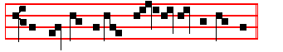
From the gate of hell, de- liver my soul, O Lord.
Antiphon Tone vij, 3.
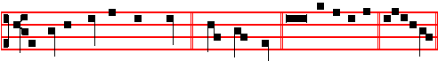
Let everything that hath breath * praise the Lord. Pss. 148, 149, 150. U e a e i.

Psalm 148 Laudate Dominum CXLVIII

O PRAISE the Lord of heaven: * praise him in the height.

2 Praise him, all ye angels of his: * praise him, all his host.

3 Praise him, sun and moon: * praise him, all ye stars and light.

4 Praise him, all ye heavens * and ye waters that be above the heavens.

5 Let them praise the Name of the Lord * for he spake the word, and they were made; he commanded, and they were created.
6 He hath made them fast for ever and ever * he hath given them a law which shall not be broken.
7 Praise the Lord upon earth * ye dragons, and all deeps.

8 Fire and hail, snow and vapours * wind and storm, fulfilling his word.

9 Mountains and all hills * fruitful trees and all cedars.

cclxix
10 Beasts and all cattle * worms and feathered fowls.

11 Kings of the earth and all people * princes and all judges of the world;

12 Young men and maidens, old men and children, praise the Name of the Lord * for his Name only is excellent, and his praise above heaven and earth.
13 He shall exalt the horn of his people; all his saints shall praise him * even the children of Israel, even the people that serveth him.

Here is not said, Glory be to the Father.
Psalm 149 Cantate Domino canticum novum CXLIX

O SING unto the Lord a new song; * let the congregation of saints praise him.

2 Let Israel rejoice in him that made him, * and let the children of Sion be joyful in their King.
3 Let them praise his Name in the dance: * let them sing praises unto him with tabret and harp.
4 For the Lord hath pleasure in his people * and helpeth the meek-hearted.

5 Let the saints be joyful with glory; * let them rejoice in their beds.

6 Let the praises of God be in their mouth; * and a two–edged sword in their hands;

7 To be avenged of the nations * and to rebuke the peoples;

8 To bind their kings in chains * and their nobles with links of iron;

9 That they may be avenged of them, as it is written, * Such honour have all his saints.
Here is not said, Glory be to the Father
Psalm 150 Laudate Dominum CL

O PRAISE God in his holiness * praise him in the firmament of his power.

2 Praise him in his noble acts * praise him according to his excellent greatness.

3 Praise him in the sound of the trumpet * praise him upon the lute and harp.

4 Praise him in the cymbals and dances * praise him upon the strings and pipe.

5 Praise him upon the well-tuned cymbals * praise him upon the loud cymbals.

cclxx
6 Let everything that hath breath * praise the Lord.

Rest eternal.
Antiphon 5.
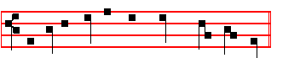
Let everything that hath breath praise the Lord.
 I heard a voice from heaven saying un-to me.
 Blessed are the dead which die in the Lord.
Antiphon on Benedictus Tone ij.
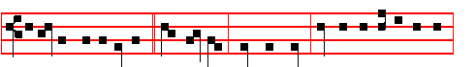
I am the resurrection * and the life, saith the Lord: he that believeth in me,
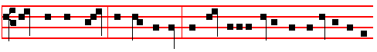
though he were dead, yet shall he live: and whosoever liveth and believeth in me
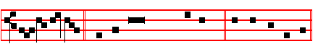
shall never die. Canticle Benedictus, as below. U e a e i.

The Song of Zacharias Benedictus Dominus Luke 1: 68-79.

BLESSED be the Lord God of Israel; * for he hath visited and redeemed his people;
2 And hath raised up a mighty salvation for us * in the house of his servant David;

3 As he spake by the mouth of his holy prophets, * which have been since the world began;
4 That we should be saved from our enemies * and from the hand of all that hate us;

cclxxj
5 To perform the mercy promised to our forefathers, * and to remember his holy covenant;
6 To perform the oath which he sware to our forefather Abraham, * that he would give us;
7 That we being delivered out of the hand of our enemies, * might serve him without fear;
8 In holiness and righteousness before him, * all the days of our life.

9 And thou child shalt be called the Prophet of the Highest: * for thou shalt go before the face of the Lord to prepare his ways; .
10 To give knowledge of salvation unto his people, * for the remission of their sins.

11 Through the tender mercy of our God; * whereby the day-spring from on high hath visited us;
12 To give light to them that sit in darkness, and in the shadow of death, * and to guide our feet into the way of peace.
Rest eternal.Antiphon.
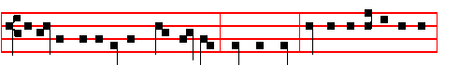
I am the resurrection and the life, saith the Lord: he that believeth in me,
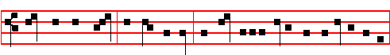
though he were dead, yet shall he live: and whosoever liveth and believeth in me
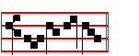
shall never die.
Then kneeling: Our Father secretly until
   And lead us not into temptation.  But deliver us from evil.
Psalm 130 De Profundis, p. ccxxxvj, with the Prayers and Collects, as above in Vespers, p. ccxxxix.

¶ Here follows a simpler setting of the ix Responsory on p. cclxiij:

cclxxij

