All from the Common of one Martyr, p. xxix, except the following.

COLLECT
O GOD, who through the victory of martyrdom didst translate blessed Wenceslas from an earthly principality to the glory of heaven: defend us through his prayers from all adversity, and grant us likewise to rejoice in his fellowship. Through.

In the first Nocturn Lessons from the occurrent Scripture.

IN THE SECOND NOCTURN
Lesson iv
WENCESLAS, Duke of Bohemia, was the son of a Christian father, Wratislaus, and a pagan mother, Drahamira. He was brought up piously by his grandmother, Ludmilla, a very holy woman, and was noted for every virtue; he preserved his virginity unstained throughout his life with the greatest zeal. His mother, through the brutal murder of Ludmilla, seized the government of the kingdom and lived a wicked life together with her younger son, Boleslaus. This stirred up against her the indignation of the nobility, who, wearied of their wicked rule, threw off the yoke of both mother and son and proclaimed Wenceslas as king in the city of Prague.

 The Lord made him honourable, defended him from his enemies, and kept him safe from those that lay in wait. * And gave him perpetual glory.
 He went down with him into the pit, and left him not in bonds. And gave him.

Lesson v
HE ruled the kingdom by piety rather than by power, relieving the orphans, widows and needy with so great charity that sometimes he bore firewood by night to the indigent on his own shoulders, frequently carrying paupers to burial, liberating captives, visiting those detained in prison at all hours of the night, consoling then with money and wisest counsel. In tenderness of heart the Prince mourned deeply anyone condemned to death, even if guilty. He had the most pious respect for priests, and with his own hands sowed the wheat and pressed the wine which they used in the sacrifice of the Mass. By night he went around the Churches on snow and ice with bare feet, leaving behind him bloodstained footprints that warmed the earth.

 O Lord,thou hast given him his heart's desire, * And hast not denied him the request of his lips.
 For thou hast prevented bim with the blessings o£ goodness, thou hast set upon

1970
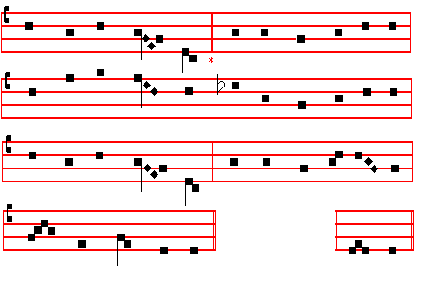
4 Send thy Archangel, Raphael, the restorer. A- men.
Of the misguided ways of men who wander,
Who at thy bidding strengthens soul and body
With thine anointing. .

5 May the blest Mother of our God and Saviour,
May the assembly of the Saints in glory,
May the celestial companies of Angels
Ever assist us.

6 Father almighty, Son and Holy Spirit,
God ever blessed, be thou our preserver;
Thine is the glory which the Angels worship
Veiling their faces. Amen

 An Angel stood at the altar of the temple.
 Having in his hand a golden censer.

On Magnificat, Antiphon. Tone j, 1
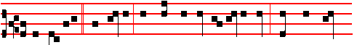
I am Raphael * the Angel, that stand before the Holy One: wherefore bless

2011
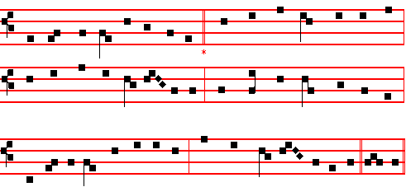

Thee, O Christ, the Father's splendour, 3 By whose watchful care repelling -
Life and virtue of the heart, King of everlasting grace -
In the presence of the Angels Every ghostly adversary,
Sing we now with tuneful art, All things evil, all things base,
Meetly in alternate chorus Grant us of thine only goodness
Bearing our responsive part. In thy Paradise a place.

2 Thus we praise with veneration 4 Laud and honour to the Father,
All the armies of the sky; Laud and honour to the Son,
Chiefly him, the warrior Primate, Laud and honour to the Spirit
Of celestial chivalry, Ever Three, and ever One,
Michael, who in princely virtue Consubstantial, co-eternal,
Cast Abaddon from on high. While unending ages run. Amen.

 An Angel stood at the altar of the temple.
 Having in his hand a golden censer.

On Magnificat, Antiphon. Tone viij, 1
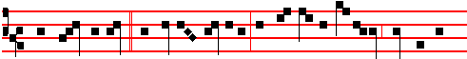
While John beheld * the sacred mystery, the Archangel Michael sounded the
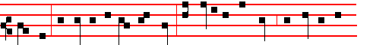
trumpet: Forgive us, O Lord our God, that openest the book, and loosest the

1972

from the beginning were eyewitnesses and ministers of the word. So he wrote the Gospel as he had heard it, but composed the Acts of the Apostles as he himself had seen. He lived tor eighty-four years, and had no wife. He is buried
at Constantinople, to which city, in the twentieth year of Constantine, his bones were transferred from Achaia, together with the remains of Andrew the Apostle.

 These men are conquerors and friends of God, who despised the orders of governors, and earned the everlasting reward: * Now are they crowned and receive palms.
 These are they which came out of great tribulation, and have washed their robes in the blood of the Lamb. Now are they. Glory be. Now are they.

In the third Nocturn Homily by Saint Ambrose, Bishop, on the Gospel, The Lord appointed, from the Common of Evangelists, p. xxj.

__________________________________________________________________

The Twenty-first of October
Saint Hilarion, Abbot
COLLECT
O LORD,we beseech thee, let the intercession of the blessed Abbot Hilarion canmend us unto thee: that those things which for our own merits we cannot ask, we may through his advocacy obtain. Through.
And commemoration is made of SS. Ursula and her Companions.
In Vespers and Lauds, Antiphon.
O ye wise Virgins, arise, and trim your lamps:for behold the Bridegroom cometh; go ye out to meet him.
 The Virgins that be her fellows shall bear her company.
 And shall be brought unto thee.

COLLECT
GRANT, we beseech thee, O Lord our God, that we may at all times so devoutly honour the triumphs of thy holy Virgins and Martyrs Ursula and her Companions: that, although we cannot worthily shew forth their praise, yet we may continually honour them with lowly service. Through.

Lesson ij
HILARION, from Tabatha in Palestine, of pagan parents, was sent to Alexandria to study, and there flourished to the praise of his life and intelligence: and adopting the religion of Jesus Christ, he advanced wonderfully in faith and charity. For he was often in Church, zealous in fasting and prayer: he

2009
Lesson ij Ch. 10, 4-14
IN the four and twentieth day of the first month, as I was by the side of the great river, which is Hiddekel; then I lifted up mine eyes, and looked, and behold a certain man clothed in linen, whose loins are girded with fine gold of Uphaz: his body also was like the beryl, and his face as the appearance of lightning, and his eyes as lamps of fire, and his arms and his feet like in colour to polished brass, and the voice of his words like the voice of a multitude. And I Daniel alone saw the vision: for the men that were with me saw not the vision; but a great quaking fell upon them, so that they fled to hide themselves. Therefore I was left alone, and saw this great vision, and there remained no strength in me: for my comeliness was turned in me into corruption, and I retained no strength.

 An Angel stood at the altar of the temple, having a golden tenser in his hand, and was given unto him much incense: * And the smoke of the incense ascended up before the Lord out of the Angel's hand.
 Before the Angels will I sing praise unto thee; I will worship toward thy holy temple, and praise thy Name, O Lord. And the.

Lesson iij
YET heard I the voice of his words: and when I heard the voice of his words, then was I in a deep sleep, and my face toward the ground. And, behold, an hand touched me, which set me upon my knees and upon the palms of my hands. And he said unto me, O Daniel, a man greatly beloved, understand the words that I speak unto thee, and stand upright : for unto thee am I now sent. And when he had spoken this word unto me, I stood trembling. Then said he unto me, Fear not, Daniel: for from the first day that thou didst set thine heart to understand, and to chasten thyself before thy God, thy words were heard, and I am come for thy words. But the prince of the kingdom of Persia withstood me one and twenty days: but, lo, Michael, one of the chief princes, came to help me; and I remained there with the kings of Persia. Now I am come to make thee understand what shall befall thy people in the latter days: for yet the vision is for many days.

 In the presence of the Angels will I sing praise unto thee. I will worship toward thy holy temple. * And praise thy Name, O my God.
 Because of thy loving-kindness and truth; for thou hast magnified thy Name and thy Word above all things. And praise. Glory be. And praise.

IN THE SECOND NOCTURN

Antiphon. Archangel Michael, * come to the help of God's people. Psalm 19 Cæli enarrant

1974
wonderfully restored to health the soldier Privatus, who was full of ulcers, and united him to Christ:for which the latter, having only just received the faith, was beaten to death with leaden whips.

 O Lord,thou hast given him his heart's desire, * And hast not denied him the request of his lips.
 For thou hast prevented him with the blessings of goodness, thou hast set upon his head a crown of pure gold. And hast not.

Lesson vj
CALLISTUS was in his See for five years, one month, and twelve days. In five ordinations, in the month of December, he made sixteen priests, four deacons, and eight bishops. After long starvation and repeated scourgings he was thrown head-first into a well, and having thus been crowned with martyrdom under the Emperor Alexander, he was placed in the cemetery of Calepodius on the Via Aurelia, three miles from the City, on the fourteenth of October. Afterwards his body was taken into the Basilica of Saint Mary across the Tiber, which had been built by him, and is honoured with the greatest veneration beneath the high altar.

 The Lord clothed him with a robe of glory. * And set upon his head a crown of pure gold.
 With the bread of life and understanding shall the Lord feed him, and give him the water of wisdom to drink. And set.Glory be. And set.
In the third Nocturn, Homily on the Gospel, There is nothing covered, from the Common in the fourth place, p. xxxiv.
__________________________________________________________________

THE EIGHTEENTH OF OCTOBER
ON THE FEAST OF SAINT LUKE, EVANGELIST
DOUBLE OF THE SECOND CLASS

All from the Common of Apostles, p. ij, except the following.

COLLECT
WE beseech thee, O Lord, that the holy Evangelist Luke may intercede for us: who for the honour of thy name continually bare in his own body the mortification of the cross. Through.

In the first Nocturn Lessons from the Prophet Ezekiel placed in the Common of Evangelists, p. xix.
IN THE SECOND NOCTURN

2007
 The Archangel Michael, to whom God had committed the souls of the righteous, came with a multitude of Angels, * To lead them to the joys of Paradise.
 O Lord, send forth thy Holy Spirit from heaven, the Spirit of wisdom and understanding.

Lesson vj
AND whenever anything mighty is to be done, Michael is called, to be sent; so that by his very name and deed we are to understand that none is able to do what pertains unto God to do. Whence also that ancient enemy who through pride desired to be like God, saying: I will ascend into heaven, I will exalt my throne above the stars of God; I will be like the most High; when at the end of the world he is left with nothing but his own strength, to perish in his final punishment; then he is called to combat with Michael the Archangel, as it is said by means of John: There was war in heaven: Michael and his Angels fought against the dragon. Gabriel, too, was sent to Mary, he who was called God's Fortitude; for he came to announce him who vouchsafed to appear in lowliness in order to overcome the powers of the air. And again, Raphael means, as we have said, God's Healing; for clearly, when he touched Tobit's eyes in his capacity of healing, he wiped away the shades of blindness.

 At that time shall Michael stand up, the great Prince which standeth for the children of thy people: * And there shall be a time of trouble, such as never was since there was a nation even to that same time.
 And at that time thy people shall be delivered, every one that shall be found written in the book of life. And there. Glory be. And there.

IN THE THIRD NOCTURN
Antiphon.. Angel Archangel * Michael, God's messenger for the souls of the righteous, alleluia, alleluia. Psalm 96 Cantate Domino
Antiphon. There was given unto him * much incense, that he should offer it upon the golden altar which is before the eyes of the Lord. Psalm 97 Dominus regnavit
Antiphon. Many were the glorious * deeds of Michael the Archangel, who, valiant in warfare, won the victory. Psalm 103 Benedic, anima mea

 In the presence of the Angels will I sing praise unto thee, O my God.
 I will worship toward thy holy temple, and praise thy Name.

The Lesson from the Holy Gospel according to S. Matthew
Lesson vij Ch. 18
THE disciples came unto Jesus, saying: Who is the greatest in the kingdom of heaven? And the rest.
1976
 The root of Jesse hath budded, a star is arisen from Jacob.
 The Virgin hath brought forth a Saviour, we praise thee, O our God.
On Benedictus, Antiphon. Tone j, 3
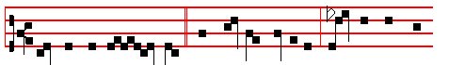
O ho- ly Ma- ry, * help thou the suffering, strengthen the faint-
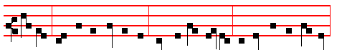
hearted, comfort the sorrowful; pray for the people, entreat for the clergy,
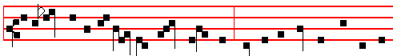
intercede for all womankind vowed unto God: may all acknowledge the help of 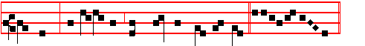
thy prayer, who celebrate thy wondrous Motherhood. Canticle Benedictus

COLLECT
O GOD, who wast pleased that thy Word should take flesh of the womb of the blessed Virgin Mary at the message of an Angel: grant to thy humble servants; that we, who believe her to be truly the Mother of God, may be aided by her intercession in thy sight. Through the same.

At Prime in the Short  is said.  Who wast born of the Virgin Mary.
At the Hours, the Antiphons and Collect are taken from Lauds, the rest from the Common of blessed Mary, p. ccxv
(At Terce, the Chapter from Lauds above).
In second Vespers, all as in first.
On Magnificat, Antiphon. Tone j, 4
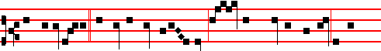
Thy Maternity, * O Virgin Mother of God, hath brought tidings of joy to the

2005
appointed as guardian. Hence we read in the Revelation of S. John: Unto the angel of the church of Ephesus write. The Apostle also enjoins that the heads of women be veiled in the churches because of the Angels.
Te Deum Laudamus, p. 24.

AT LAUDS, AND THROUGH THE HOURS
Antiphon 1. Tone iv, 1
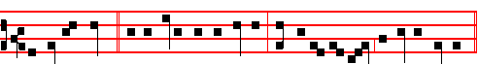
An Angel stood * at the altar of the temple, having in his hand a golden censer.

Psalm 93 and the rest, p. 28.

Antiphon 2. Tone vij, 3
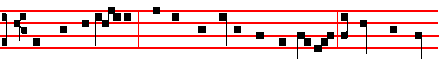
While the Archangel * Michael contended with the dragon, a voice was heard

of them that said: Salvation to our God. E u o u a e.

Antiphon 3. Tone viij, 1
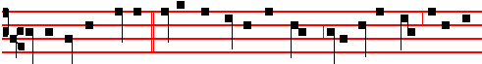
O Archangel Michael,* I have appointed thee prince over all the souls about to

be received. E u o u a e.

Antiphon 4. Tone viij, 1

1978
 Full of grace are thy lips: intercede for us to the Lord our God. Therefore.

 viij. Rejoice with me, all ye that love the Lord, for athough I was lowly I pleased the Most High. * And from my womb I have brought forth God and man.
 All generations shall call me blessed, for the Lord hath rewarded the lowliness of his handmaiden. And from. Glory be. And from.

Lesson ix from the Homily of the occurrent Sunday (Lesson ix, p. 476-7).

Te Deum Laudamus, p. 24.

AT LAUDS, and through the Hours
Antiphon 1. Tone j, 1
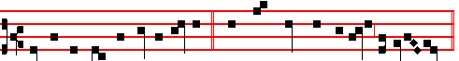
Blessed art thou, O Virgin Mary, * who hast borne the Creator of all things.
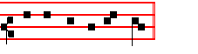
Psalm 93 Dominus regnavit, and the rest, p. 28.

Antiphon 2. Tone iij, 1
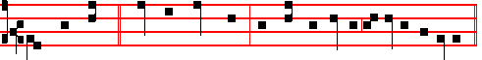
Thou hast borne * him who made thee, and thou remainest a Virgin for ever.
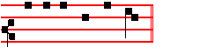
E u o u a e.

Antiphon 3. Tone v
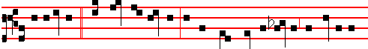
All generations * shall call me blessed, for the Lord hath regarded the lowliness

2003
CHRIST, the fair glory of the holy Angels,
Thou who hast made us, thou who o'er us rulest,
Grant of thy mercy unto us thy servants
Steps up to heaven.

2 Send thy Archangel, Michael, to our succour;
Peacemaker blessed, may he banish from us
Striving and hatred, so that for the peaceful
All things may prosper.

3 Send thy Archangel, Gabriel, the mighty;
Herald of heaven, may he from us mortals
Spurn the old serpent, watching o'er the temples
Where thou art worshipped.

4 Send thy Archangel, Raphael, the restorer
Of the misguided ways of men who wander,
Who at thy bidding strengthens soul and body
With thine anointing.

5 May the blest Mother of our God and Saviour,
May the assembly of the Saints in glory,
May the celestial companies of Angels
Ever assist us.

6 Father almighty, Son and Holy Spirit,
God ever blessed, be thou our preserver;
Thine is the glory which the Angels worship,
Veiling their faces. Amen.

 An Angel stood at the altar of the temple, alleluia.
 Having in his hand a golden censer, alleluia.
On Benedictus, Antiphon. Tone viij, 1
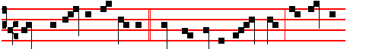
There was silence in heaven * while the dragon waged war: and Michael
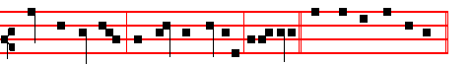
fought against him, and had the victory, alle-luia Canticle Benedictus

1980
IN THE SECOND NOCTURN

Sermon by S. Leo the Great
Lesson iv Sermon 1 on the Lord's Nativity
A ROYAL Virgin of the stem of Jesse is chosen, who in order to become pregnant with the holy Child, was to conceive the divine and human Offspring in mind before conceiving in body. And lest, being unaware of the heavenly counsel, she should be troubled at the strange tidings, she learned from her conversation with the Angel what was to be performed in her through the operation of thc Holy Ghost, nor did she think it a loss to her maiden honour that she would soon be the Mother of God. For why should she be without hope in the novelty of her conception, when the operation of divine power had been promised to her? The faith of her belief is confirmed by the testimony of a foregoing miracle. Unhoped-for fruitfulness is given to Elisabeth, that there might be no doubt that he who had given conception to the barren would also give it to the Virgin. Therefore the Word, the Son of God, who was in the beginning with God, by whom all things were made and without whom was nothing made, in order to set man free from eternal death, was made man.

 Let us celebrate worthily the Maternity of the glorious Virgin Mary: * whose lowliness the Lord regarded, when at the message of. the Angel she conceived the Saviour of the world.
 Let us sing glory unto Christ on this holy festlval of the wondrous Mother of God. Whose.

Lesson v Sermon 2 On the Lord's Nativity
JESUS Christ entered this lower realm, descending from his heavenly throne and leaving not his Father's glory, and is begotten in accordance with a new order, a new birth. A new order, because invisible in his own nature he is made visible in ours: incomprehensible, he willed to be comprehended: remaining before time, he began to be in time. He is begotten in accordance with a new nativity: conceived by the Virgin he is born of the Virgin, without concupiscense of paternal flesh, without injury to his Mother's integrity: such a birth befits the future Saviour of men, who would have the nature of human substance in himsclf, and yet know not the stain of human flesh. Unlike in origin, yet like in nature, his was a birth without the use and custom of mankind: for it was contingent on divine power that the Virgin conceived, the Virgin bore, and Virgin she remained.

 Blessed art thou, O Daughter of the Lord, for through thee we have received the fruit of life: * For thou alone without compare wast pleasing to our Lord Jesus Christ.

2001
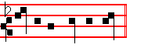
 Out of the Angel's hand. Ascended up. Glory be. The smoke.
 In the presence of the Angels I will sing praise unto thee, O my God.
 I will worship toward thy holy temple, and praise thy Name.

AT NONE
Antiphon. Angels and Archangels, p. 1979.
Chapter Rev. 12
THERE was war in heaven: Michael and his Angels fought against the dragon; and the dragon fought and his angels, and prevailed not; neither was their place found any more in heaven.
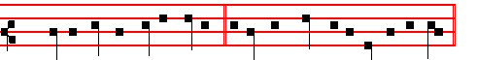
Short  In the presence of the Angels * I will sing praise unto thee, O my God.
In the.
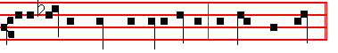
 I will worship toward thy holy temple, and praise thy Name. I will sing.
Glory be. In the.  O praise God.  All ye Angels of his.

AT II VESPERS
Antiphons and Chapter from Lauds. Psalms 110, 111, 112, 113 of Sunday, and in the last place, psalm 138 Confitebor tibi Hymn E.H. 241 Tibi Christe, p. 1972.
 In the presence of the Angels I will sing praise unto thee, O my God.
 I will worship toward thy holy temple, and praise thy Name.
On Magnificat, Antiphon. Tone j, 3
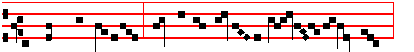
O Prince most glorious, * Michael the Archangel, keep us in remembrance:
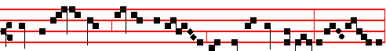
here and everywhere, always, en-treat the Son of God for us, al-le lu- ia,

1982
Hymn Ave, Maris Stella, p. ccv.

 Blessed art thou among women.  And blessed is the fruit of thy womb.
On Magnificat, Antiphon. Tone vij, 1
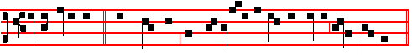
Let us celebrate * with gladness the Maternity of blessed Mary ever Virgin.
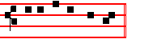
Canticle Magnificat
COLLECT
O GOD, who wast pleased that thy Word should take flesh of the womb of the blessed Virgin Mary at the message of an Angel: grant to thy humble servants; that we, who believe her to be truly the Mother of God, may be aided by her intercession in thy sight. Through the same.

The Hymns of Compline and the Hours are sung to the Mode of Matins or Lauds in the Common, and conclude as follows:
All honour, laud, and glory be
O Jesu, Virgin-born, to thee;

AT MATINS
Invitatory:- Let us celebrate the Maternity of the blessed Virgin Mary, * Let us worship Christ the Lord her Son.
Hymn Cælo Redemptor prætulit
From heaven of old the Redeemer chose 3 May joyous hope drive from our hearts
The blessed Virgin's holy womb Anxiety and all our fears,
From whence, assuming mortal flesh, For she indeed brings to her Son
As future victim he would come. Our supplications and our tears.

2 And him the Virgin bore for us 4 The Son receives his parent's words
As Saviour of all human life: And hears her when she intercedes:
He bought us with his precious Blood, O let us ever love her more
Endured the Cross and mortal strife. And call to her in all our needs.

5 Be glory to the Trinity
Who in the Mother's womb most pure
Bestowed the precious Offspring blessed:
Be praise while ages ere endure. Amen.

1999
 The Lord guided the righteous in right paths, and shewed him the kingdom of God. And gave.

Lesson v
THEN he withdrew into the vast Syrian desert, where he spent four years in reading divine books and comtemplating heavenly blessedness, tormenting himself with unremitting abstinence, many tears, and affliction of the body. He was ordained priest by Paulinus, Bishop of Antioch, and went to Pope Damasus in Rome with Paulinus and Epiphanius in connection with controversies of some bishops, and assisted him in writing ecclesiastical epistles. But overcome by desire for his former solitude, he returned to Palestine, to the crib of Christ the Lord in Bethlehem, and in the monastery which had been erected by Paula the Roman, he formed a certain heavenly rule of life; and though much afflicted with various diseases and sufferings, yet he overcane his bodily discomforts by works of piety and ceaseless study and writing.

,.The Lord loved him,and adorned him: he clothed him wiyh a robe of glory. * And at the gates of paradise he crowned him.
The Lord put on him the breastplate of faith,and adorned him. And at.

Lesson vj
FROM all parts of the world he was referred to as an oracle on questions of expounding the divine Scriptures. Pope Damasus and Saint Augustine often consulted him on most difficult passages of Scripture, on account of his remarkable learning, and of his knowledge, not only of Latin and Greek, but also of Hebrew and Chaldaic, and because he had read almost all the Scriptures, as testified by the same Augustine. He attacked the heretics with very fierce writings, and always took up the defence of the godly and catholic. He translated the Old Testament from the Hebrew, and at the order of Damasus rendered the New faithfully from the Greek, and also expounded the greater part. He also rendered into Latin many writings of learned men: and himself illuminated the Christian rule with other monuments of his own genius. Having reached extreme old age, and being renowned for learning and holiness, he passed to heaven in the reign of the Emperor Honorius. His body was buried at Bethlehem, but was afterwards translated to the Basilica of S. Mary at the Crib, in Rome.

 This man did according to all that God commanded him: and God said unto him: Enter thou into my rest: * For thee have I seen righteous before me among all people.
.This is he which hated his life in this world, and is come unto life eternal. For thee. Glory be. For thee.

1984
The very hairs of your head are all numbered: fear ye not, therefore, ye are of more value than many sparrows.
 Let the Saints be joyful with glory.  Let them rejoice in their beds.
Collect Mav the blessed example, as above.
__________________________________________________________________

The Ninth of October
On the Feast of SS. Dionysius (Denys), Rusticus, and Eleutherius, Martyrs Semidouble
All from the Common of many Martyrs, p. xlvij, except the following.

COLLECT
O GOD, who on this day didst strengthen blessed Dionysius, thy Martyr and Bishop, with the virtue of constancy in his passion, and didst vouchsafe to join unto him Rusticus and Eleutherius for the preaching of thy glory to the Gentiles: grant us, we beseech thee; by their example, to despise for love of thee the prosperity of the world, and to fear none of its adversities.

IN THE SECOND NOCTURN

Lesson iv
DIONYSIUS of Athens, one of the Areopagite judges, was a man instructed in all kinds of learning. He had been wandering in the errors of paganisn until, on the day when Christ the Lord was nailed to the Cross, noticing that the sun was unnaturally weak, he is reported to have exclaimed: Either the God of nature is suffering, or the fabric of the world is breaking up. But when the Apostle Paul, coming to Athens, and being brought into the Areopagus, gave the reason for the doctrine which he preached, affirming that Christ the Lord had risen, and would restore all the dead to life; both many others, and Dionysius himself believed in Christ.

 Thy Saints, O Lord, have passed a wonderful way, serving thy peculiar commandments that were given unto them, that thy children might be found without hurt.* Dry land appeared,and out of the Red Sea a way without impediment.
 For he smote the stony rock indeed, that the waters gushed out, and the streams flowed withal. Dry land.

Lesson v
AND so by the Apostle he was both baptized and set over the Church of Athens. Later he came to Rome, and was sent into Gaul by Pope Clement to

1997

away wrath, forbidding the tooth for a tooth. and condemning the hidden lust of the heart. Till heaven and earth pass. A new heaven and a new earth are promised unto us, which the Lord God will make. Then if the new ones are to be created, then it follows that the old ones will pass away. But from what follows: One jot or one tittle shall in no wise pass from the law, till all be fulfilled: it is shown from the example of a letter, that even that which seems least in the law is full of spiritual mysteries, and that all is gathered up in the Gospels.
Te Deum Laudamus, p. 24.
In II Vespers commemoration is made of Saint Remigius.
__________________________________________________________________

FEASTS OF OCTOBER

On the first unimpeded day is said the Office of the Dead.
__________________________________________________________________

The First of October
Saint Remigius, Bishop and Confessor

Antiphon. O thou Priest and Bishop, thou worker of mighty works, thou good shepherd of the people, pray unto the Lord for us.
 The Lord loved him and adorned him.  He clothed him with a robe of glory.

COLLECT
GRANT, we beseech thee, almighty God: that the venerable solemnity of blessed Remigius, thy Confessor and Bishop, may increase our devotion and set forward our salvation. Through.

Lesson iij
REMIGIUS, Bishop of Rheims, flourished in the time of Clovis, king of the Franks, whom he also baptized, and he was the first of all to lead the Franks to the faith of Christ the Lord by his teaching and miracles. By his prayers he raised a dead girl to life. He expounded many of the books of Holy Scripture. For more than seventy years he ruled the Church of Rheims in the most exemplary manner. The sanctity of his life and death were proved by the many miracles which followed after them.
Te Deum Laudamus, p. 24.
__________________________________________________________________

THE SECOND OF OCTOBER
ON THE FEAST OF THE HOLY GUARDIAN ANGELS
DOUBLE

1986
BUT if thou shalt indeed obey his voice, and do all that I speak; then I will be an enemy unto thine enemies, and an adversary unto thine adversaries. For mine Angel shall go before thee.
Short as p. 1982
In the presence of the Angels * I will sing praise unto thee, O my God. In the.
 I will worship toward thy holy temple, and praise thy Name. I will sing. Glory be. In the.
 O praise God.  All ye Angels of his.

IN II VESPERS
Antiphon God shall give, with the rest from Lauds, p. 1279. Psalms 110, 111, 112, 113 of Sunday, and in the last place Psalm 138 Confitebor tibi
Chapter, Hymn and Versicle as above in I Vespers, p. 1987.
On Magnificat, Antiphon. Tone vj
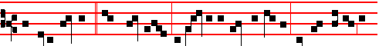
Ye holy Angels, * our Guardians, defend us in time of battle, lest we perish in
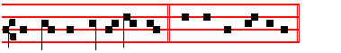
the dreaded day of judgment. Canticle Magnificat
Collect as above, p. 1994.
__________________________________________________________________

The Fifth of October
SS. Placidus and his Companions, Martyrs.

COLLECT
O GOD, who vouchsafest unto us to celebrate the birthday of thy holy Martyrs Placidus and his Companions: grant that we may rejoice in the everlasting felicity of their fellowship. Through.

Lesson iij
PLACIDUS, born at Rome the son of Tertullus a high nobleman, was as a child consecrated to God and entrusted to Saint Benedict. He became so proficient in the discipline and institutions of the monastic life, that he was numbered among his distinguished disciples. Sent by him into Sicily, he built a monastery and Church in honour of Saint John the Baptist near the gate of Messana, where he lived with his monks in admirable sanctity. When Eutychius and Victorinus, his

1995
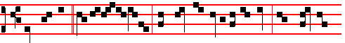
They are all * ministering spirits, sent forth to minister to them who shall be

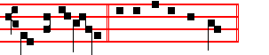
heirs of salvation. Canticle Magnificat

COLLECT
O GOD, who of thy ineffable providence dost vouchsafe to send thy holy Angels to be our guardians: grant unto us thy humble servants; that we may ever both be defended by their protection, and rejoice in their everlasting fellowship. Through.
AT MATINS
Invitatory.- The Lord, the King of the Angels, * O come, let us worship. Psalm 95 Venite, p. 2
Hymn Custodes hominum, as above in Vespers.

IN THE FIRST NOCTURN
Antiphon. The Lord God * of heaven and earth shall send his Angel before thee. Psalm 8 Domine, Dominus noster
Antiphon. My God * hath sent his Angel, and hath shut the lions' mouths, that they have not hurt me. Psalm 11 In Domino confido
Antiphon. Go prosperously, * and the Lord be with you in your journey, and his Angel keep you company. Psalm 15 Domine, quis
 An Angel stood at the altar of the temple.
 Having in his hand a golden censer.
¶ The Lessons of the first Nocturn which follow are omitted in a year in which the beginning of the book of Esther cannot be read on the preceding days, for then it must be read on this Feast.

From the Book of Exodus
Lesson j Ch. 23, 20-23
BEHOLD, I send an Angel before thee, to keep thee in the way, and to bring thee into the place which I have prepared. Beware of him, and obey his voice, provoke him not; for he will not pardon your transgressions: for my name is in him. But if thou shalt indeed obey his voice, and do all that I speak; then I will be an enemy unto thine enemies, and an adversary unto thine adversaries. For mine Angel shall go before thee.
1988
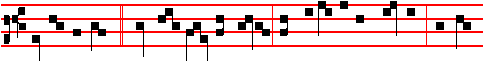
Blessed be God, * who hath sent his Angel, and delivered his servants who put
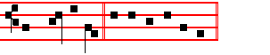
their trust in him. E u o u a e.
Antiphon 5. Tone vij, 3
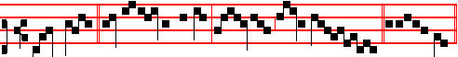
Praise God, * all ye Angels of his: praise him, all his host. E u o u a e.
Chapter Ex. 23
BEHOLD, I send an Angel before thee, to keep thee in the way, and to bring thee into the place which I have prepared. Beware of him, and obey his voice.

Hymn Orbis patrator optime Mode viij 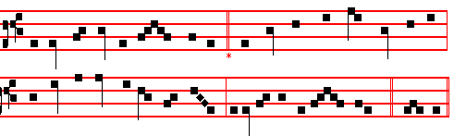
Creator of the circling sky, 4 Let him destroy that hidden snare
Who madest all by power most high, The eager serpent doth prepare,
Thy Providence will never cease Lest we be taken in the net
To rule thy works in might and peace. Before our heedless bosoms set.

2 Be present when we cry to thee, 5 At his command let every fear
A sinful people though we be; Of hostile foemen disappear;
And as the day-dawn grows apace Let civil strife give way to peace,
Illume our minds with light of grace. And pestilence and famine cease.

3 O send thine Angel thitherward 6 To God the Father glory be;
Assigned by thee to be our guard, For those the Saviour setteth free,
That now his presence may begin Anointed by the Holy Ghost
To keep us from all stain of sin. Are guarded by the Angel host. Amen.

1993
removed, and went behind them. Psalm 21. Domini est terra
Antiphon. The Angel of the Lord * tarrieth round about them that fear him, and delivereth them. Psalm 34 Benedicam Domino
 The smoke of the incense ascended up before the Lord.
 Out of the Angel's hand.

¶ In place of the Sermon by Bernard of Clairvaux, not given here, may be read the Lessons for S. Michael, above, p. 1975, with the  as below.

 iv. As the Lord liveth, * His Angel hath kept me in my way that I went thither, and in my sojourning there, and in mine home-coming again hither.
 And the Lord hath not suffered me that am his hand- maid to be defiled. His.

 v. The Angel of the Lord came down into the furnace together with Azarias and his fellows, and smote the flame of the fire out of the furnace, * So that the fire touched them not at all, neither hurt them.
 Blessed be their God, who sent his Angel, and delivered his servants that trusted him. So that.

 vj. In all their affliction he was afflicted, * And the Angel of his presence saved them.
 In his love and pity he redeemed them; and he bare them, and carried them all the days of old. And the. Glory be. And the.

IN THE THIRD NOCTURN
Antiphon. 'The Lord sent * an Angel, which cut off all the mighty men of valour. and the leaders and captains in the camp of the king of Assyria. Psalm 96 Cantate Domino
Antiphon. Worship the Lord, * all ye Angels: Sion heard of it, and rejoiced. Psalm 97 Dominus regnavit
Antiphon. O praise the Lord, * ye Angels of his, ye that excel in strength, ye that fulfil his commandment, and hearken unto the voice of his words. Psalm 103
Benedic, anima mea
 In the presence of the Angels will I sing praise unto thee, O my God.
 I will worship toward thy holy temple, and praise thy Name

The Lesson from the Holy Gospel according to S. Matthew
Lesson vij Ch. 18
THE disciples carne unto Jesus saying: Who is the greatest in the kingdom of heaven? And the rest.
Homily by S. Hilary, Bishop Comm. On Matt. 18

1990
THE Lord teaches: Except ye become as little children, ye shall not enter into the kingdom of heaven. That is, through returning to the simplicity of children we are to do away with the sins of our body and soul. He calls all those, Children, who believe by means of the faith that cometh by hearing. For these obey their father, love their mother, wish no evil to their neighbour, care nothing for riches; are not haughty, not despiteful, they lie not, they believe what they are told, and what they hear they hold as troth. We are to return, then, to the simplicity of babes; for if we be established therein, we shall bear within us the image of the Lord's humility.

 When Maccabeus and they that were with him heard that Lysias besieged the holds, they and all the people with lamentation and tears besought the Lord that he would send * A good Angel to deliver Israel.
 So they went forth together with a willing mind, and as they were at Jerusalem, there appeared before them on horseback one in white clothing.

Blessing May they whose.
Lesson viij
WOE unto the world because of offences! The humiliation of the Passion is an offence to the world. Herein lies the greatest stupidity of mankind: that, because of the shame of the cross, it would not accept the Lord of eternal glory. And what is more perilous to the world, than not to accept Christ? For it must needs be, he says, that offences come; because for the accomplishment of the mystery of the giving us back of eternal life, all the humiliation of the Passion had to be fulfilled in him.

 O Lord, thou didst send thine Angel in the time of Hezekiah, king of Judah, and didst slay in the host of Sennacherib an hundred, four score and five thousand. * Now also, O Lord of heaven, send thy good Angel before us for a fear and dread unto them.
 And through the might of thine arm let those be stricken with terror that come against thy holy people to blaspheme. Now also. Glory be.

Lesson ix
TAKE heed that ye despise not one of these little ones that believe in me. He made a fitting bond of mutual love, and set it especially on those who truly believed in the Lord. For I say unto you that in heaven their angels do always behold the face of my Father which is in heaven. For the Son of man is come to save that which was lost. Therefore the Son of man saves, and the Angels see God, and the Angels of the little ones have wardship over the prayers of the faithful. And in wardship the Angels have absolute authority. The Angels daily

1991

